How To Link Your License To Your Online Account

This guide is for existing license holders who have not yet linked their license to their online account. If you are an applicant for license, use one of the “How To Apply Online…” guides for your desired license type. If you don’t yet have an online account, the “How-To” guide for setting one up is the first option at the top of this page.
Log into your online account. The login page can be accessed here: https://vo.licensing.hpc.texas.gov/datamart/login.do
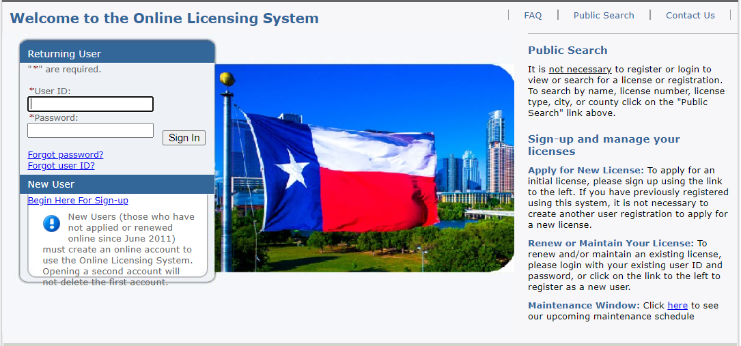

Review the “License Information” box in the upper right corner of the “Quick Start Menu” to ensure your license is not already linked to the account. Click “Select” on the “Add Licenses…” line to begin the adding process.
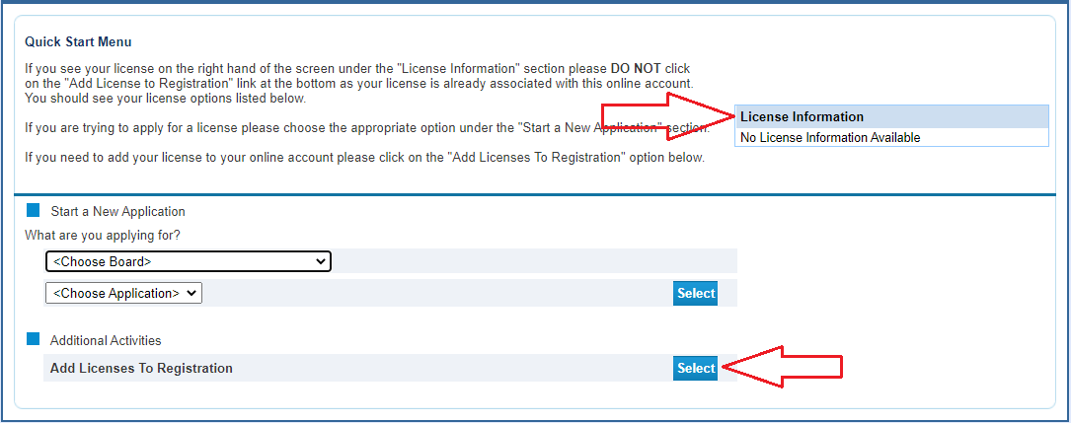
Select “Yes” and click “Next”. By selecting “Yes” you are telling the system that your license is not yet associated to your online account and you are not in the process of applying for a license.
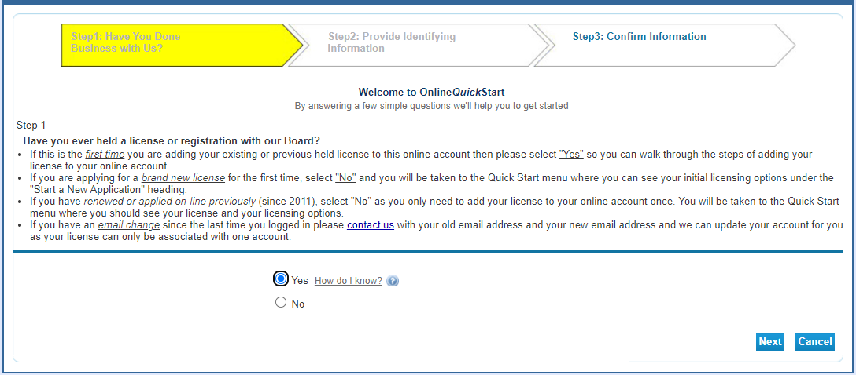
Choose “Texas Behavioral Health Executive Council” from the first dropdown and then select your profession from the second. Click “Next”.
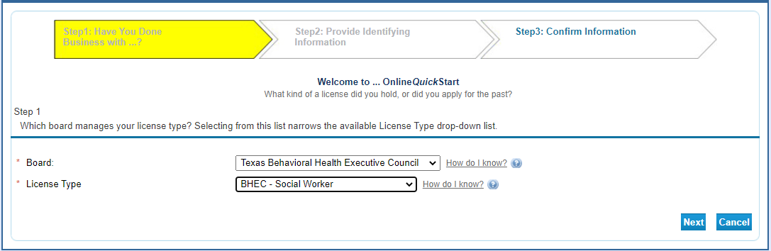

The identifying information may look slightly different depending upon the profession you have selected. The example below is for Social Workers. Answer the questions and check the “I’m not a robot” box (which may prompt you to identify items in a picture before moving forward). Click “Next”.
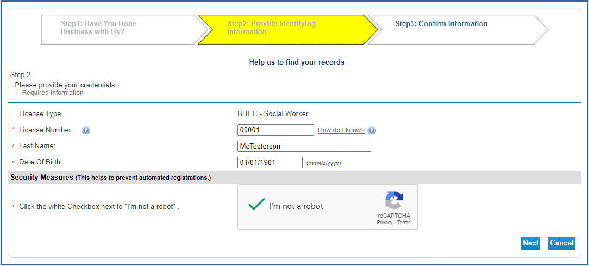

Verify the license information is yours. Select the “I confirm…” option then click “Next”.
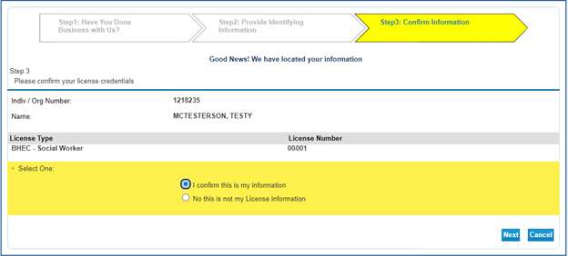

If your license is already associated to another online account, you will get this error message. It is not uncommon for a licensee to forget they created an account, especially if it happened several years ago. In this case, you will need to use the “Forgot Password” procedure or email the agency to request your license be unlinked from the current account.
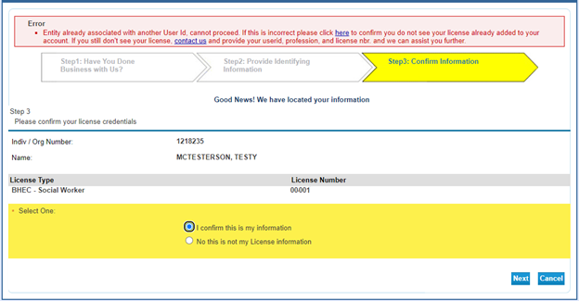

Otherwise, you will be taken back to the “Quick Start Menu”. Your license information will be displayed in the box on the upper right corner and a new “Manage your license information” drop-down menu will now be available.
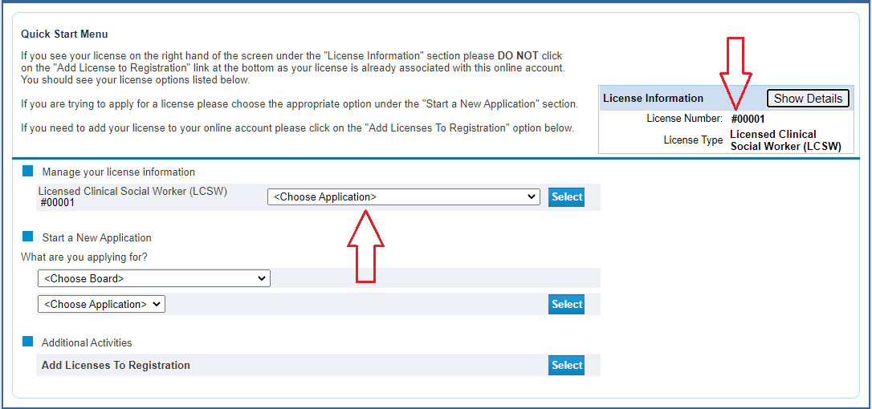
Procedure Complete.

