How To Apply Online for a Name Change

1. First, log into your online account. If you do not yet have an account or if you haven’t linked your LPC Associate license you will need to do so. Instructions for account creation can be found here.

2. From the “Manage your license information” drop-down, choose “Name Change (Online Trx)” then click “Select”.

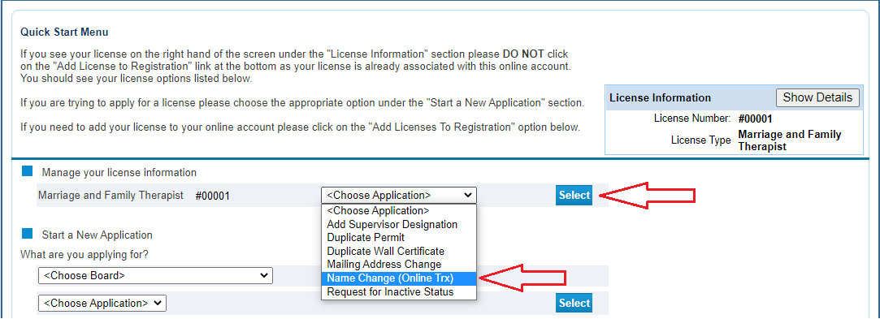

3. You will be taken to the Name Change module. This page gives you information on name change requirements. After familiarizing yourself with this information, click “Next” to move forward.

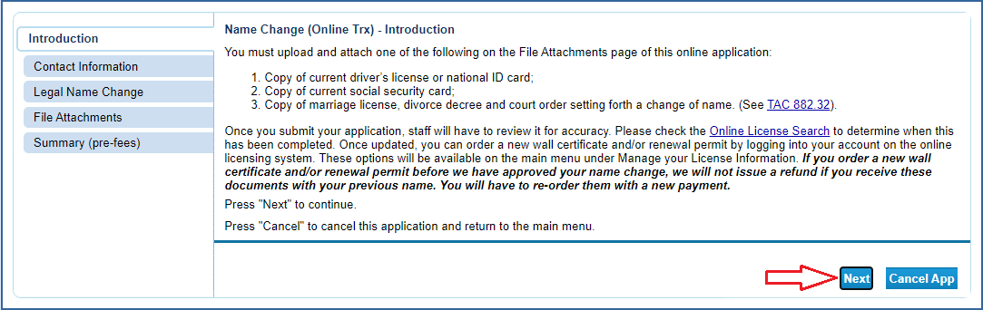

4. Verify/Update your contact information then click “Next”.

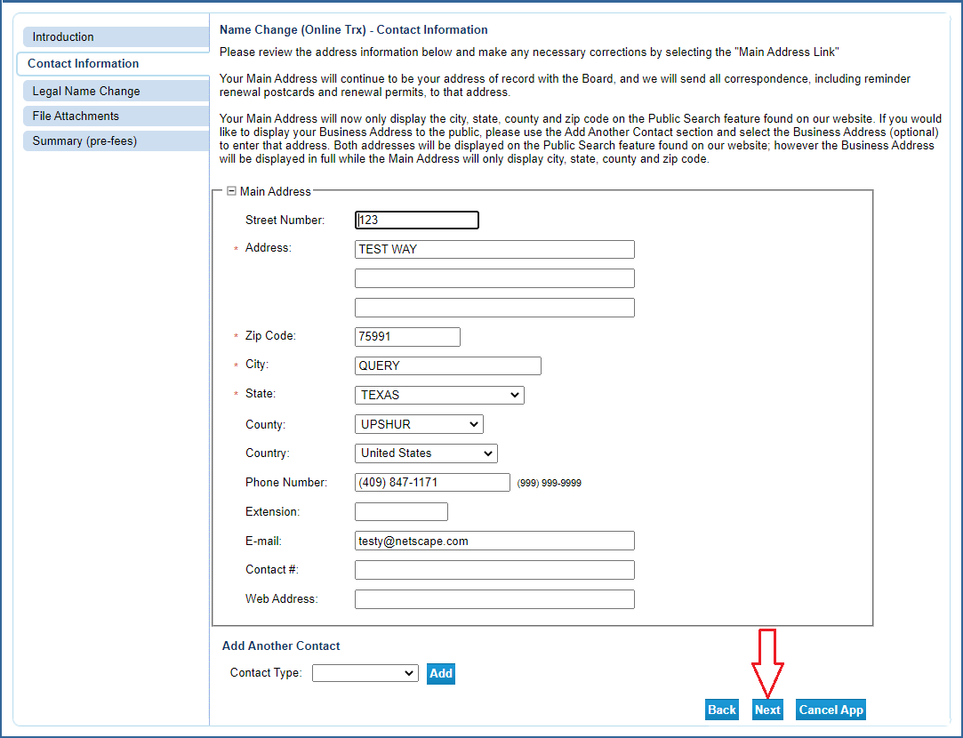

5. Enter your new legal name and click “Next”.

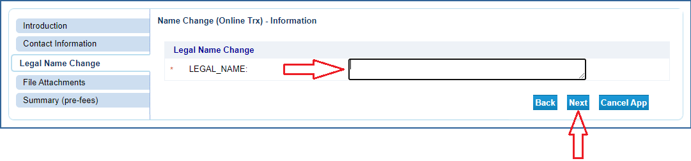
6. Upload the required supplemental documentation (documents are listed in step 3). Click “Attach” to add a document to your online application.

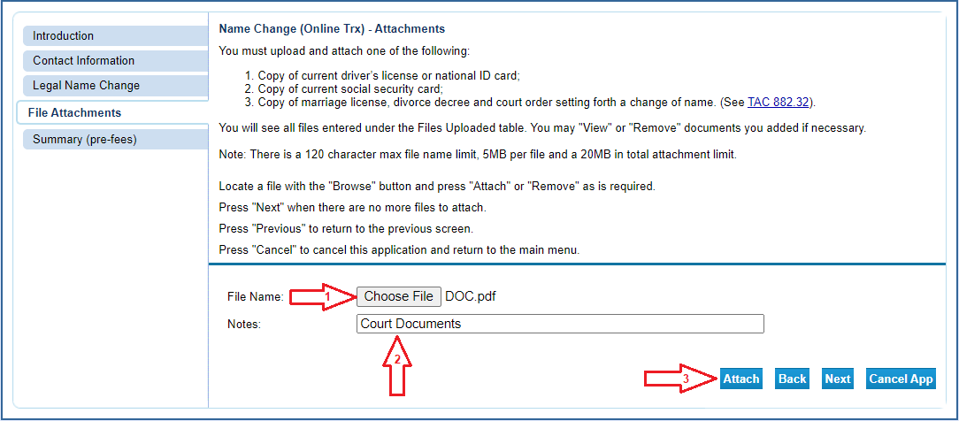

Each time you attach a file, it will appear above the selection boxes. NOTE: Be sure to avoid attaching files that exceed the max file size. Once all documentation is uploaded, click “Next”.

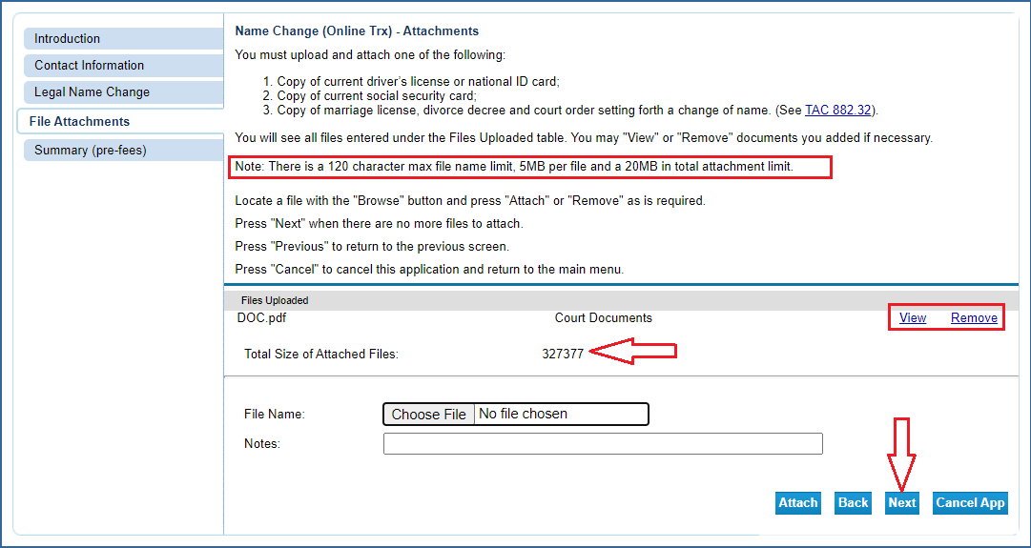

7. Review your information and edit where necessary. When complete, click “Submit”.

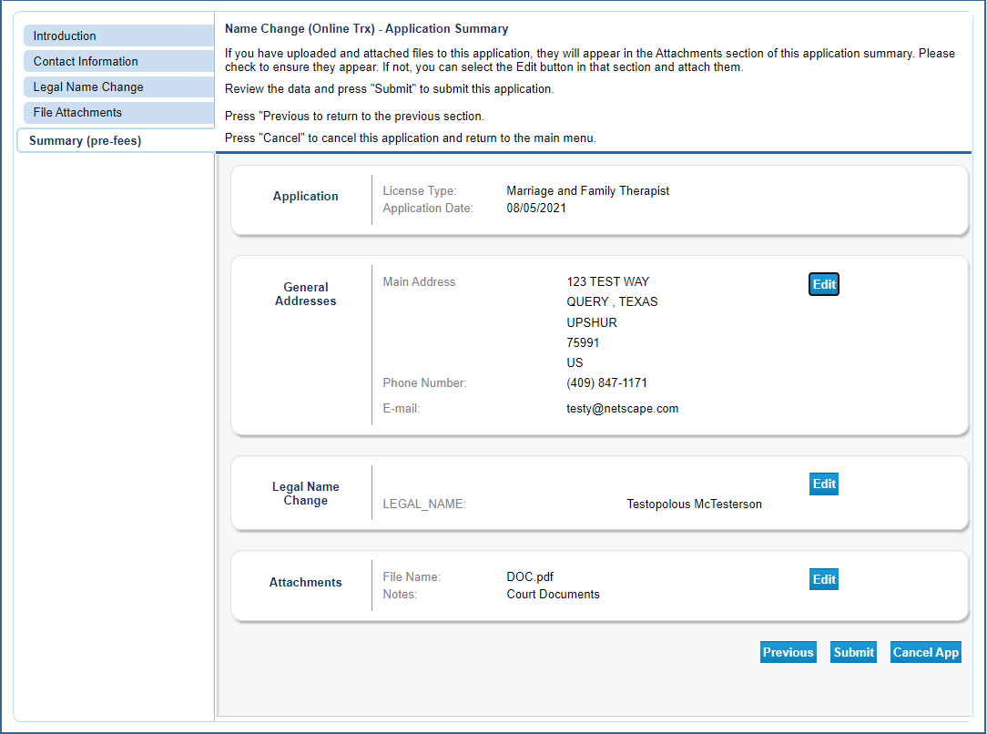

8. Attest and agree to the statement then click “Next”. Important Note: The name change is NOT AUTOMATIC! BHEC staff will review the documentation submitted to validate the name change. To confirm the name change access our license verification function here. Please allow two weeks for processing before confirming the change. Only after you have confirmed the name change has been completed should you purchase a new Wall Certificate.

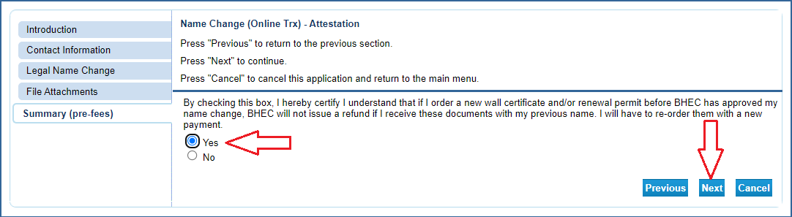

After clicking “Next” you will land on the Fee and Summary Report page. As there is no fee for a name change the report will not reflect a payment. You will also be sent a confirmation email alerting you that your name change request has been received. This email will include your name change summary as an attachment.

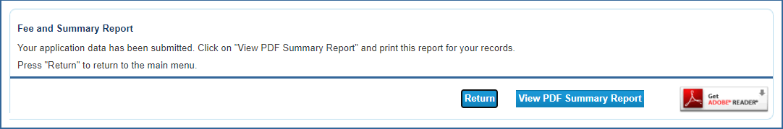

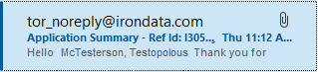

Important Note: A name change DOES NOT trigger the issuance of an updated wall certificate. You will need to purchase a new certificate. Instructions on purchasing a new wall certificate online can be found on the menu at the top of this page.

Reminder: The name change is NOT AUTOMATIC! BHEC staff will review the documentation submitted to validate the name change. To confirm the name change access our license verification function here. Please allow two weeks for processing before confirming the change. Only after you have confirmed the name change has been completed should you purchase a new Wall Certificate.

