How To Change Your Address Online

1. Log into your online licensing system account. If you do not yet have an account, you will need to create one. A guide on how to create a new account is the first “How To” listed on this page.

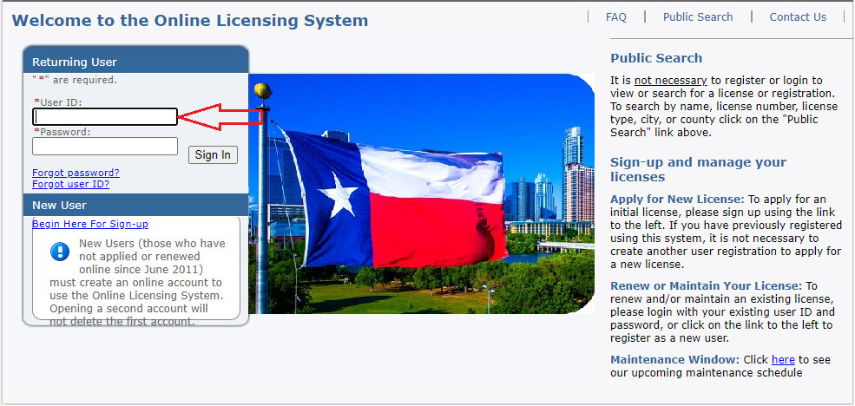

2. From the “Manage your license information” option, select “Mailing Address Change” then click “Select”.

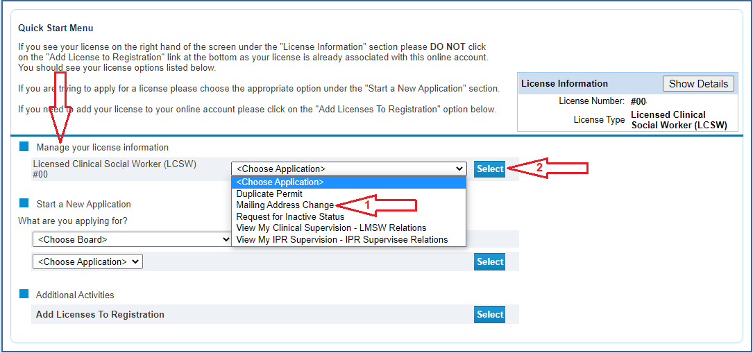

3. Read the introductory text then click “Next”.

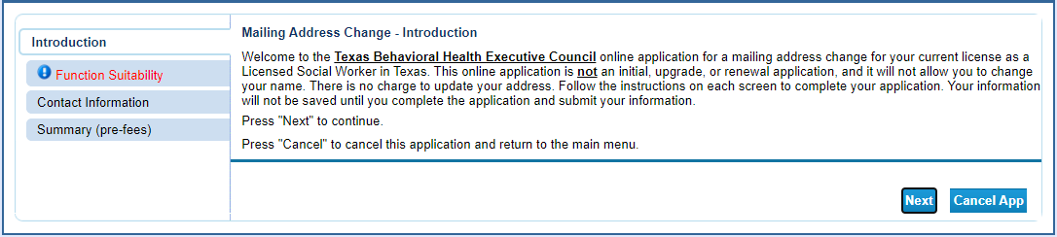

4. Answer the function questions then click “Next”. These answers help the system verify that you are using the correct online tool.

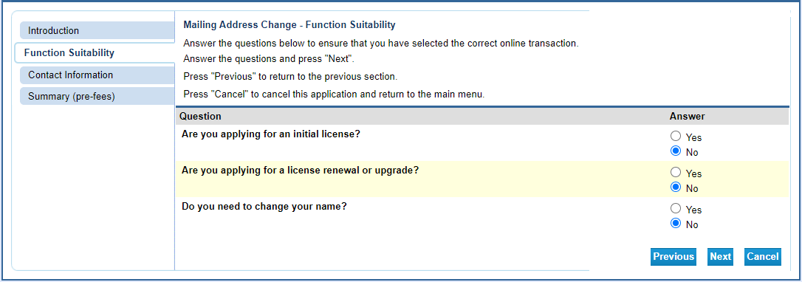

An answer that indicates a different online function will prompt an error message.

5. Enter your updated address information then click “Next”. Note: you will have to format the phone number as the system does not autoformat.

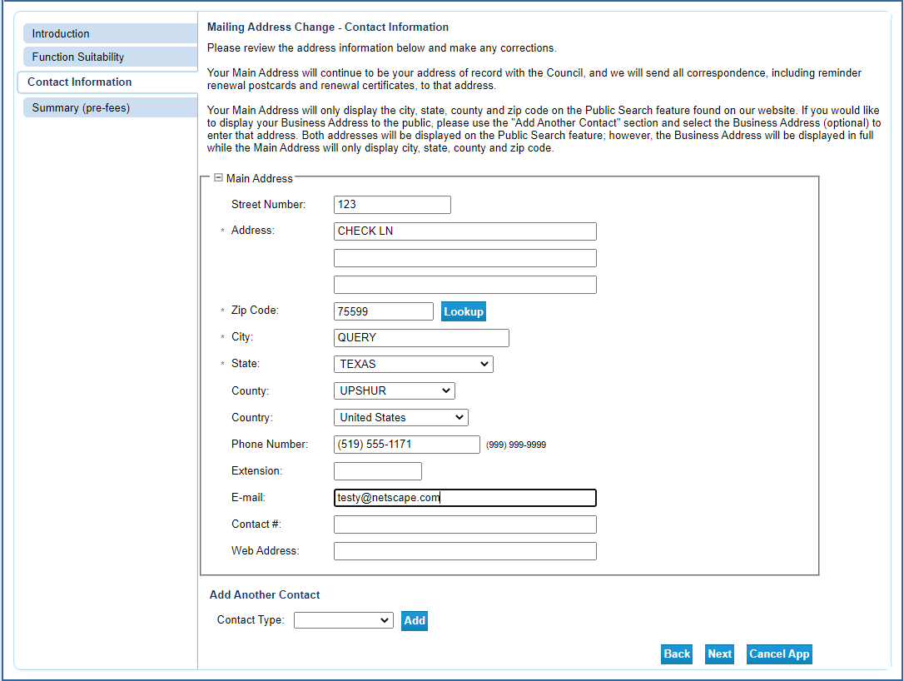

6. Review your edits for accuracy and click “Submit”.

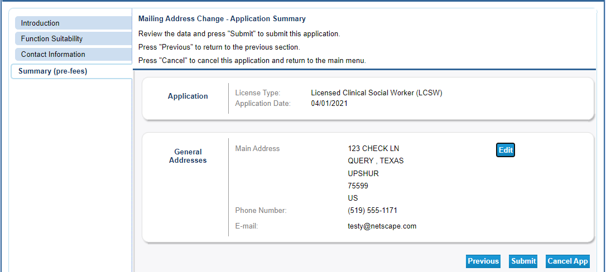

7. Answer “Yes” to the attestation then click “Next”.
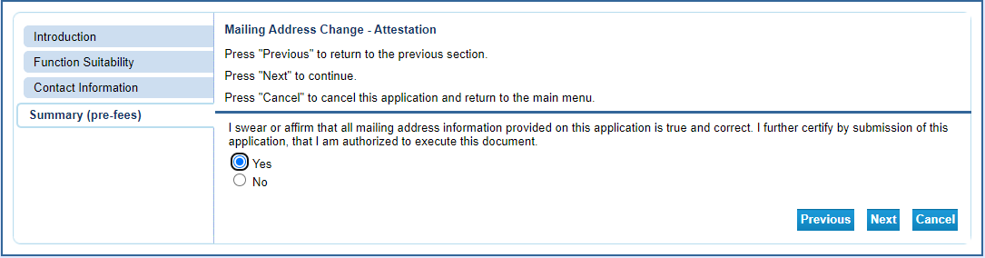

8. You will be taken to the Fee and Summary Report screen. There is no fee to update your address. Address changes become effective immediately. You will also receive a confirmation email with your change summary attached. Clicking the “Return” button will take you back to the “Quick Start” menu.

