How to Request Your License be Moved to Inactive Status

These instructions apply to LPC, MFT, and Social Worker license types.

***NOTE*** If your license is in “Delinquent” status you will have to complete the renewal process before you will be able to go into “Inactive” status.

Log into the Online Licensing System. If you do not yet have an online account, the instructions for creating one is the first option at the top of this page.

From the “Quick Start Menu” use the “Manage your license information” dropdown to choose “Request for Inactive Status” then click “Select”.

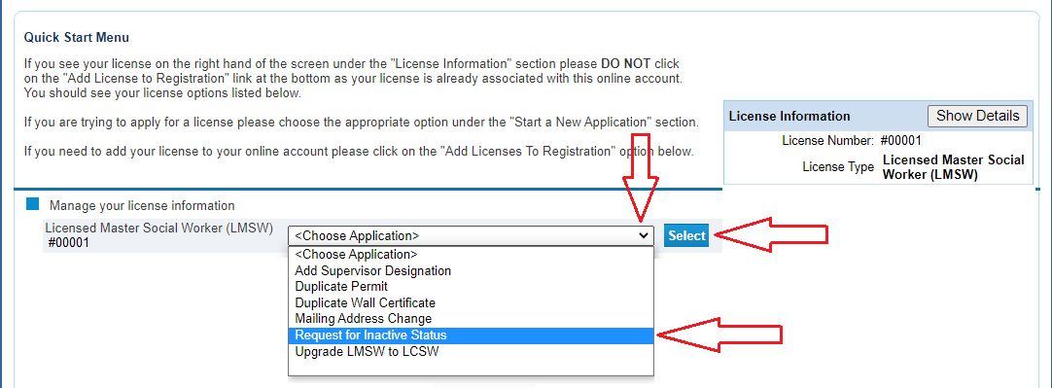

Read the Introduction information then click “Next”.

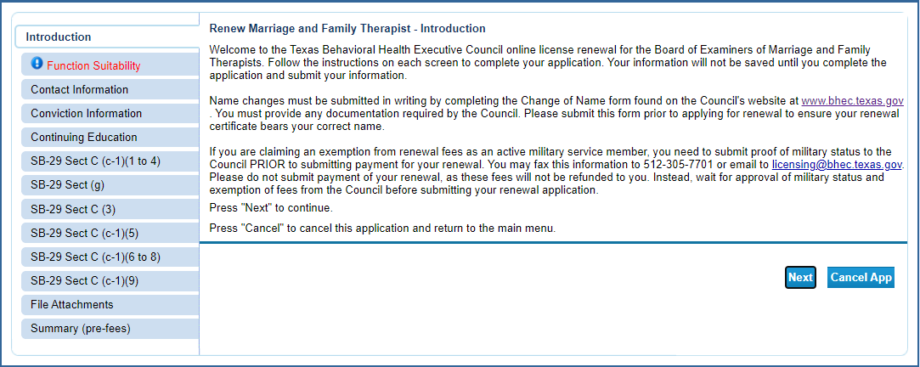

Answer the questions in the suitability section then click “Next”. These questions make sure you are accessing the correct function within the online system. If a question is answered in a fashion that indicates the incorrect function, you will receive an error message.
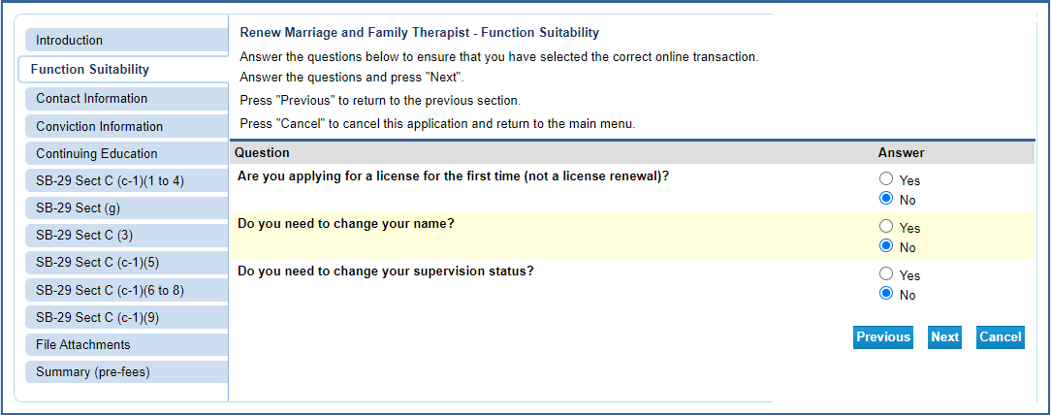

Review your contact information and make any corrections that are needed. Once complete, click “Next”.

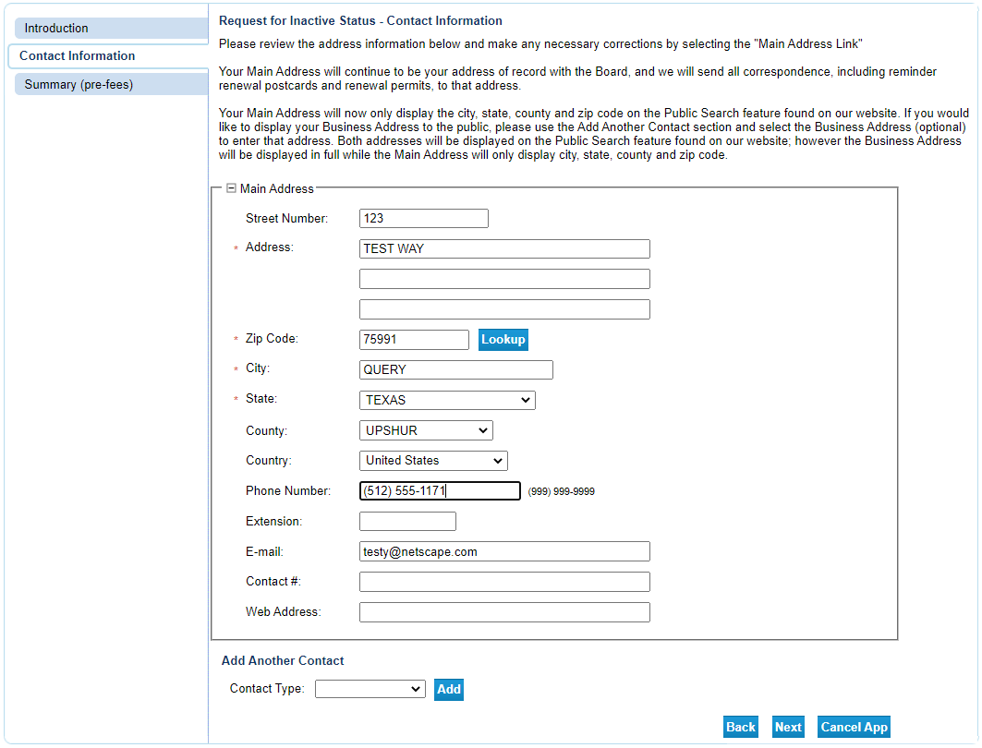

The Summary page allows you to review your entries and edit them if mistakes are found. Click on the “Edit” button in the section needing correction to update that information. Once the information is accurate, click “Submit”.

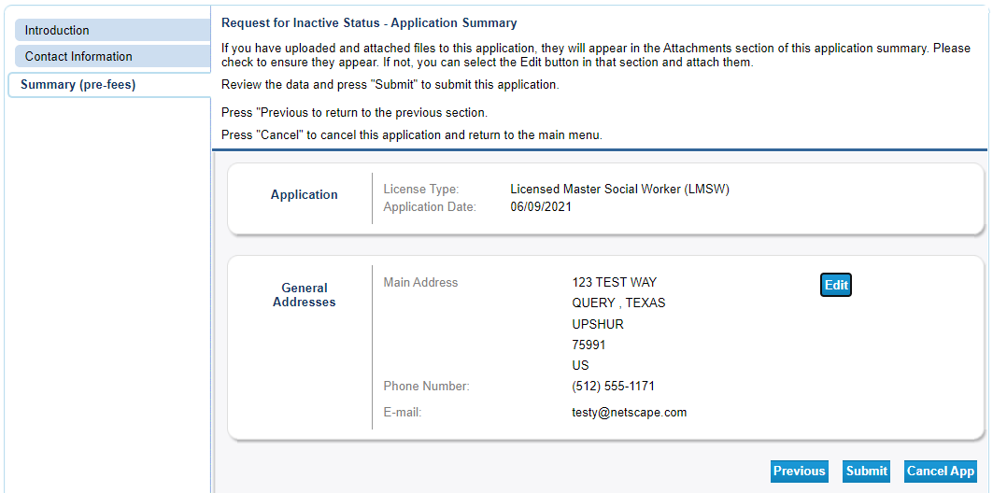

After clicking “Submit” you will be sent a confirmation email alerting you that your application data has been received. This email will include your application summary as an attachment.

The Attestation requires you to affirm that the information provided is true and correct. Answer the attestation question and click “Next”.

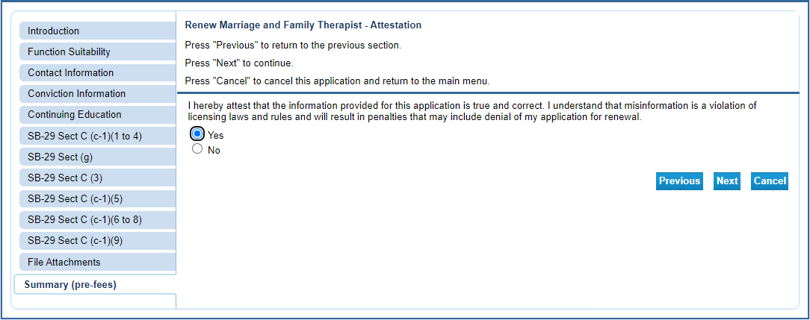

Click “Pay Now” to move to the online application payment screen.

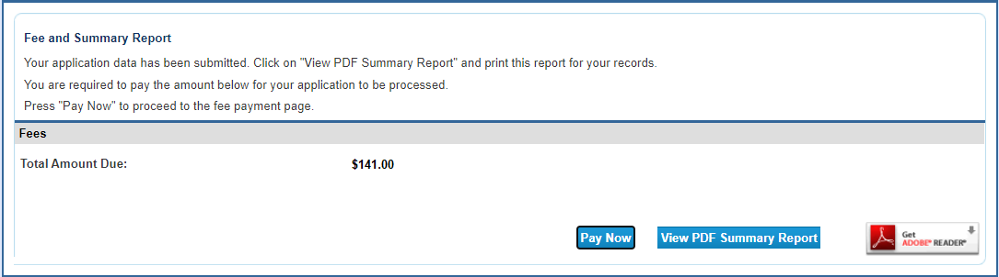

Click “Next” to move to the confirmation page.

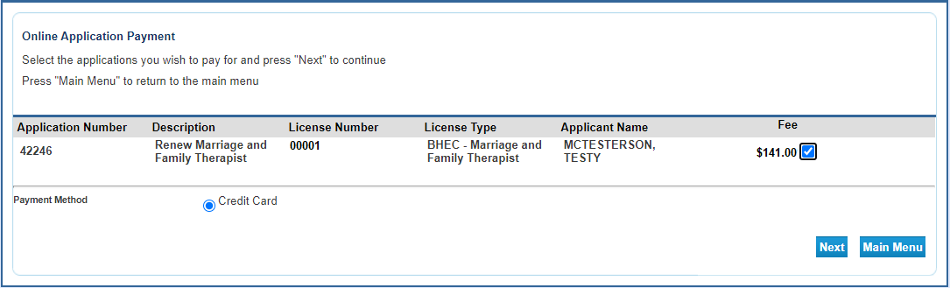

Click “Next” to move to the payment processor.

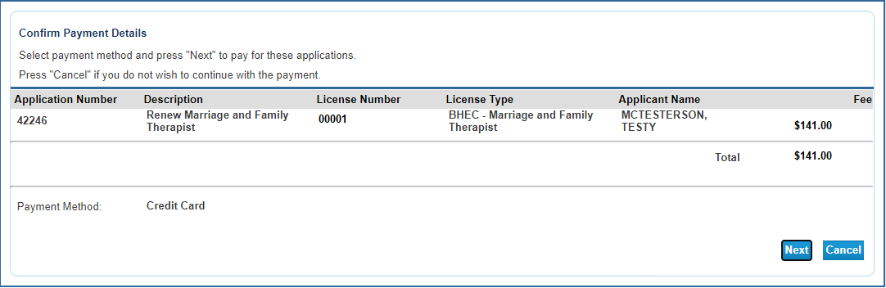

You will be redirected to the payment processor. Enter your customer information in the required fields then click “Next”.
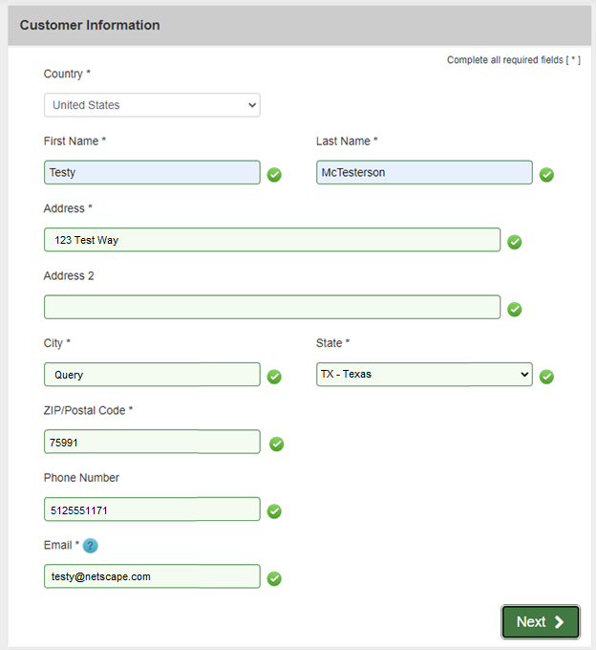

Enter your credit card information and click “Next”.

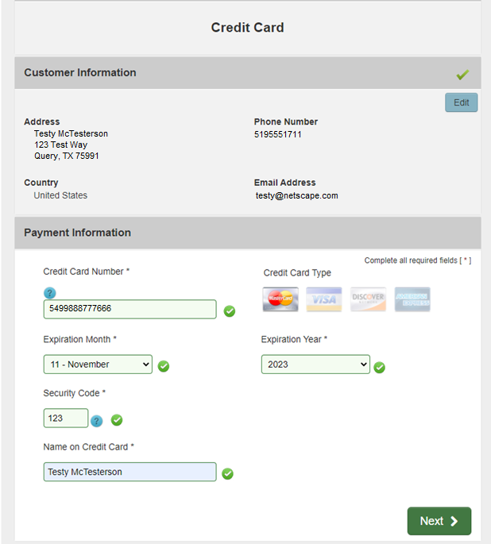

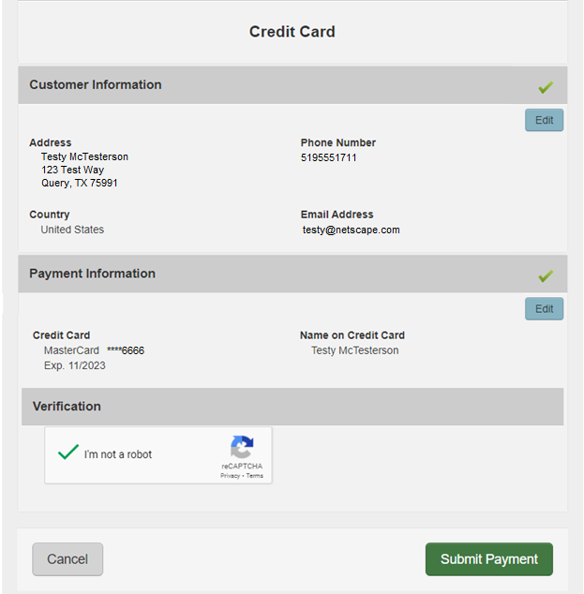

After your payment is processed you will be redirected to the payment success page. This will give you the opportunity to view/save a summary of your transaction.

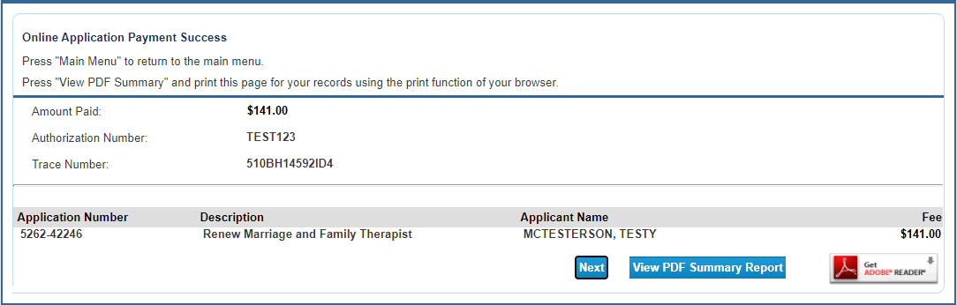

You will also receive two emails confirming your online payment. One will be from the online licensing system and the other will be from the payment processor. Please save these emails for your records.

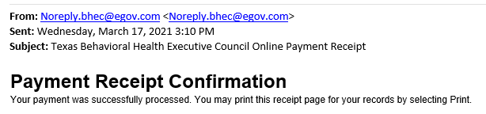

This completes the online portion of the renewal. Your license should be updated within three business days of the transaction in most cases. If you are under CE audit or have outstanding fingerprints, the process may take longer.

