LPC-Associate Application User Guide

IMPORTANT: Before you initiate the online application process, be sure you have the required supplemental documentation saved to your device. You will be prompted to upload this documentation toward the end of the process. The list of required documentation can be found here.

- Log in to your online account from our online licensing system. If you haven’t created one, the user guide for creating an account can be found here.

- Select “Texas Behavioral Health Executive Council” from the first drop-down then choose the board that issues the license you wish to apply for and click “Select”.

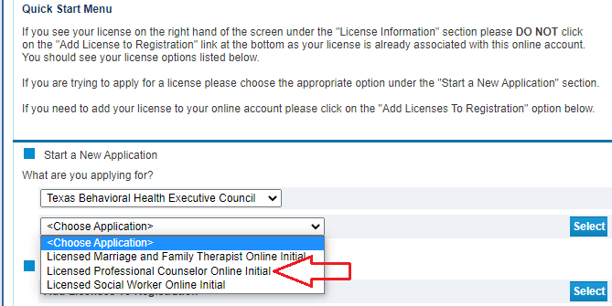

- Read the introduction and click “Next”.

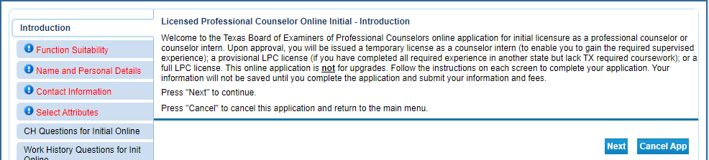

- Answer the function questions. These answers help the system verify that you are using the correct online application. Answers that indicate a different application type will prompt an error message.

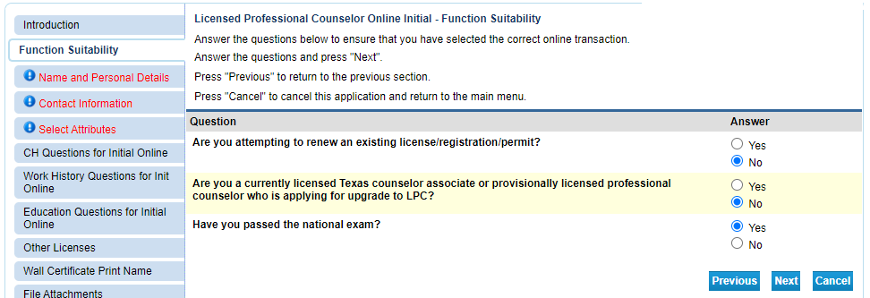

Answers that indicate a different application type will prompt an error message.

- Enter/Update your personal details then click “Next”.

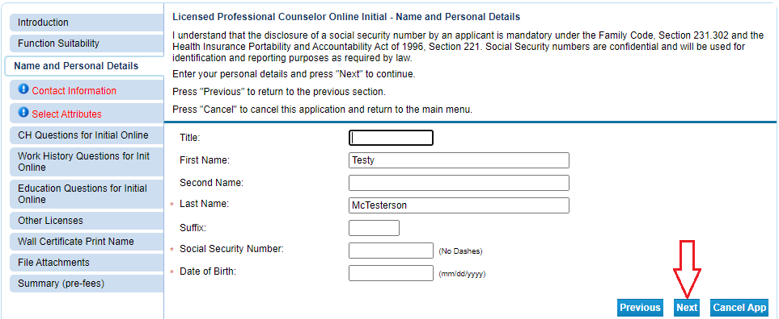

- Enter your contact information and then click “Next”.

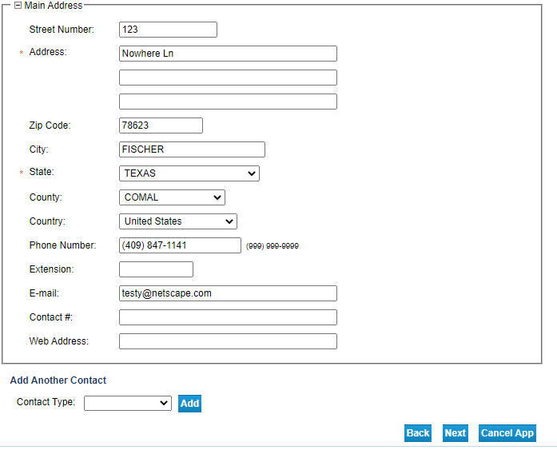

- Select the type of license you are applying for and your military status (if any) then click “Next”.

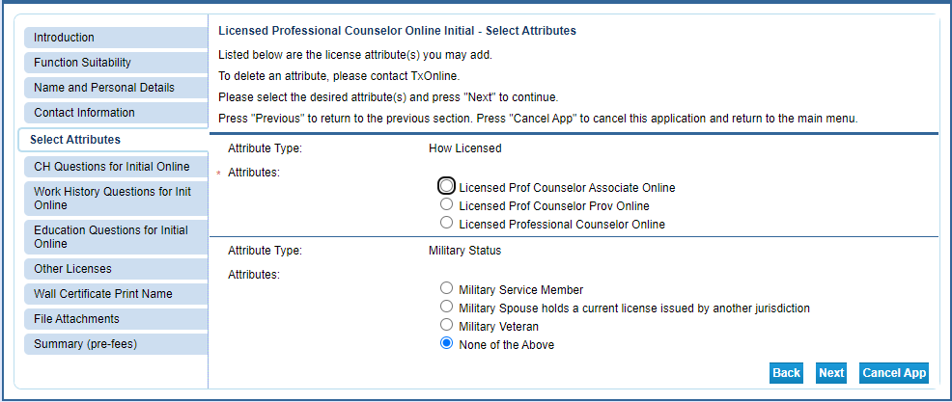
- Answer the Criminal History and Previous Name questions then click “Next”. NOTE: A criminal history is not an automatic bar to licensure.
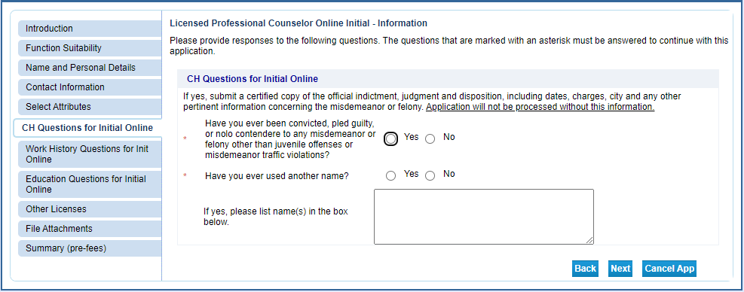
- Answer the Current Employment question and click “Next”.
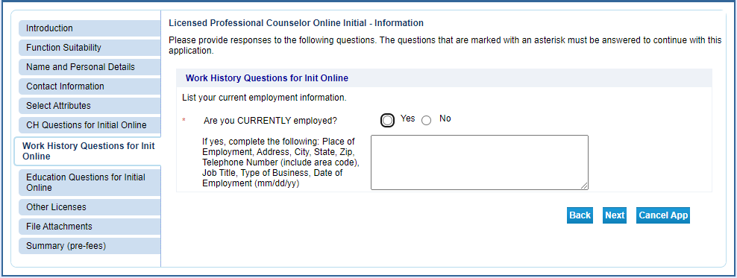
- Enter your education and examination information then click “Next”.
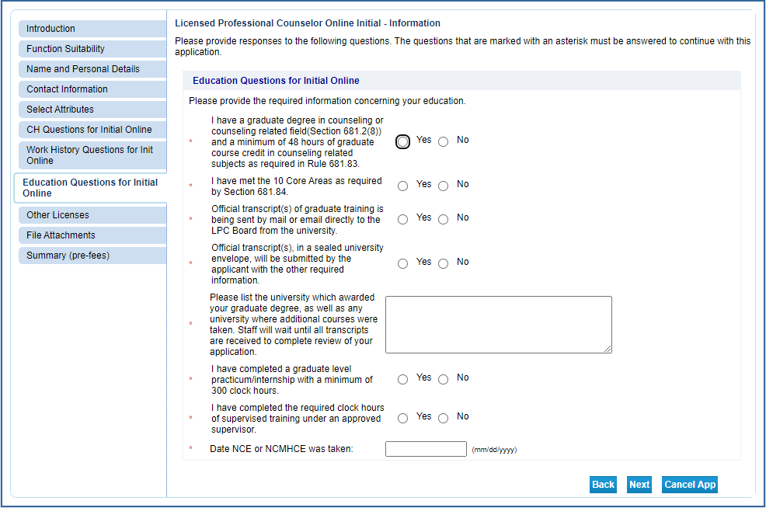
- Answer the questions about existing or previous professional licenses then click “Next”.
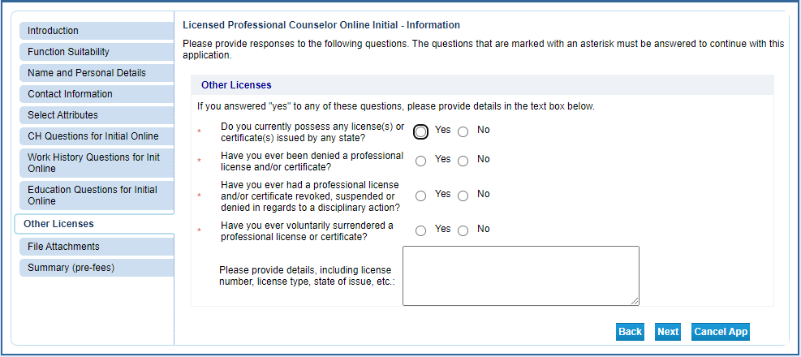
- Upload the supplemental documentation from your device. Failure to upload documentation will likely result in longer processing times.
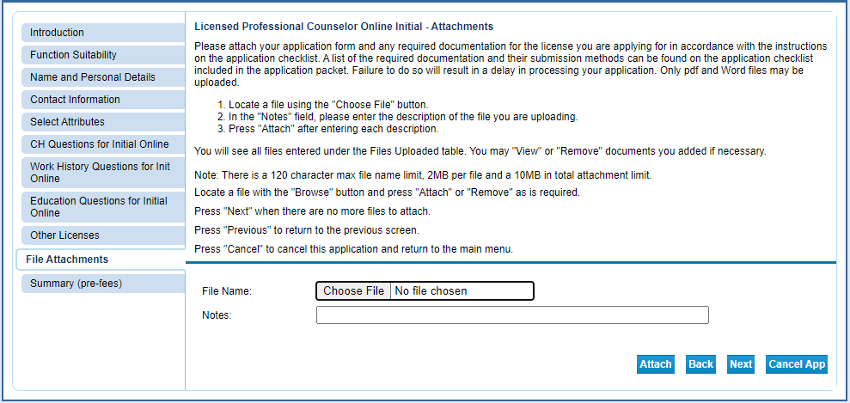
- Verify the information you have entered and make any necessary edits.
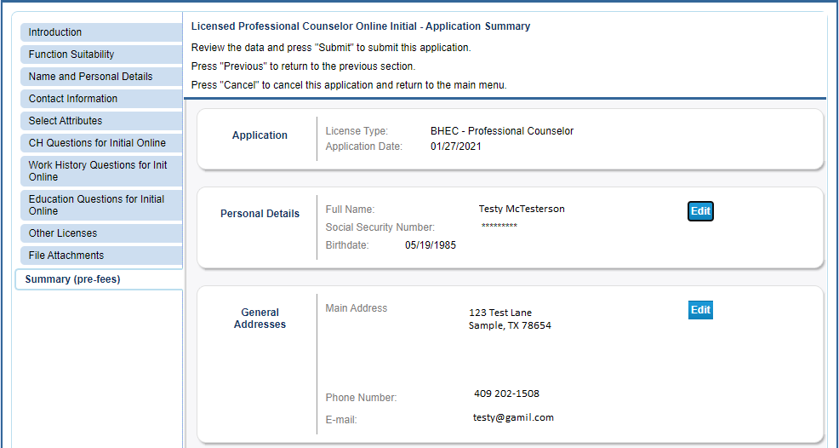
- Answer the affirmation question. Please note you will have to answer “Yes” to complete your application.
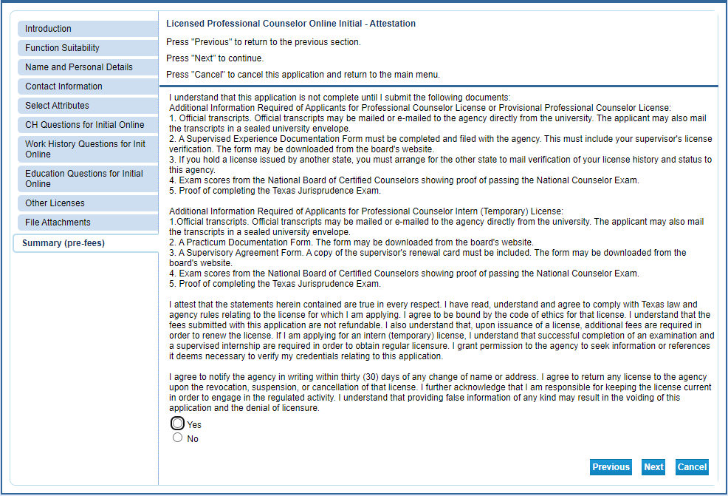
- Click “Pay Now” to advance to the payment processor.
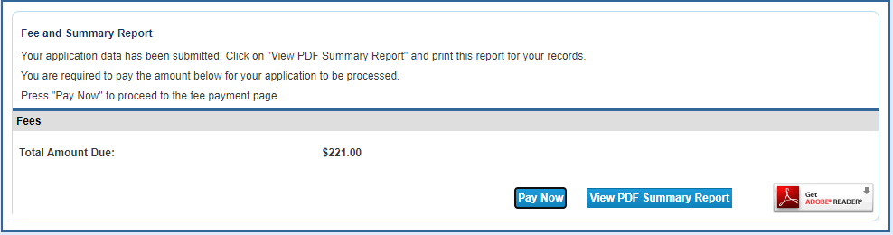
After completing the payment process you’ll be sent an email acknowledging receipt of the application. To get an idea about the turnaround time for license processing visit the “Applying For A License and Timelines” page on the BHEC website.

