How To Apply for a Social Worker License

This guide will assist you in applying online for the following licenses:

Initial LBSW or LMSW
LBSW, LMSW, or LCSW coming from another state

The online system is not yet able to receive applications for upgrade to LMSW or LCSW. Those currently require paper applications.

The online licensing system link is found here.

IMPORTANT: Before you initiate the online application process, be sure you have the required supplemental documentation saved to your device. You will be prompted to upload this documentation toward the end of the process. The list of required documentation can be found here.

- Log into your online licensing system account. If you do not yet have an account, you will need to create one. A guide on how to create a new account can be found here.
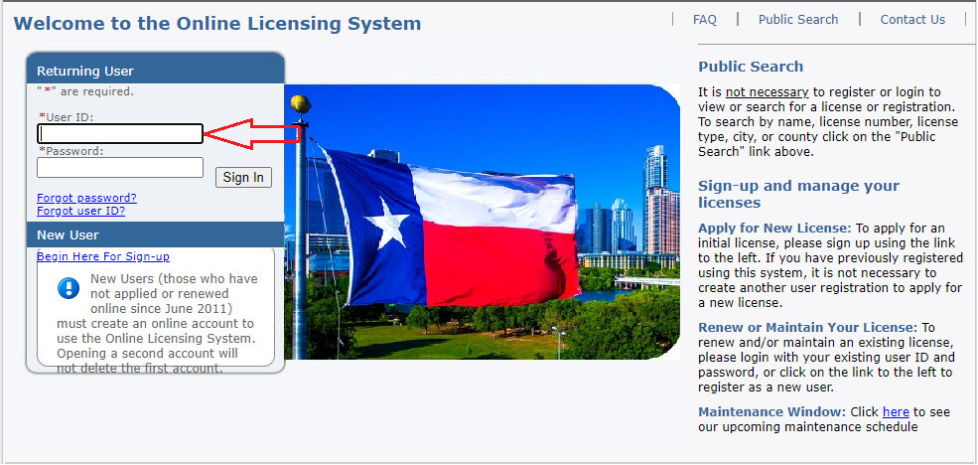
- Select “Texas Behavioral Health Executive Council” from the first drop-down then choose the board that issues the license you wish to apply for and click “Select”.
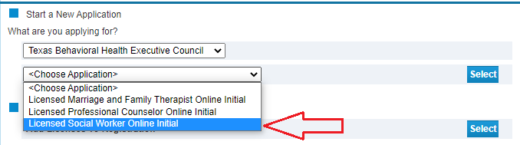

- Read the introduction and click “Next”.

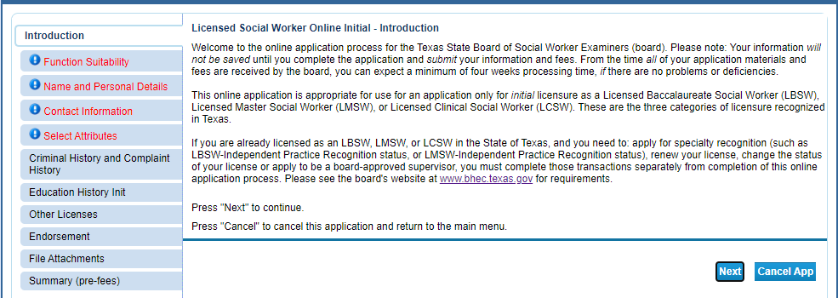

- Answer the function questions then click “Next”. These answers help the system verify that you are using the correct online application.

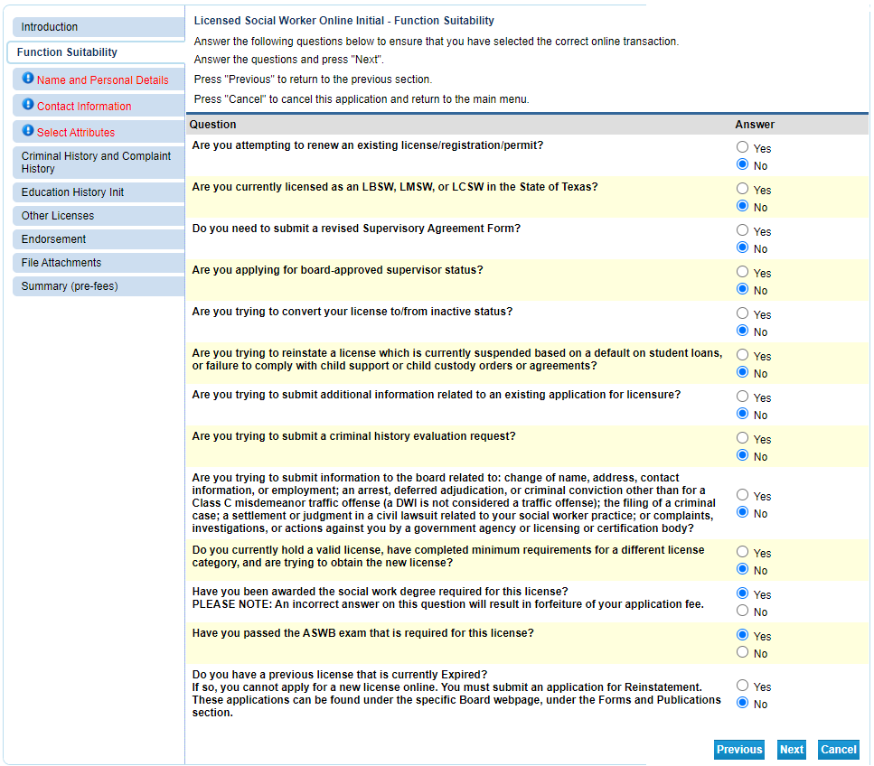

An answer that indicates a different application type will prompt an error message.

- Enter/Update your personal details then click “Next”.

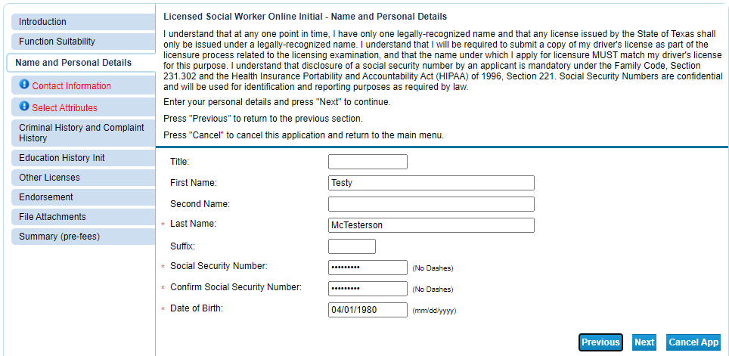

- Enter your contact information and then click “Next”.

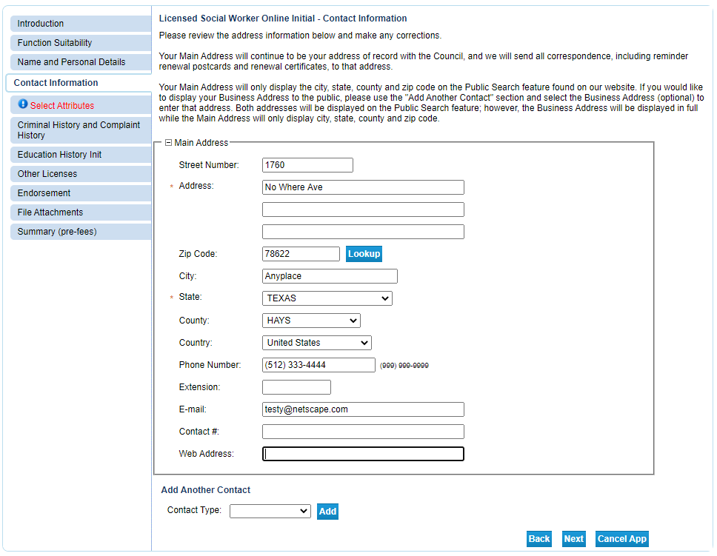

- Choose your license type and select your military status (if any) then click “Next”.

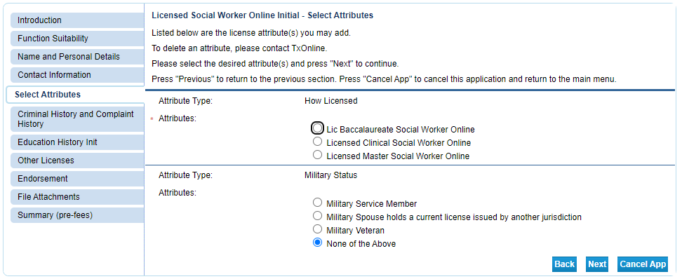

- Answer the questions about your previous complaint history (if any) and conviction history (if any).
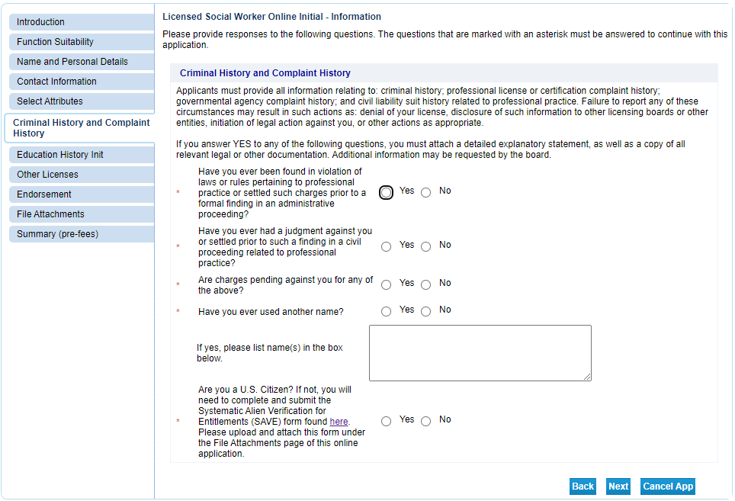

- Enter your education information then click “Next”.

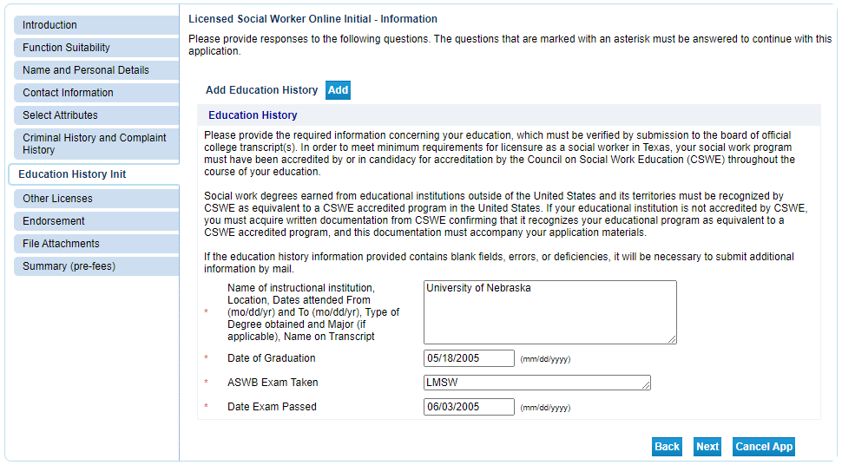
- Enter your past professional license information (if any).
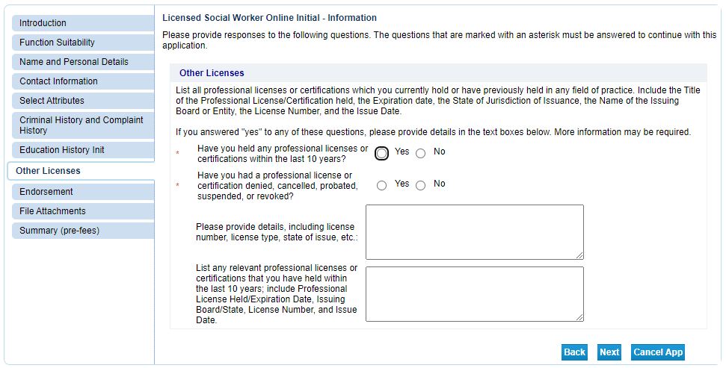

- Select your method of licensure and click “Next”. By answering “No” to the first question you are indicating this is your first social worker license. If you answer “Yes” that means you have a social worker license in another state.
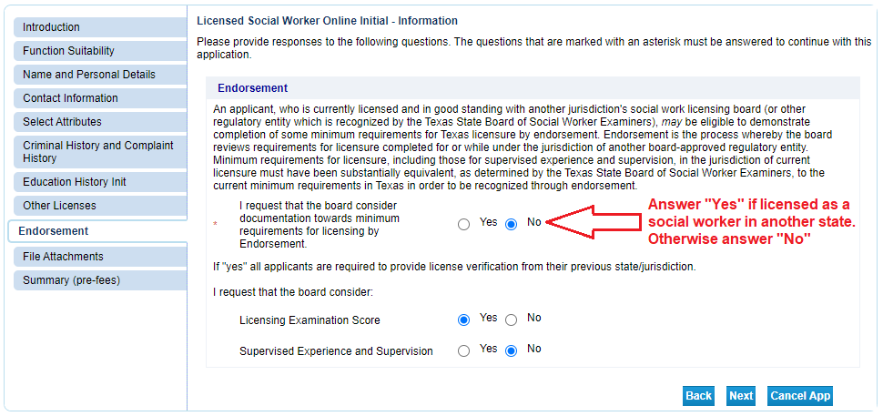
- Attach your supplemental documents (jurisprudence exam certificate, etc.).
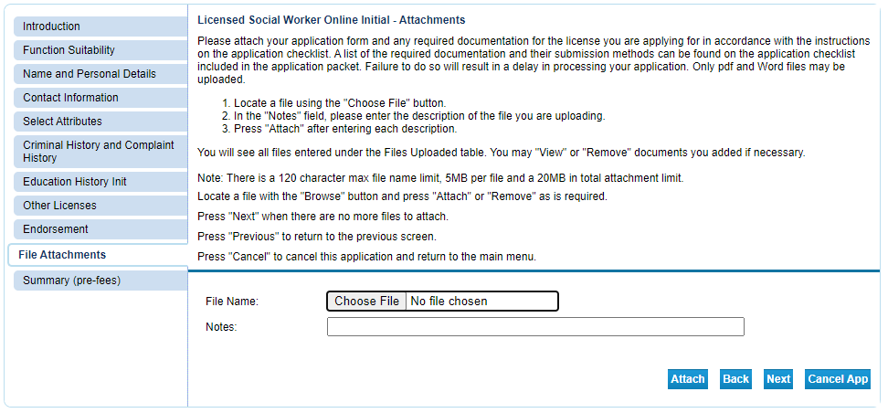
- Review your information and correct any errors. Once it is complete, click “Submit”. This will save the application and take you to the affirmation page.
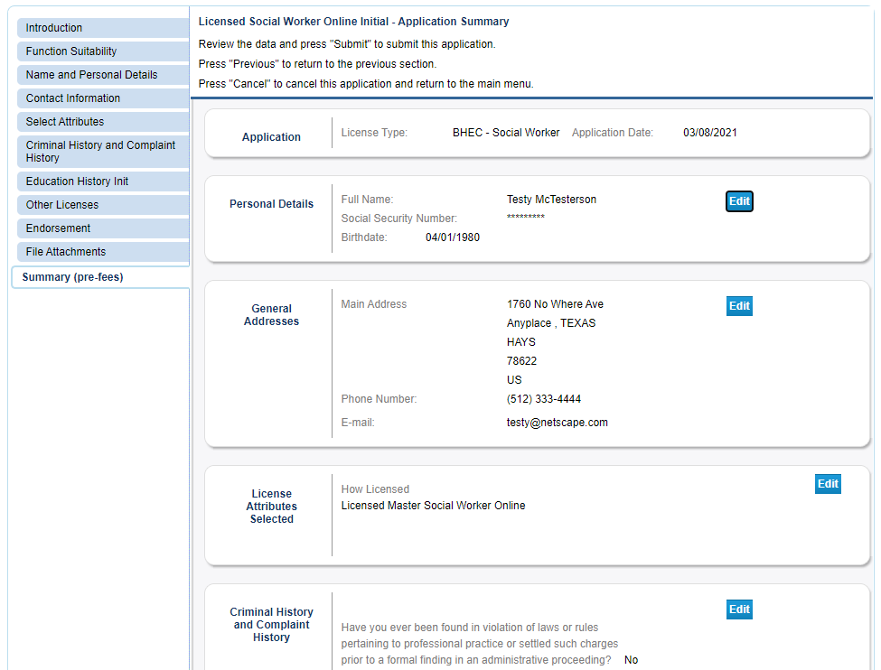

- Select “Yes” to agree to the affirmation and click “Next”.
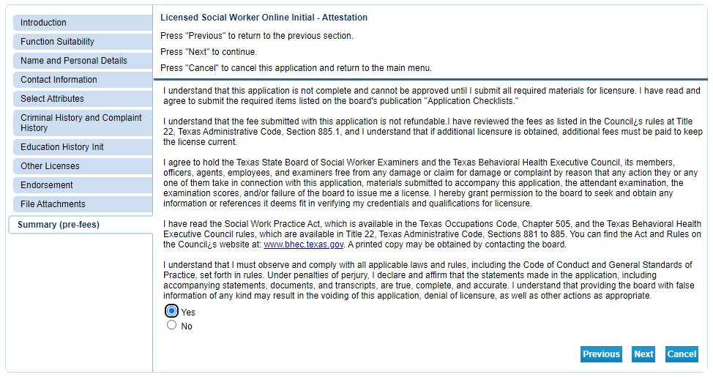
- Click “View PDF Summary Report” and save the document for your records. Then click “Pay Now” to complete the process. If you fail to pay the license fee the application will sit in limbo for 30 days and then be deleted.
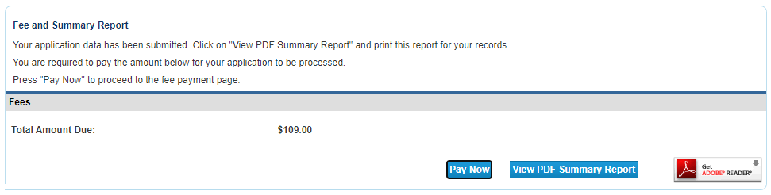

After completing the payment process you’ll be sent an email acknowledging receipt of the application.

This email will have instructions for completing the required fingerprinting process.

To get an idea about the turnaround time for license processing visit the “Applying For A License and Timelines” page on the BHEC website.

