How To Apply Online for MFT Upgrade

1. First, log into your online account. If you do not yet have an account or if you haven’t linked your MFT Associate license you will need to do so. Instructions for account creation can be found here.

2. From the “Manage your license information” drop-down, choose “Upgrade to MFT” then click “Select”.

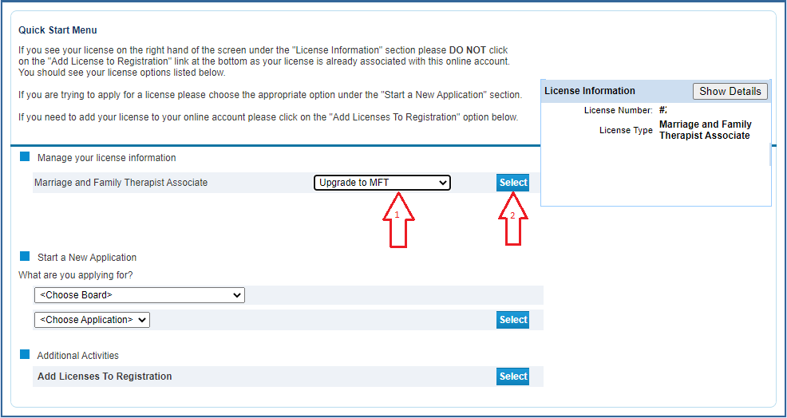

3. You will be taken to the upgrade application module. Click “Next” to move forward.

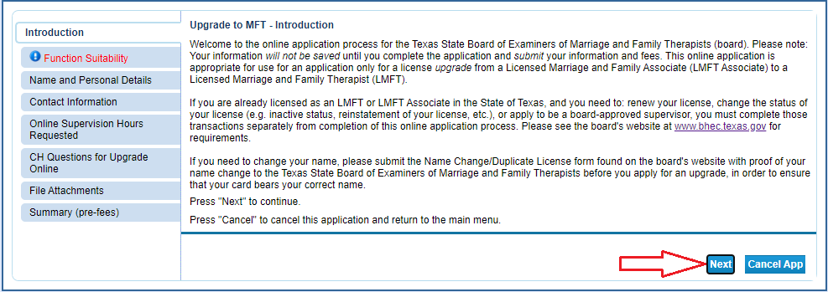

4. The Function Suitability section makes sure you are intending to upgrade to LPC rather than renew. If you don’t answer the questions correctly you will receive an error message.

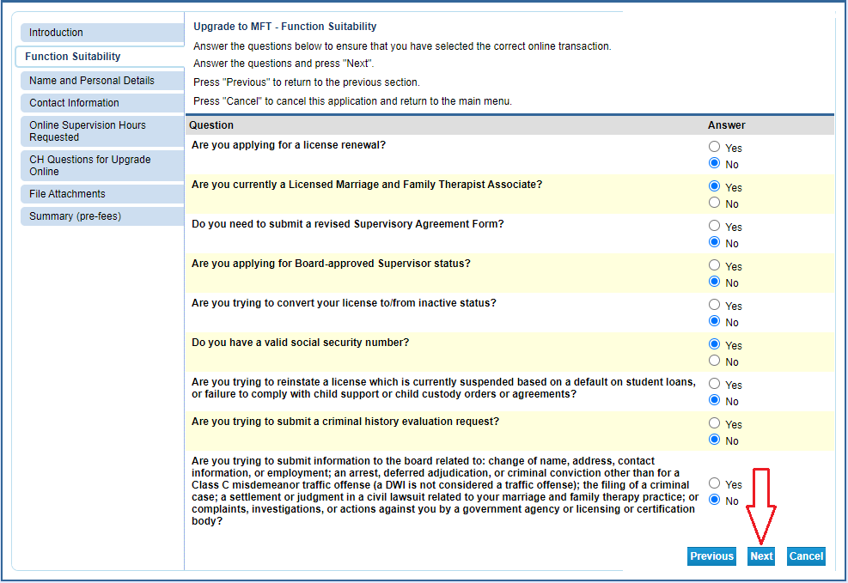

5. Verify/update your personal information.

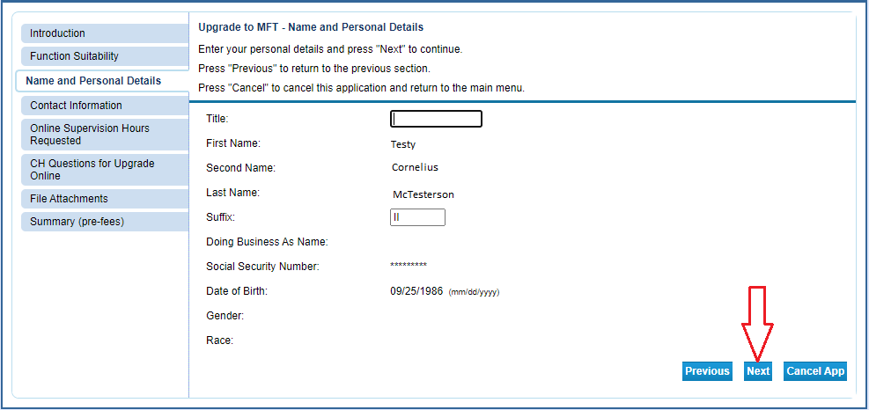

6. Verify/Update your contact information.

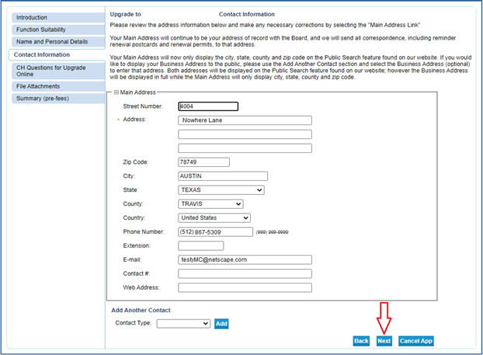

7. Enter your supervised experience info. Please NOTE you will still have to upload the Verification Of Supervised Experience form.

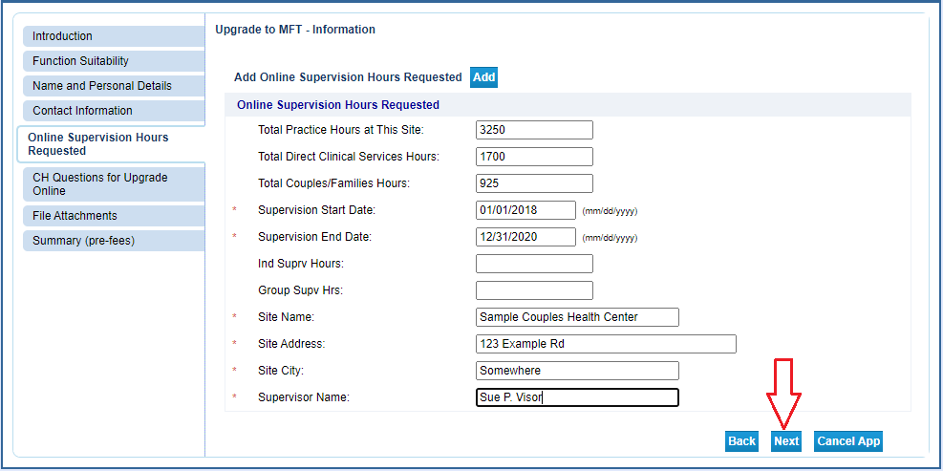
8. Answer the criminal history question. NOTE: It’s especially important to answer this question accurately. If you have a record and answer “No” you might be falsifying your application, which can be grounds for denial.

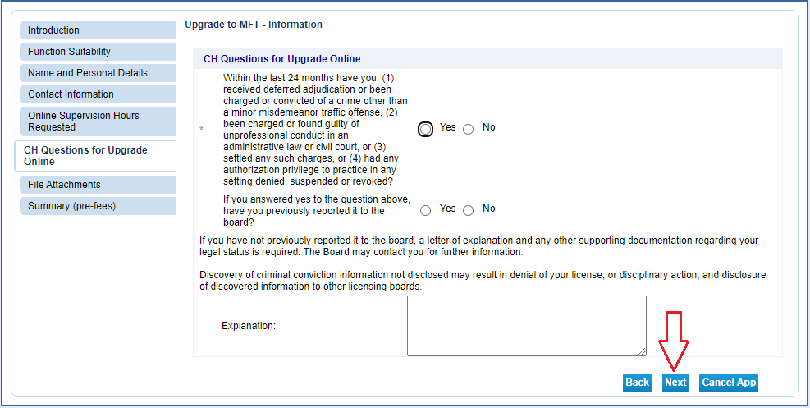

9. Upload your supplemental documentation to your application. For upgrades you’ll need your Supervised Experience Verification Form(s) and Jurisprudence Examination Certificate (showing completion within the past 6 months). If your supervisor used the online supervision management tool to submit your verifications you will only need to upload your Jurisprudence Examination Certificate.

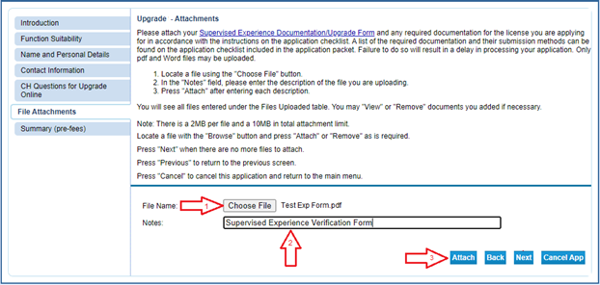

Each time you attach a file, it will appear above the selection boxes. NOTE: Be sure to avoid attaching files that exceed the max file size.

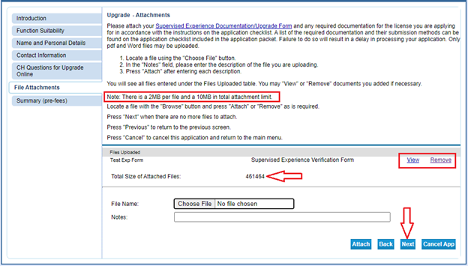

10. Attest and agree to the statement.

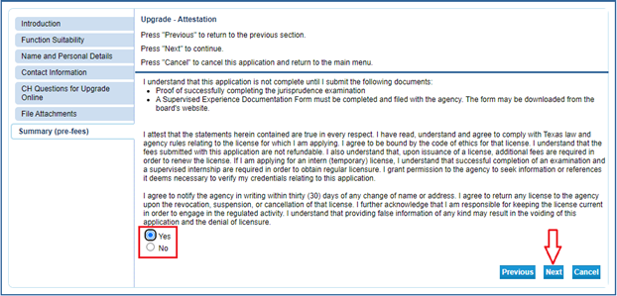

11. Select “Pay Now” to go to the payment processor. Use a credit or debit card to pay the application and licensing fee.
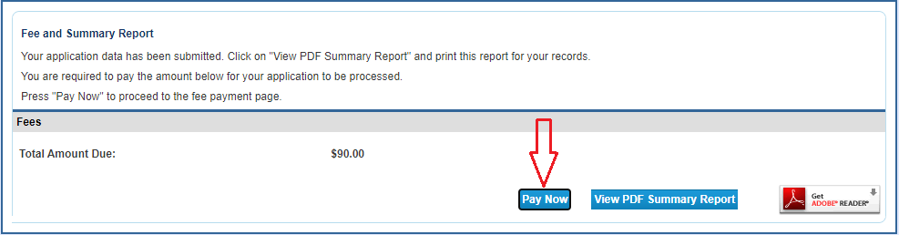

12. After payment, click the “View PDF Summary Report” and save it for your records.

