How To Apply Online for LPC Supervisor Designation

1. First, log into your online account. If you do not yet have an account or if you haven’t linked your LPC Associate license you will need to do so. Instructions for account creation are at the top of this webpage.

2. From the “Manage your license information” drop-down, choose “Add Supervisor Designation” then click “Select”.

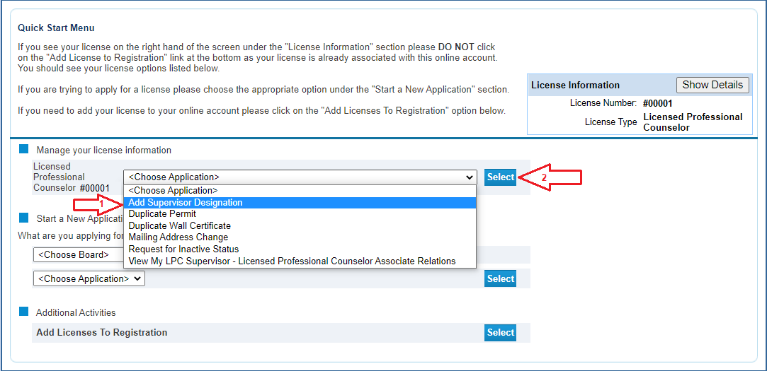

3. You will be taken to the application module. Click “Next” to move forward.

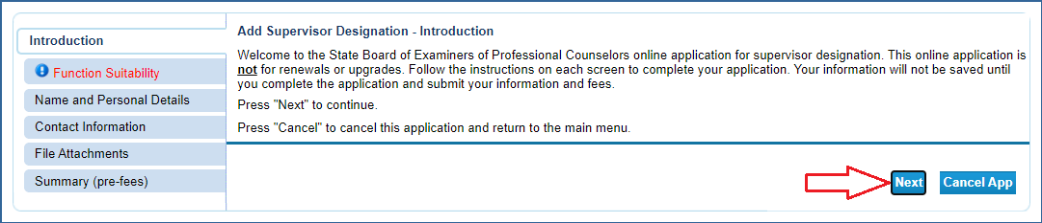

4. The Function Suitability section makes sure you are intending to add the supervisor designation. If you don’t answer the questions correctly you will receive an error message. Click “Next” when complete.

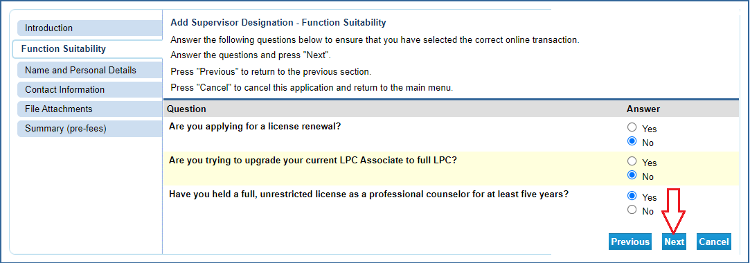

5. Verify/update your personal information.

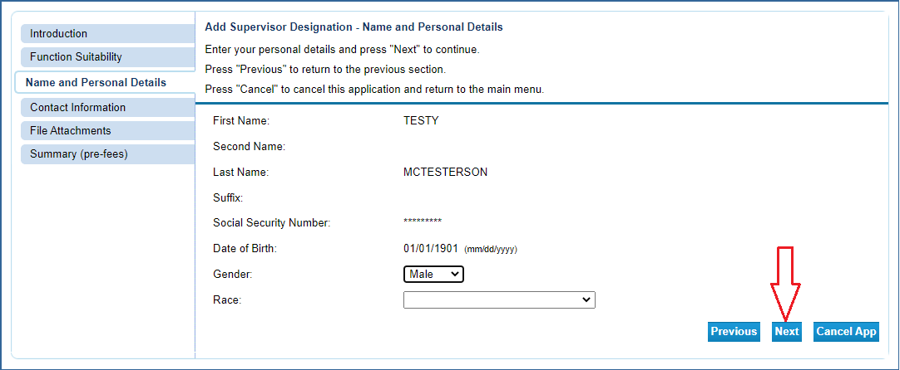

6. Verify/Update your contact information then click “Next”.

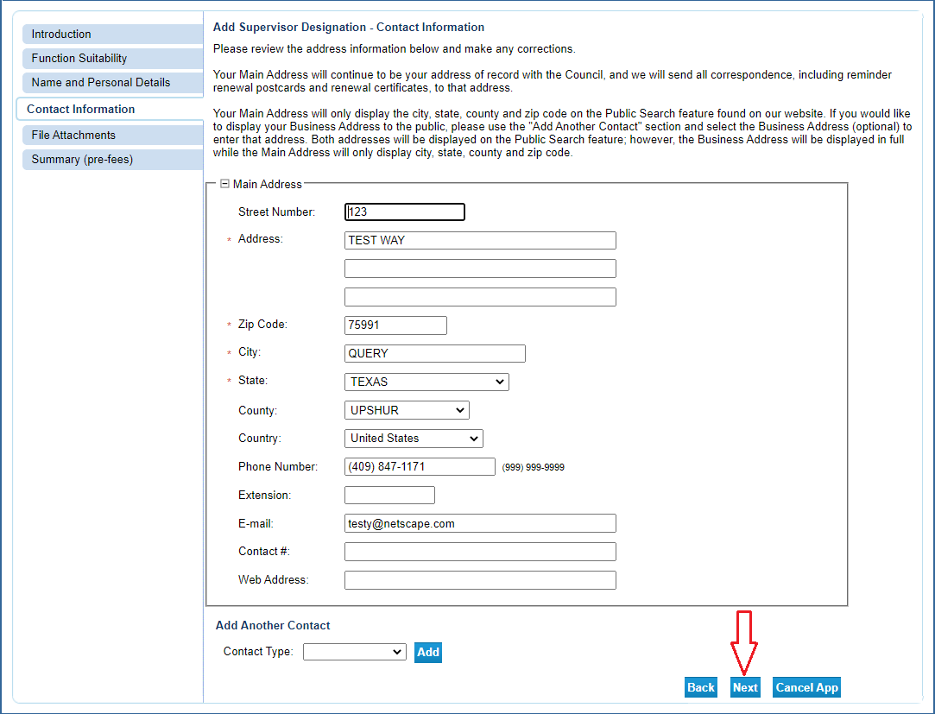

7. Upload your supplemental documentation to your application. For Supervisor Designation you’ll need your 40-Hour Supervisor Training Certificate.

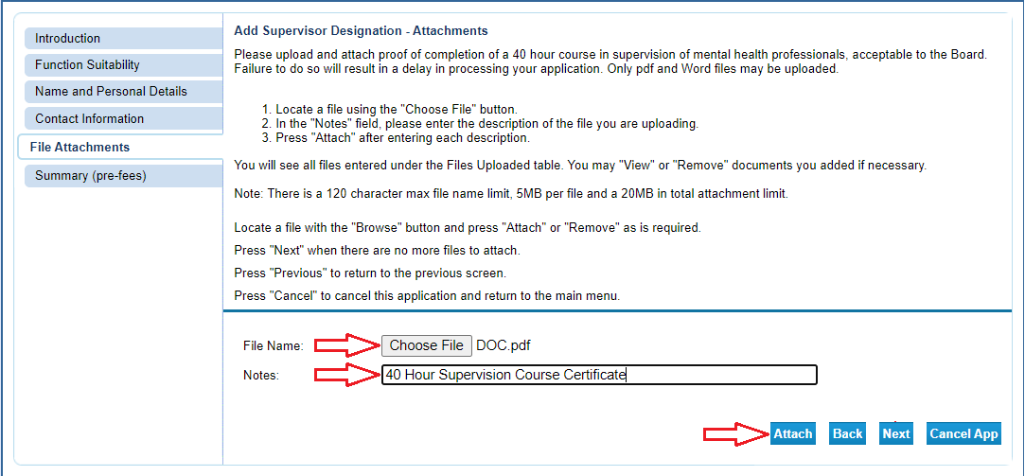

Each time you attach a file, it will appear above the selection boxes. NOTE: Be sure to avoid attaching files that exceed the max file size. Once all documentation is uploaded, click “Next”.

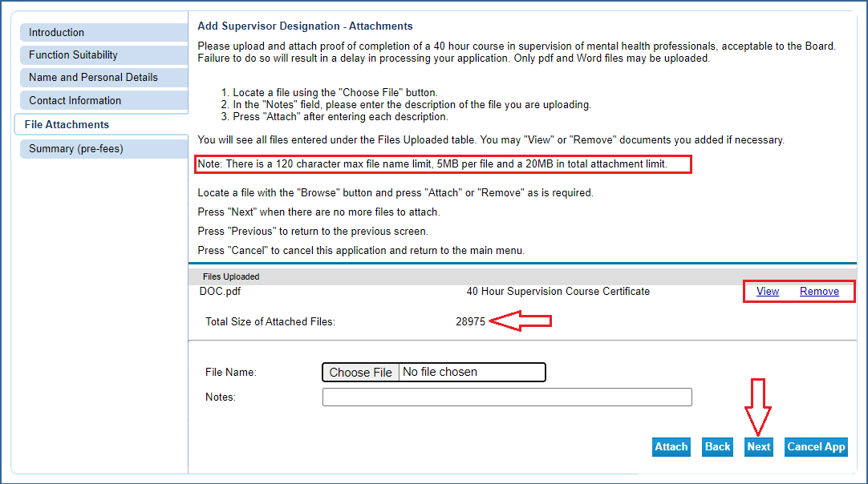

8. Review your information and edit where necessary. When complete, click “Submit”.

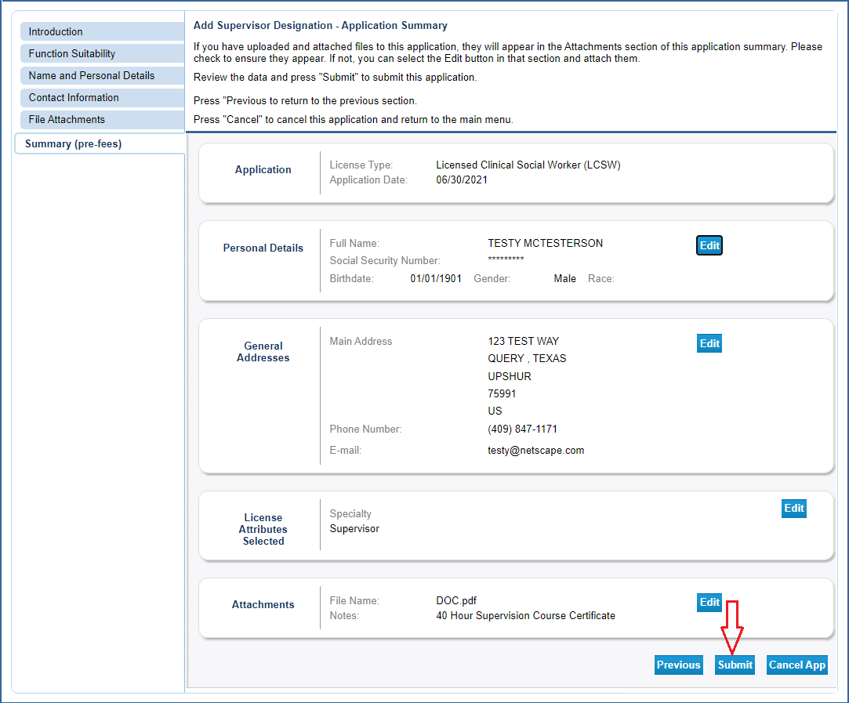

9. Attest and agree to the statement then click “Next”.

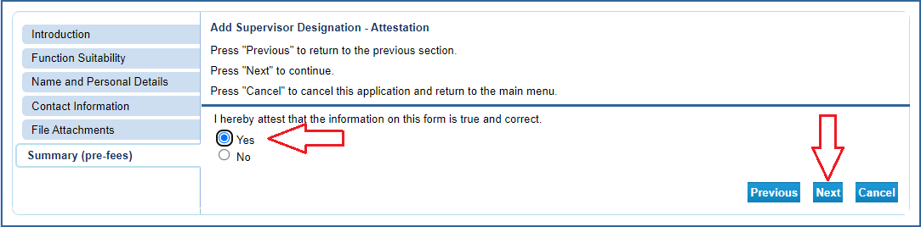

After clicking “Next” you will be sent a confirmation email alerting you that your application data has been received. This email will include your application summary as an attachment.

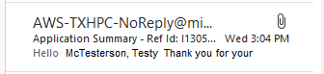

10. Click “Pay Now” to move to the online application payment screen.

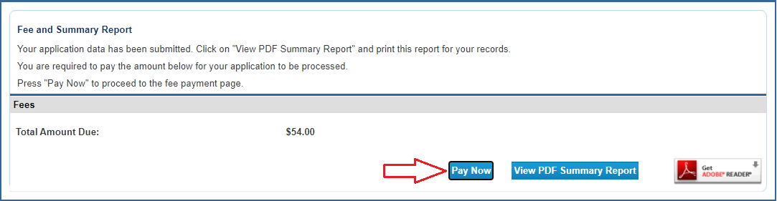

11. Click “Next” to move to the confirmation page.

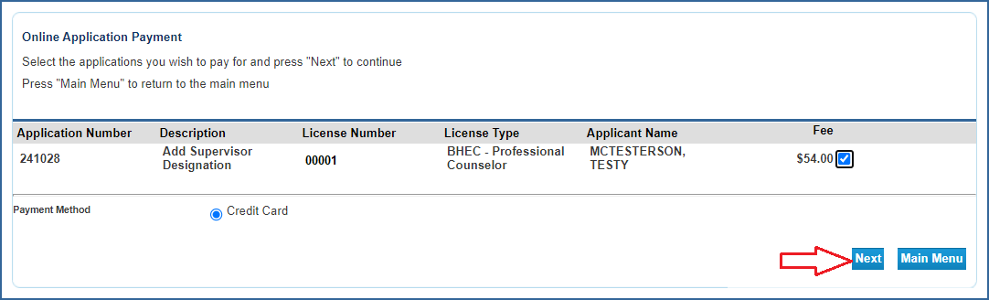

12. Click “Next” to move to the payment processor.

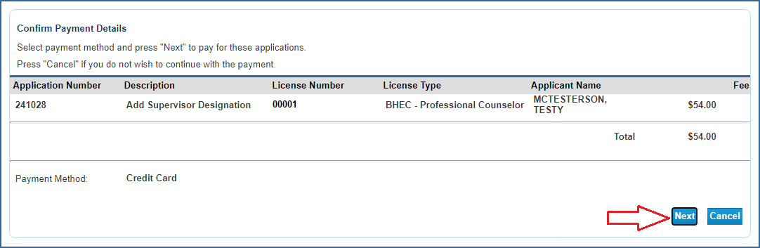

13. You will be redirected to the payment processor. Enter your customer information in the required fields then click “Next”.
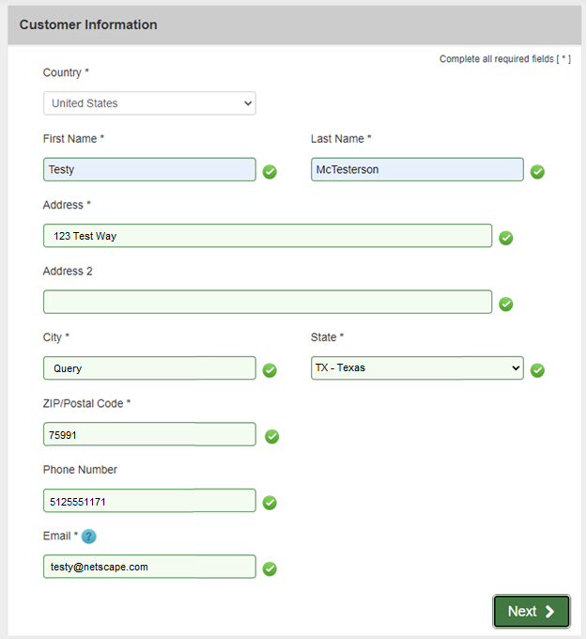

14. Enter your credit card information and click “Next”.

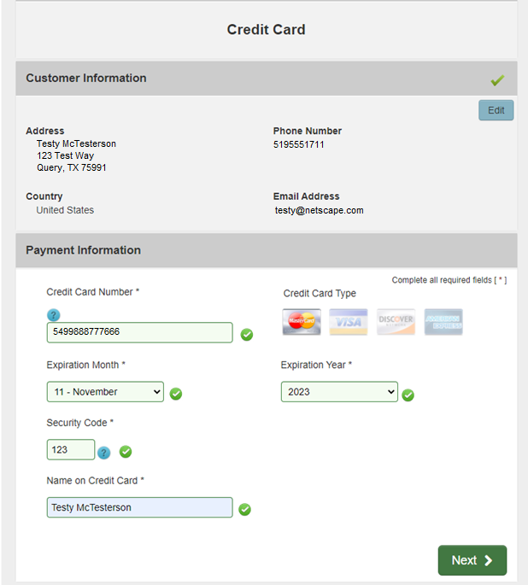

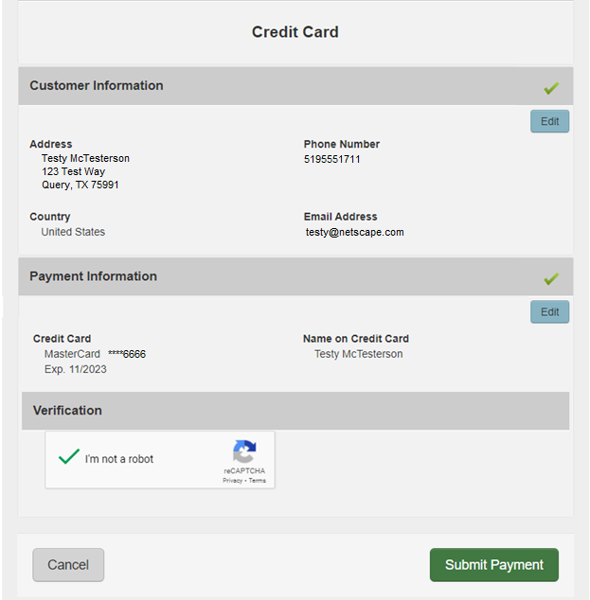

15. After your payment is processed you will be redirected to the payment success page. This will give you the opportunity to view/save a summary of your transaction.

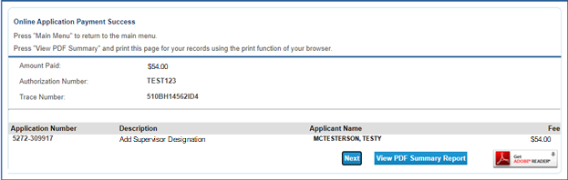

You will also receive two emails confirming your online payment. One will be from the online licensing system and the other will be from the payment processor. Please save these emails for your records.

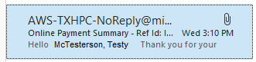

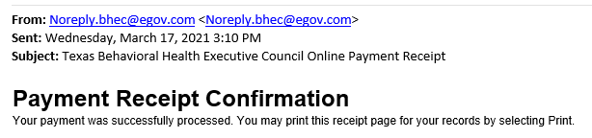

This completes the online portion of the application process. Your application will be reviewed by staff in the order it was received. Once reviewed, staff will either contact you to request missing documentation or, if everything in your application is complete and correct, send you updated license showing supervisor designation. Due to heavy volume, please wait at least six weeks before contacting BHEC for a status update.

