How To Request A Renewal Card/Permit
Log into the Online Licensing System here: https://vo.licensing.hpc.texas.gov/datamart/login.do. If you do not yet have an online account, the guide for creating one is the first option at the top of this page.

From the “Quick Start Menu” use the “Manage your license information” dropdown to highlight “Duplicate Permit” then click “Select”.

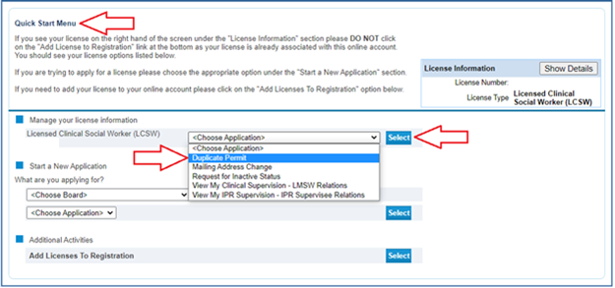

Click “Next”.
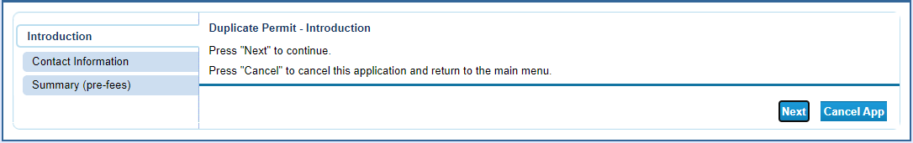

Verify or edit your contact information and click “Next”.
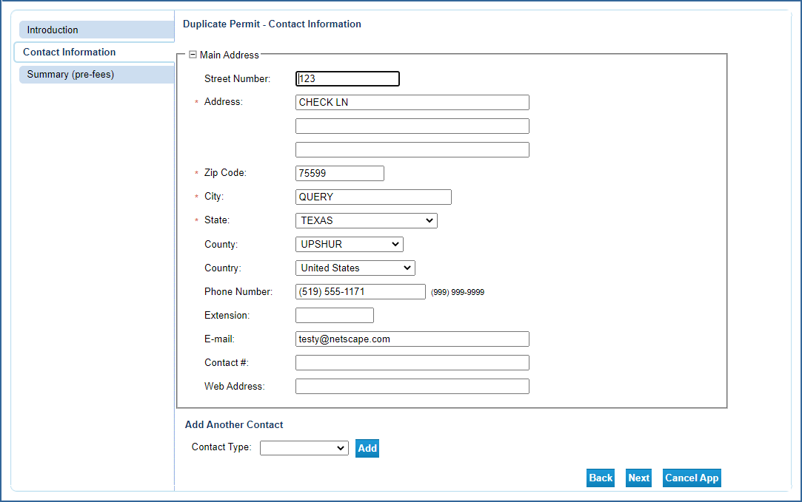

If the information is correct click “Submit”.
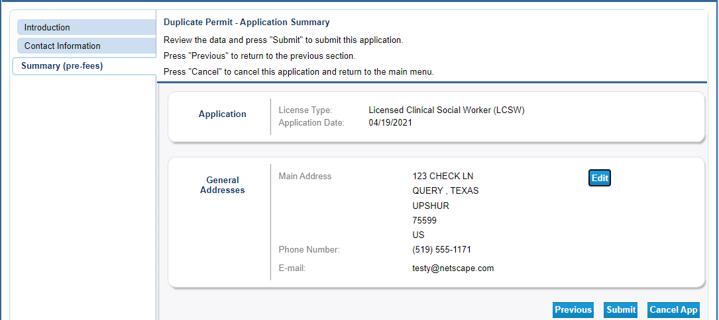

Answer “Yes” to the attestation and click “Next”.
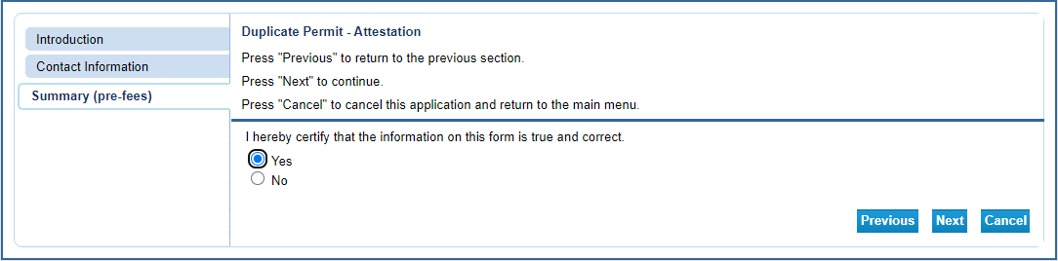

Click “Pay Now”.
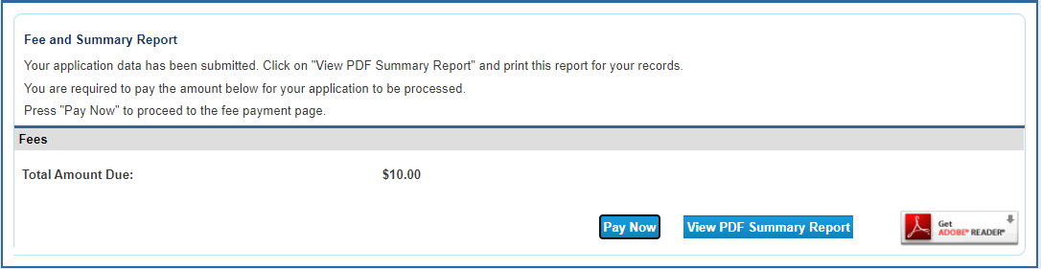

Click “Next”
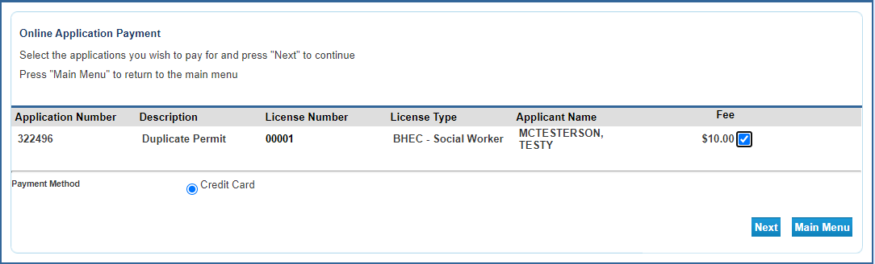

Click “Next” (again!). This will redirect you to the payment processor website.
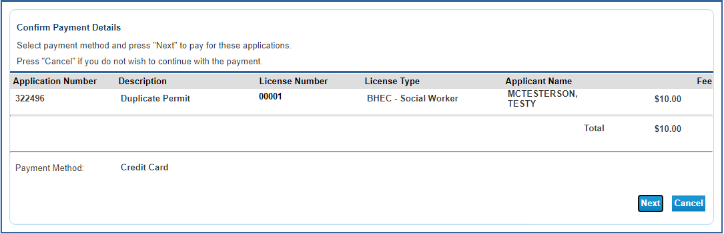

You will be redirected to the payment processor. Enter your customer information in the required fields then click “Next”.
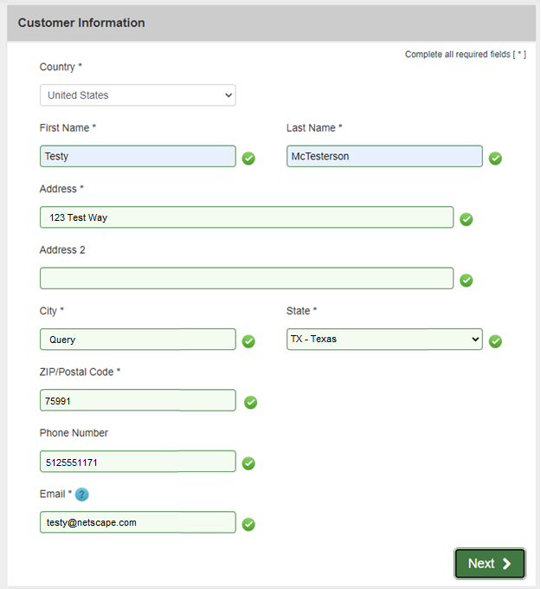

Enter your credit card information and click “Next”.

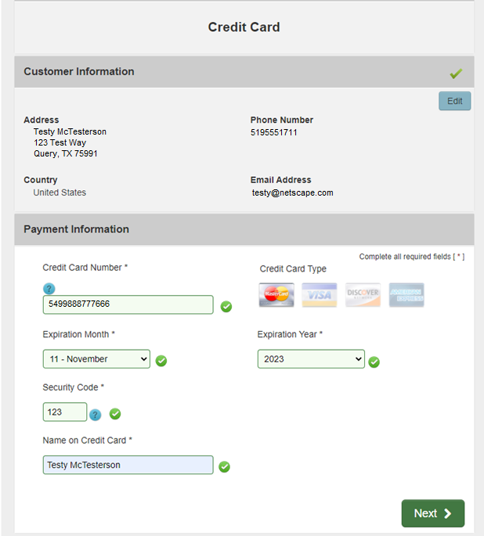

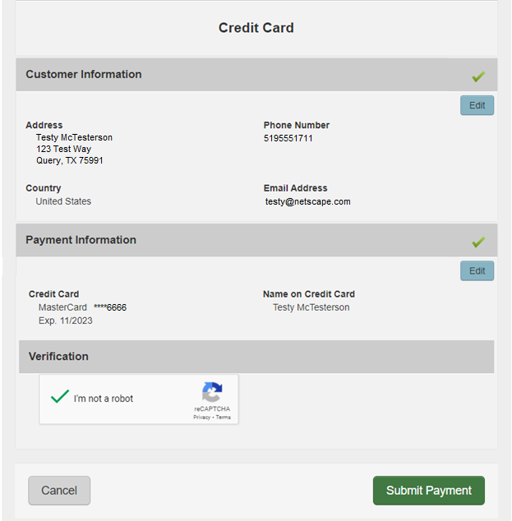

After your payment is processed you will be redirected to the payment success page. This will give you the opportunity to view/save a summary of your transaction.

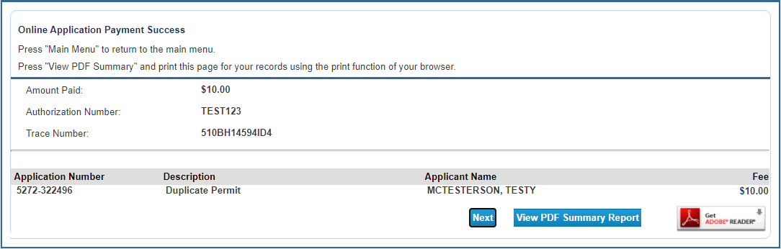

You will also receive two emails confirming your online payment. One will be from the online licensing system and the other will be from the payment processor. Please save these emails for your records.

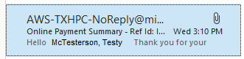

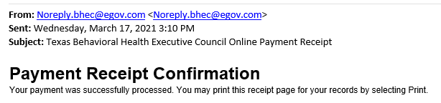

This completes the permit request process. Please allow two weeks for receipt of the permit.

