How To Apply for MFT License (Associate or Full License)

IMPORTANT: Before you initiate the online application process, be sure you have the required supplemental documentation saved to your device. You will be prompted to upload this documentation toward the end of the process. The list of required documentation can be found here.

- Log into your online licensing system account. The online licensing system link is found here. If you do not yet have an account, you will need to create one. A guide on how to create a new account can be found at the top of this webpage.
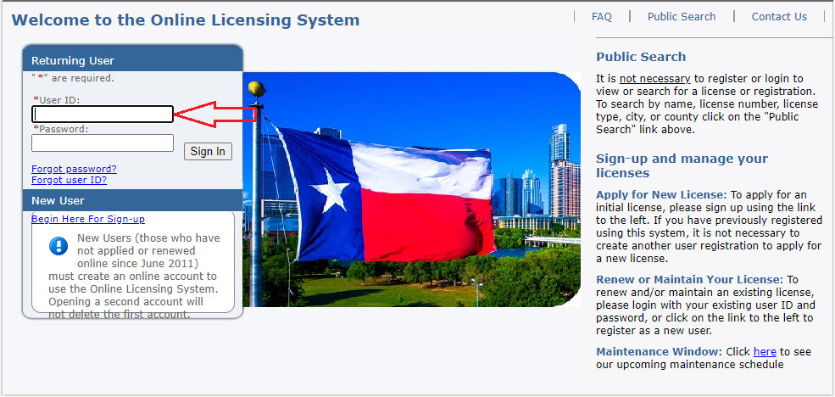
- Select “Texas Behavioral Health Executive Council” from the first drop-down then choose the board that issues the license you wish to apply for and click “Select”.
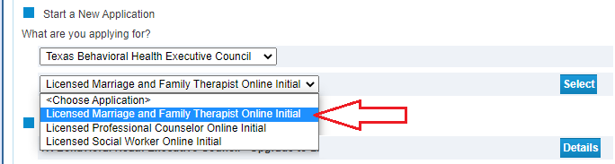

- Read the introduction and click “Next”.

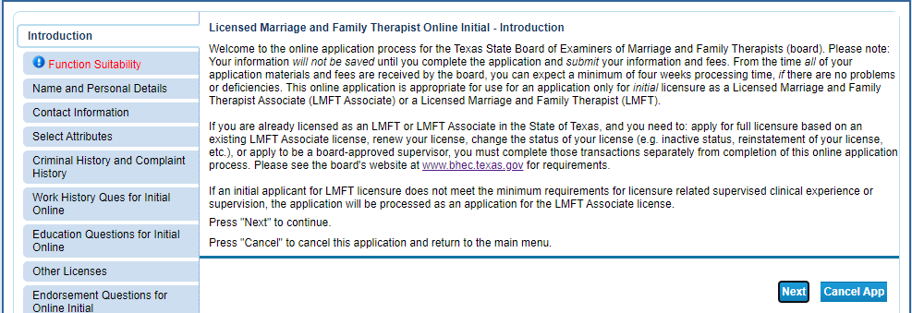

- Answer the function questions then click “Next”. These answers help the system verify that you are using the correct online application.

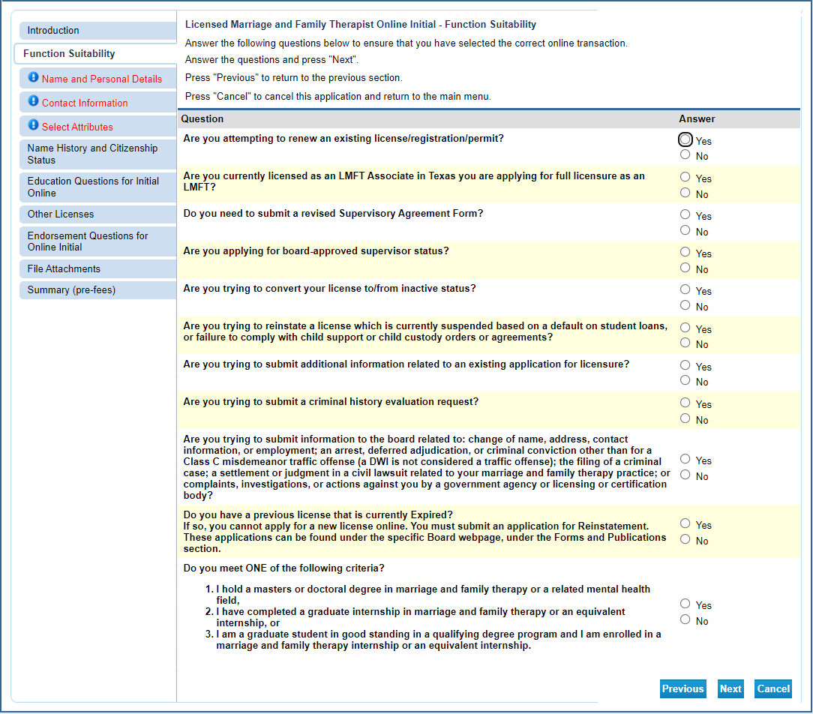

An answer that indicates a different application type will prompt an error message.

- Enter/Update your personal details then click “Next”.

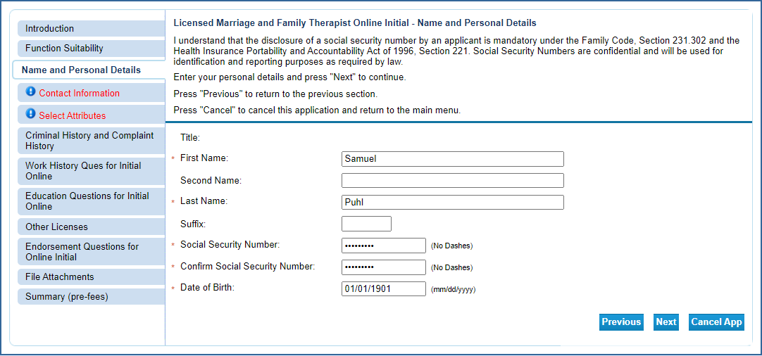

- Enter your contact information and then click “Next”.

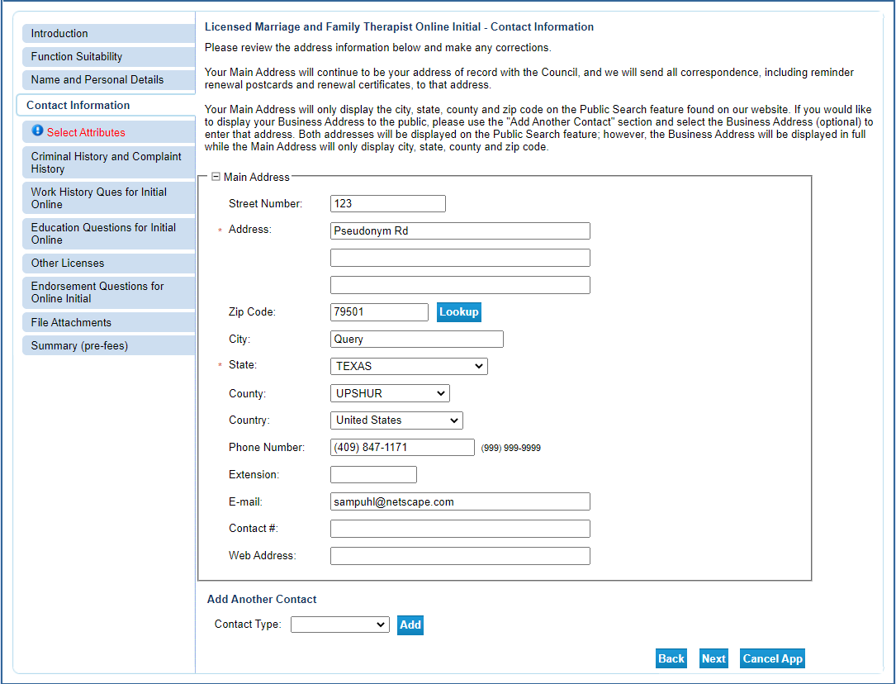

- Select the type of license you are requesting (associate or full MFT) and your military status (if any). This information will impact several aspects of the application process so be sure to answer correctly.

If you are fully licensed as an MFT in another state you should select “Marriage and Family Therapist”. If you are trying to become licensed as an MFT Associate select “Marriage and Family Therapist Associate”. If you are trying to upgrade your existing MFT Associate to full MFT, you are in the wrong module. Cancel the application and follow the upgrade instructions found here.

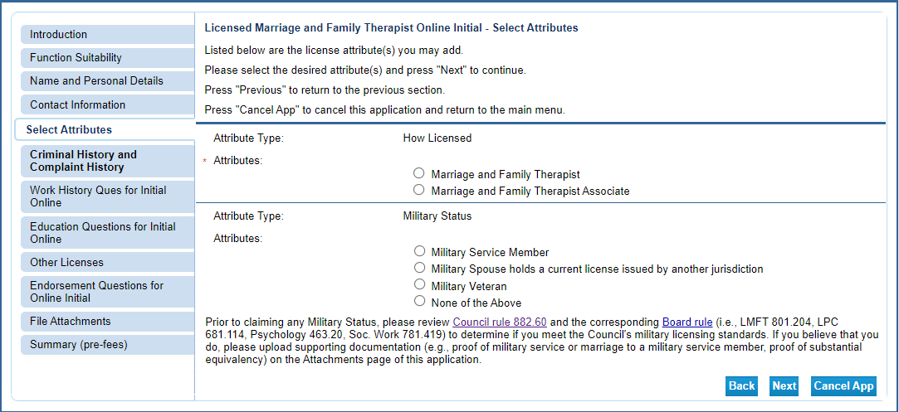

- Answer the questions about your previous names (if any) and citizenship.
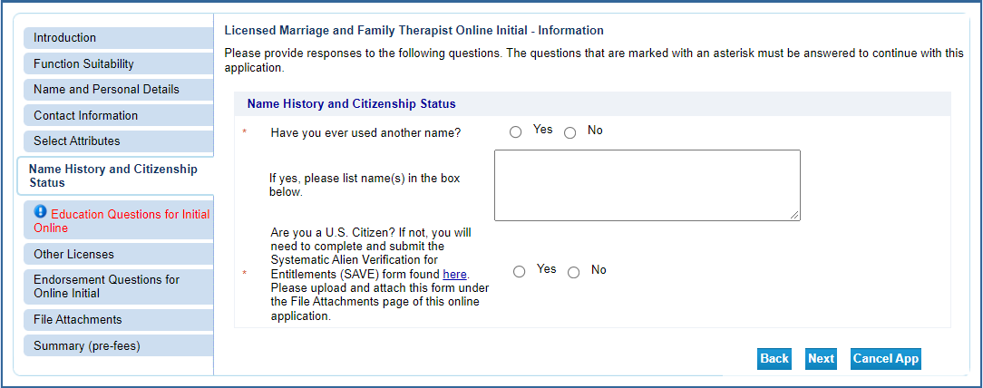

- Enter your education information then click “Next”.

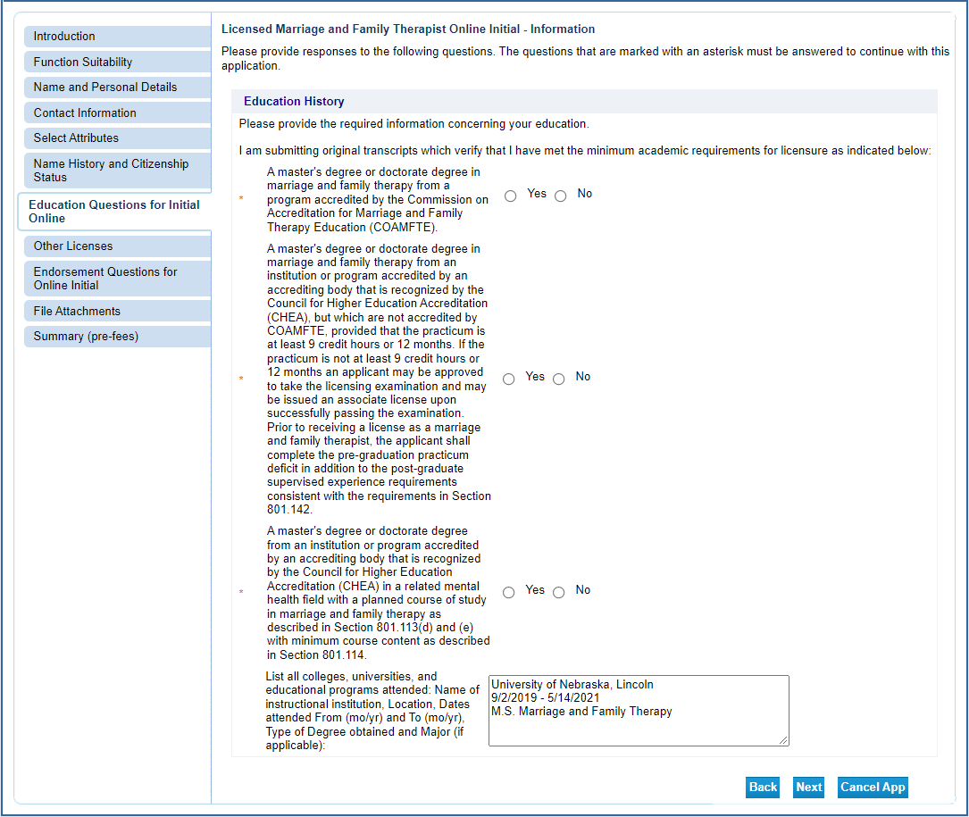
- Enter your past professional license information (if any).

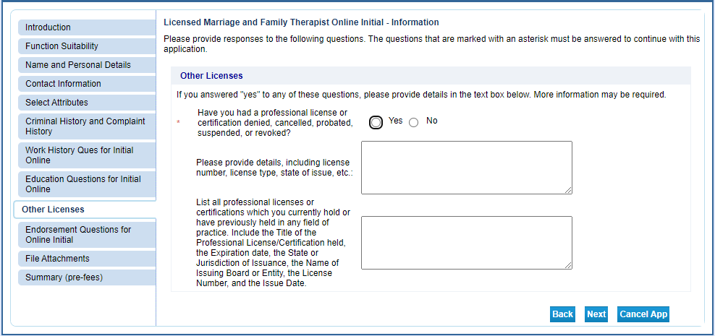

- Select your method of licensure. By answering “No” to the first question you are indicating your intent to apply for an Associate license. If you answer “Yes” that means you have an MFT license in another state. Click Next when complete.

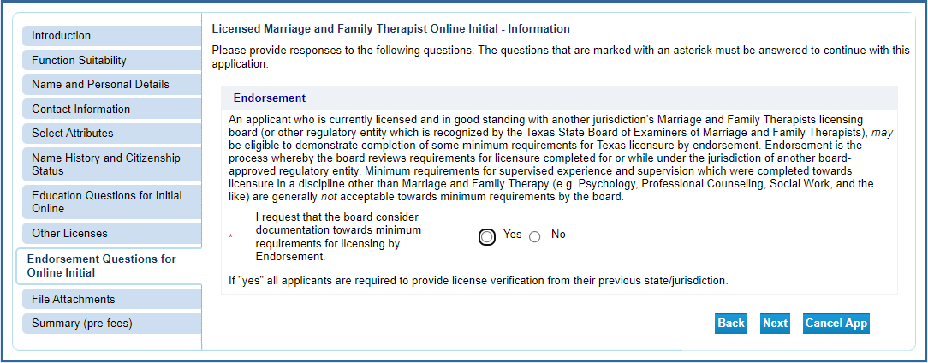

- Attach your supplemental documents (jurisprudence exam certificate, etc.).
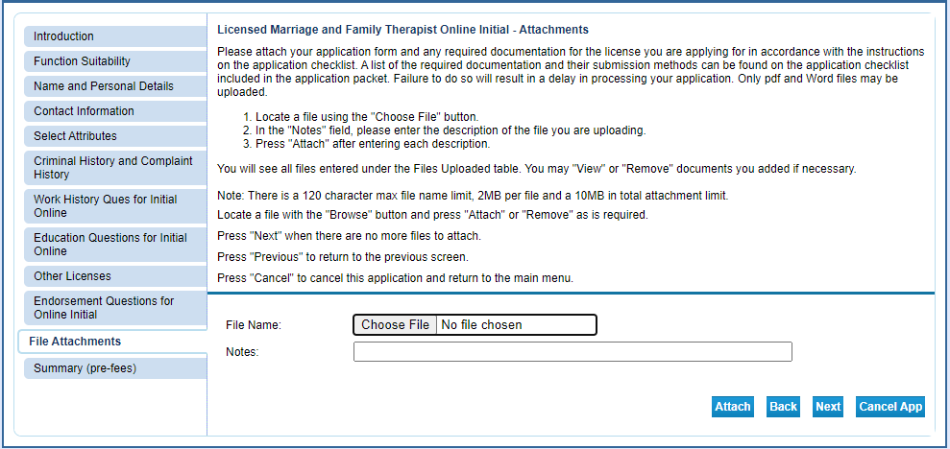

Click “Choose File” to open the selection window. Select the file you wish to upload and click “Open”. The file name will populate to the left of the Choose File button. In the Notes section type in a brief description of the file then click “Attach”.

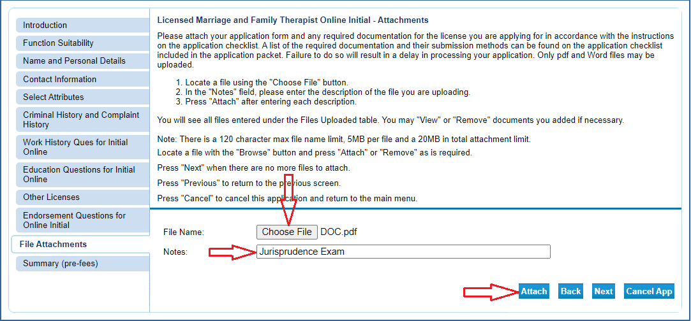

You will be able to attach multiple files in this manner. After each file is attached the screen will update and add that file to the list of attached files (Arrow 1). The total number of bytes is displayed (Arrow 2). The maximum number of bytes is 20 million (20MB). You can view each file (Arrow 3) and remove files (Arrow 4) during this process. Once you have added all the files click “Next”.
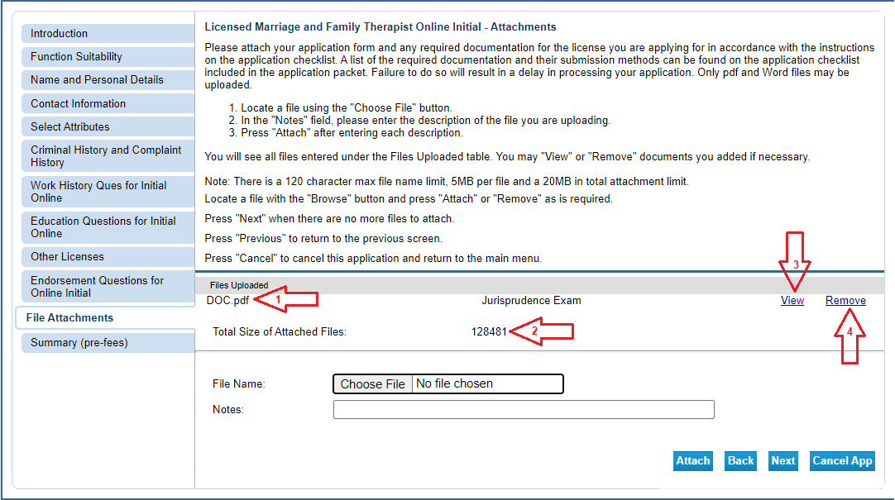

- Review your information and correct any errors. Once it is complete, click “Submit”. This will save the application and take you to the affirmation page.

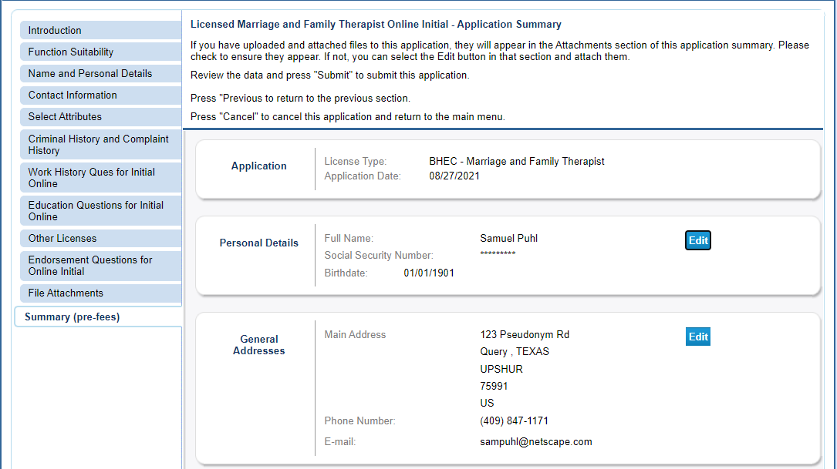

- Select “Yes” to agree to the affirmation and click “Next”.
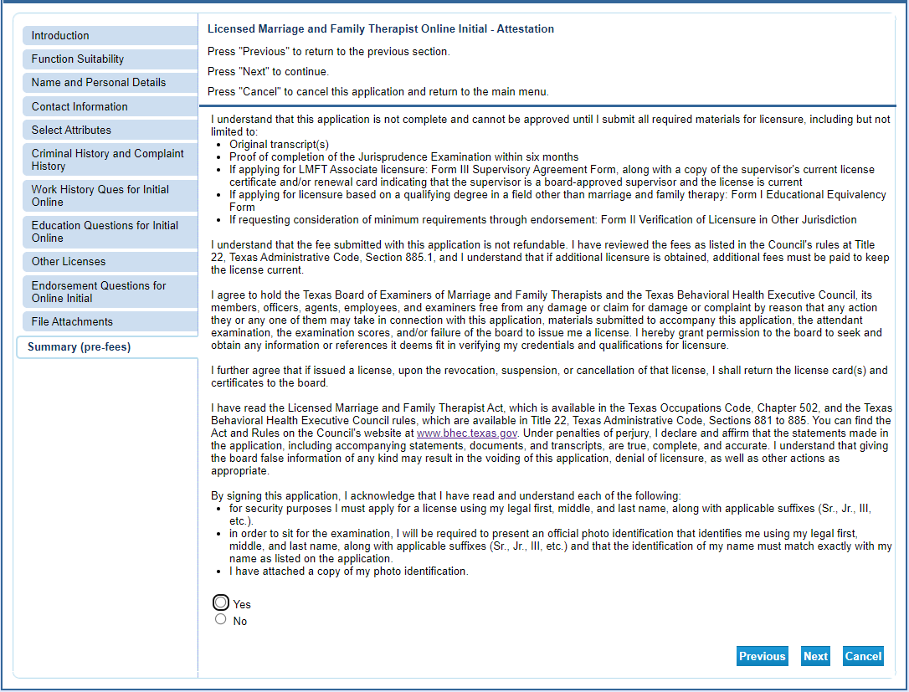

- Click on “Pay Now” to begin the payment process. If you fail to pay the license fee the application will sit in limbo for 30 days and then be deleted. If you selected any of the military options Texas law makes you exempt from this fee and you will move straight to a confirmation screen.

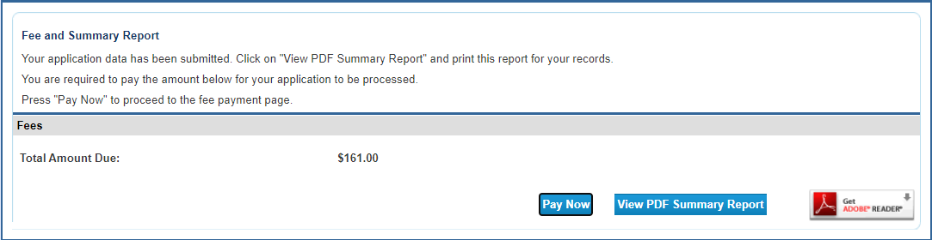

Click “Next” to move to the confirmation page.

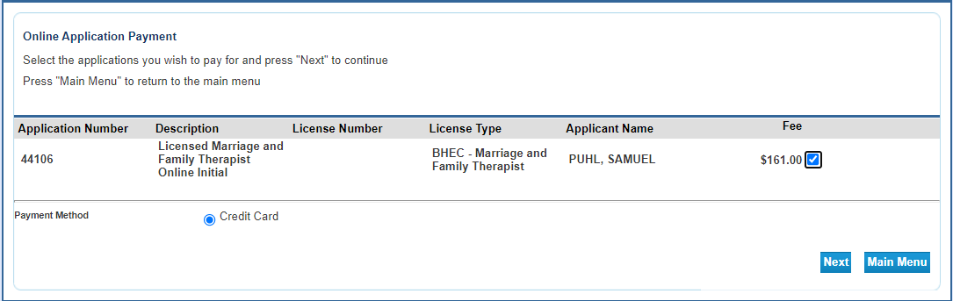

Click “Next” to move to the payment processor.

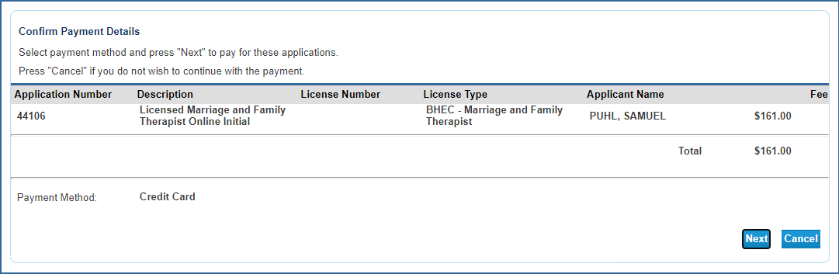

You will be redirected to the payment processor. Enter your customer information in the required fields then click “Next”.
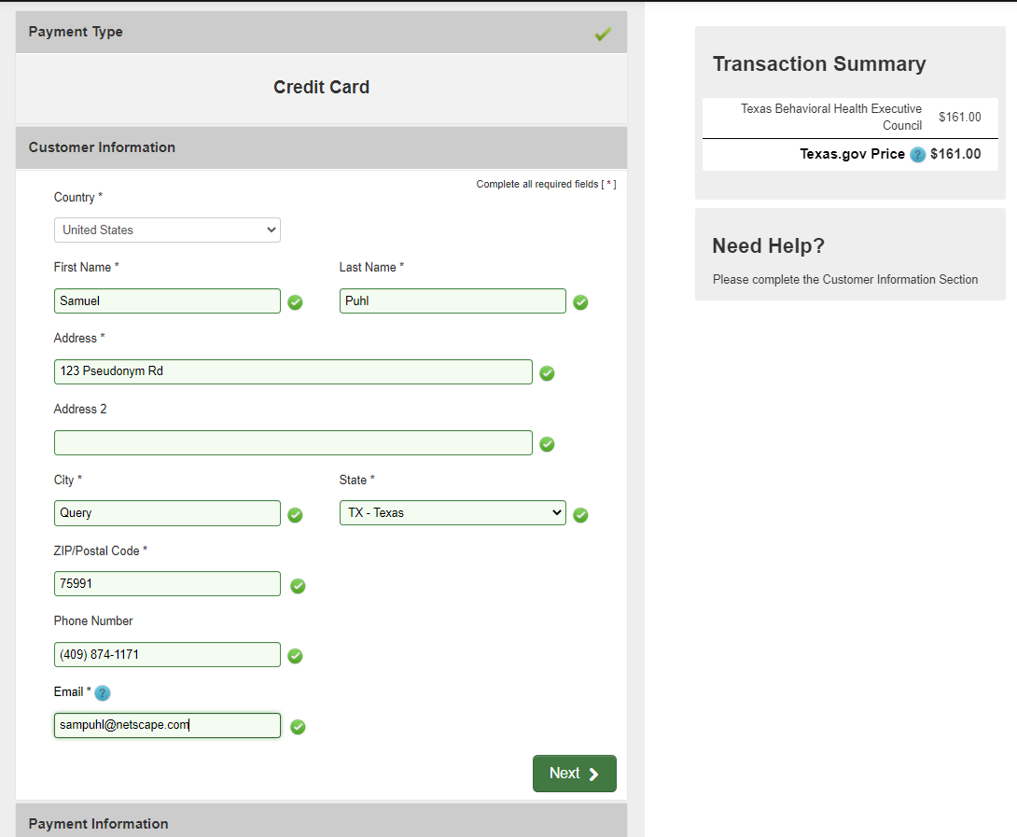

Enter your credit card information and click “Next”.

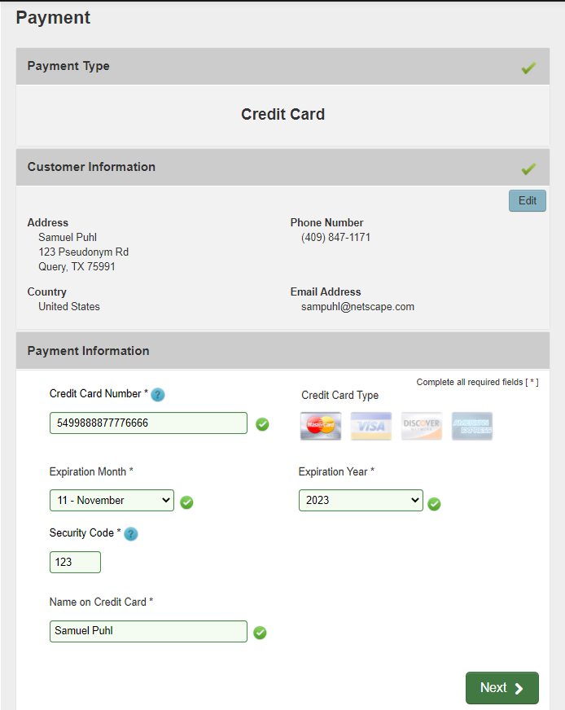

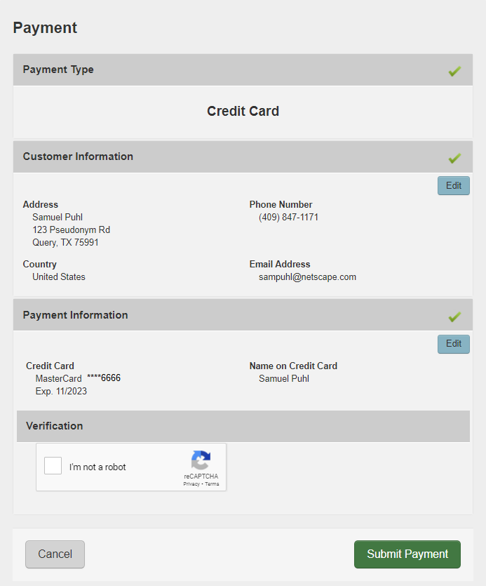

After your payment is processed you will be redirected to the payment success page. This will give you the opportunity to view/save a summary of your transaction.

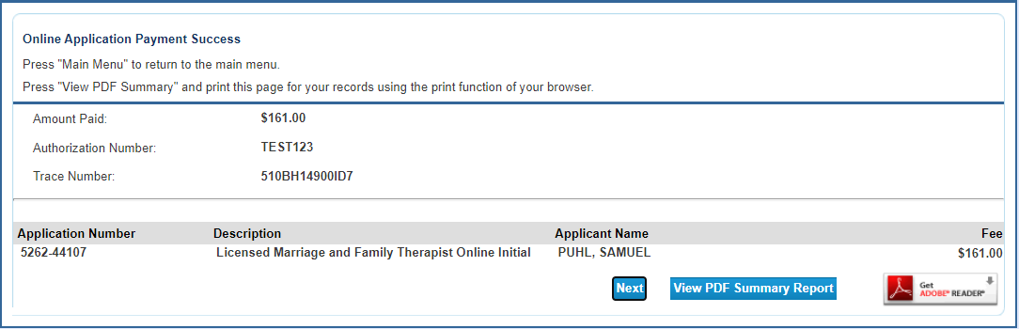

You will also receive two emails confirming your online application and payment. One will be from the online licensing system and the other will be from the payment processor. Please save these emails for your records.

*NOTE* There is important information provided in this email. Be sure to read the email in its entirety to get the necessary information to complete the fingerprinting requirement (all applicants) and your AMFTRB exam code (MFT Associate applicants only).

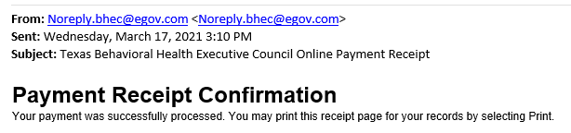

This completes the online portion of the application process. Your application will be reviewed by staff in the order it was received. Once reviewed, staff will either contact you to request missing documentation or, if everything in your application is complete and correct, send you the license. Due to heavy volume, please wait at least six weeks before contacting BHEC for a status update.

