How to Renew Your Psychologist Associate License Online

Log into the Online Licensing System here: https://vo.licensing.hpc.texas.gov/datamart/login.do. If you do not yet have an online account, the instructions for creating one is the first option on this webpage.

Approximately 60 days prior to your expiration your account will be set to “Renewal” status. This grants you access to the renewal module. From the “Quick Start Menu” you will see “It is time to Renew”. Click “Select” to begin the online renewal.

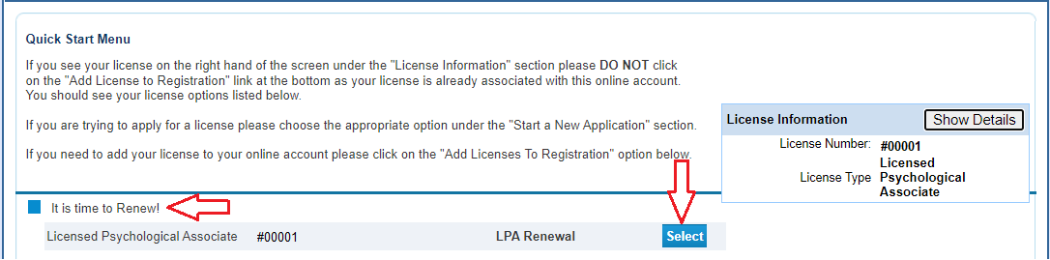

Read the Introduction information then click “Next”.

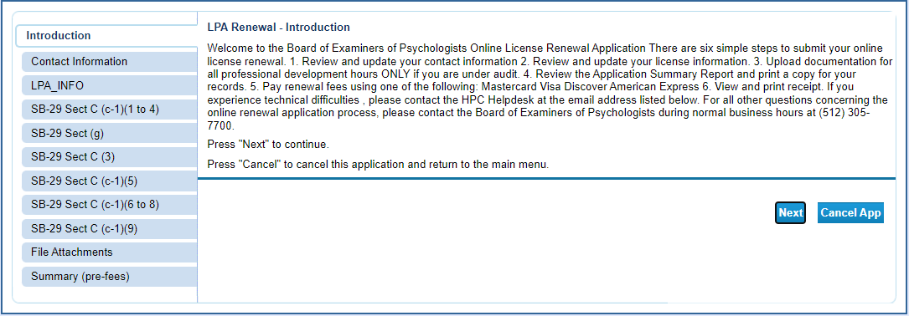

Review your contact information and make any corrections that are needed. Once complete, click “Next”.

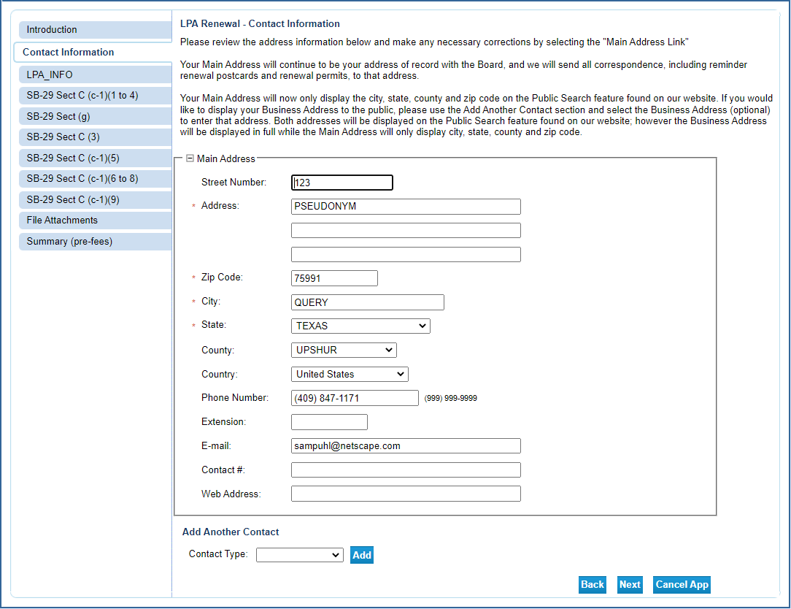

Answer the questions regarding reporting, professional development/continuing education, and the Human Trafficking Course. Note: Even if you answer “No” to any of these questions you’ll still be able to complete the online portion of the renewal. Click “Next”.

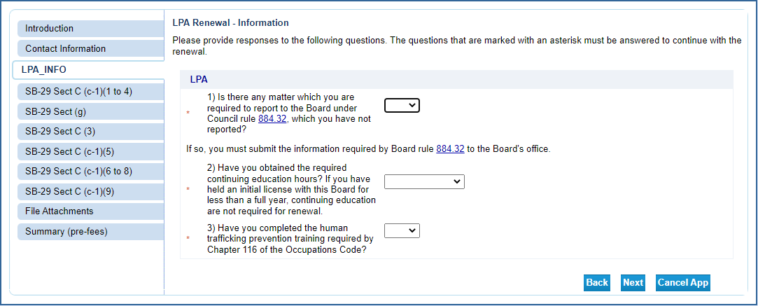

The information requested in the next several sections is required by §105.003 of the Health and Safety Code. This information is collected and provided to the Texas Department of State Health Services. Only the questions marked with a red asterisk are required. All other information is voluntary.

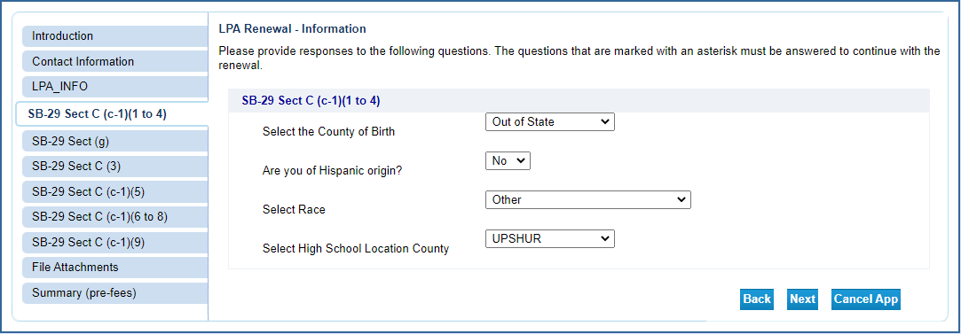

Method of Licensure: If you took an exam to get your Texas license select “Exam”. If you came to Texas as a licensee in another state, select “Reciprocity”. AMEC and Other are not intended methods of licensure for LP’s.

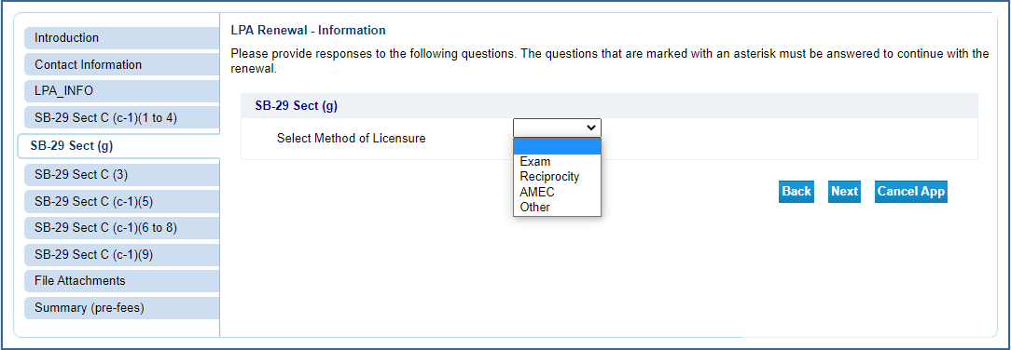

Note: Basic Health Profession degree and Highest Health Profession degree may be the same. If so,
please enter the information twice as these are required fields.
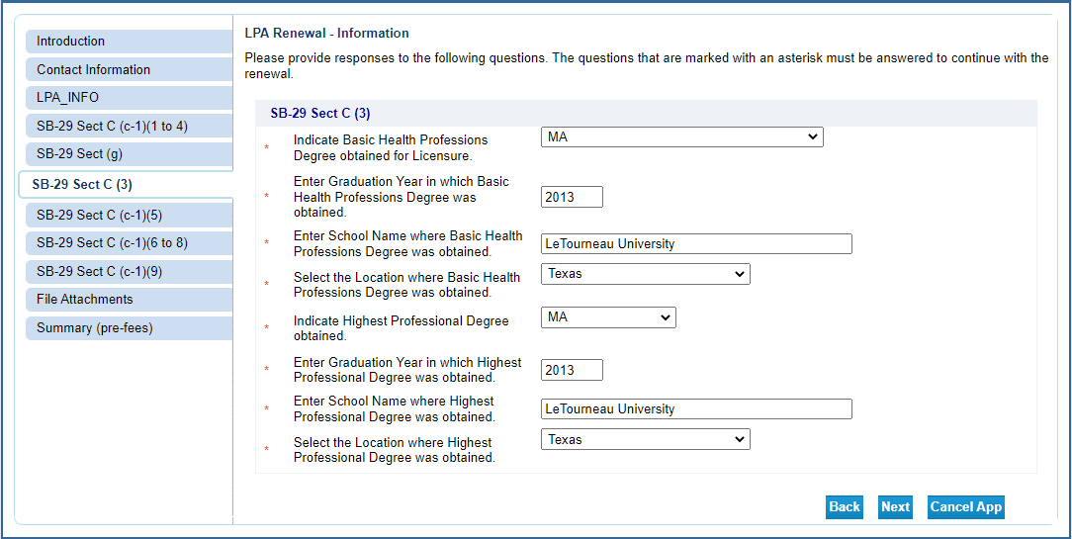

Voluntary Information.

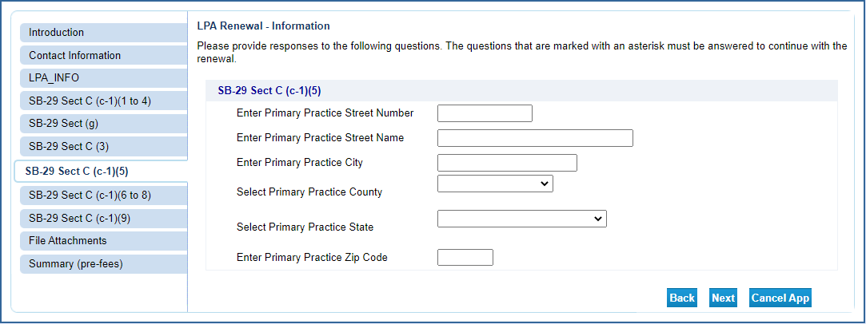

Voluntary Information.
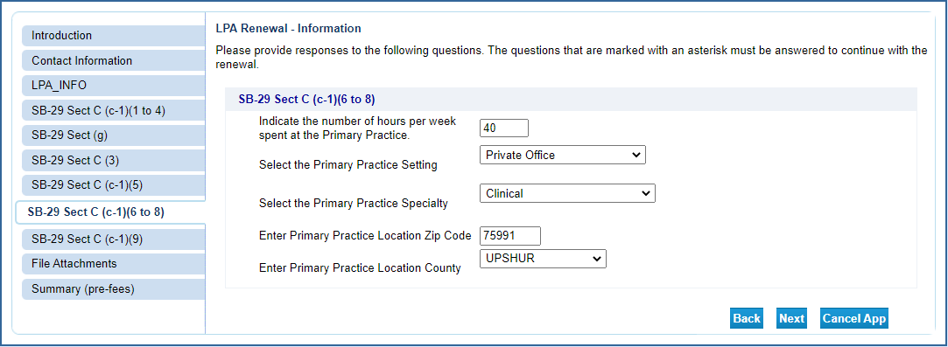

Voluntary Information.

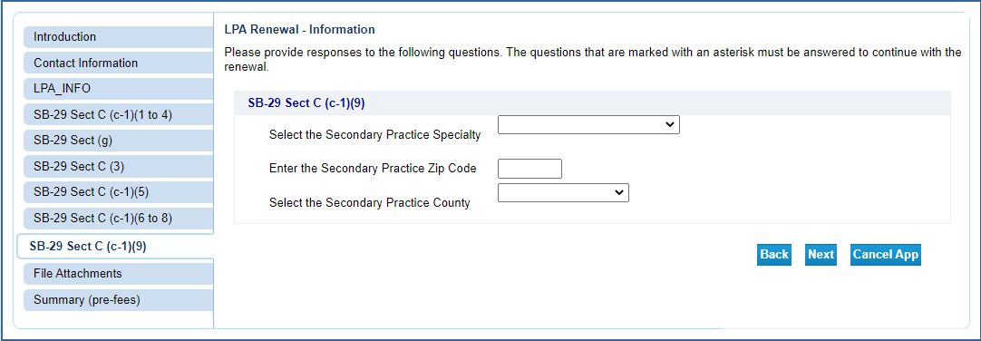

Attachments: This feature allows you to attach electronic files to your renewal that can be accessed by BHEC staff. NOTE – Only attach documents if instructed to do so in your renewal notice. Only licensees under a Continuing Education (CE) Audit are required to show proof of CE.

Click “Choose File” to open the selection window. Select the file you wish to upload and click “Open”. The file name will populate to the left of the Choose File button.
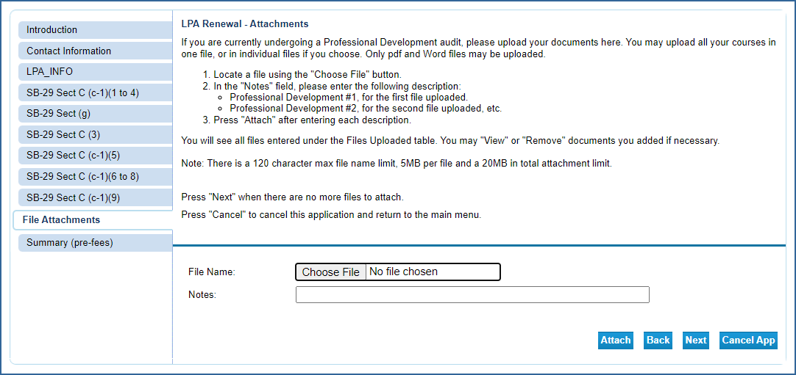

In the Notes section type in a brief description of the file then click “Attach”.

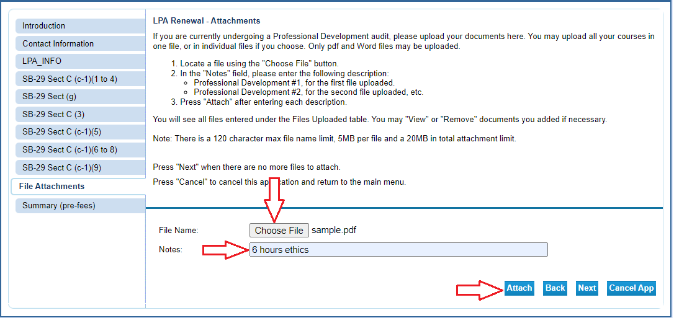

You will be able to attach multiple files in this manner. After each file is attached the screen will update and add that file to the list of attached files (Arrow 1). The total number of bytes is displayed (Arrow 2). The maximum number of bytes is 20 million (20MB). You can view each file (Arrow 3) and remove files (Arrow 4) during this process. Once you have added all the files click “Next”.

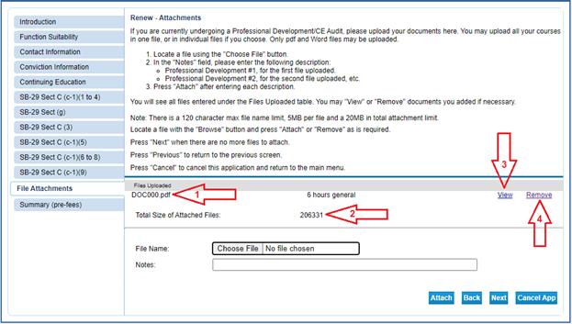
The Summary page allows you to review your entries and edit them if mistakes are found. Click on the “Edit” button in the section needing correction to update that information. Once the information is accurate, click “Submit”.

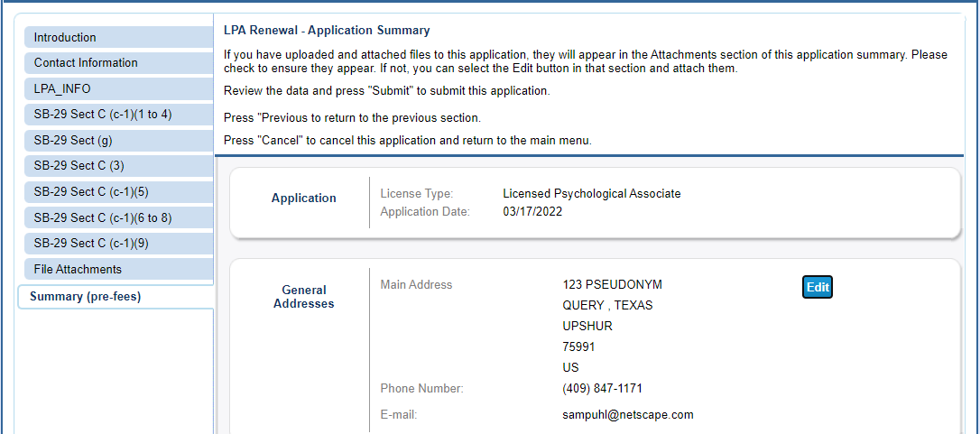

After clicking “Submit” you will be sent a confirmation email alerting you that your application data has been received. This email will include your application summary as an attachment.

The Attestation requires you to affirm that the information provided is true and correct. Answer the attestation question and click “Next”.

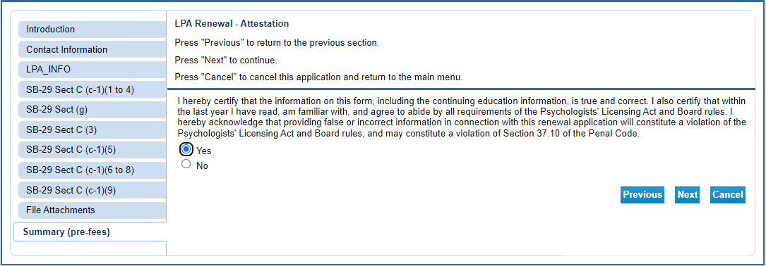

Click “Pay Now” to move to the online application payment screen.

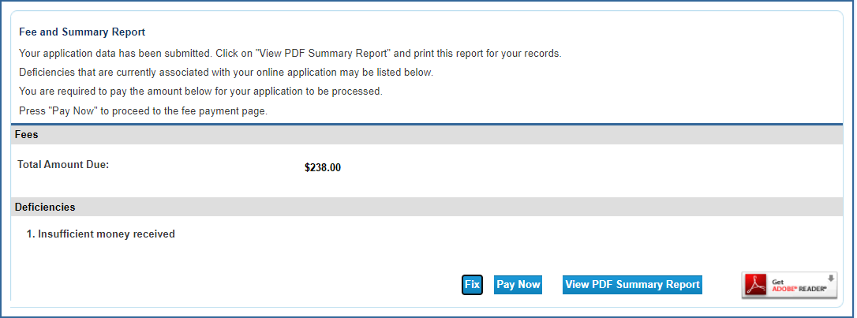

Click “Next” to move to the confirmation page.

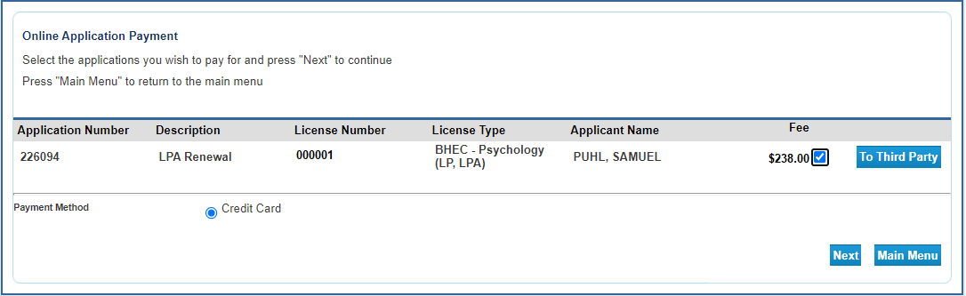

Click “Next” to move to the payment processor.

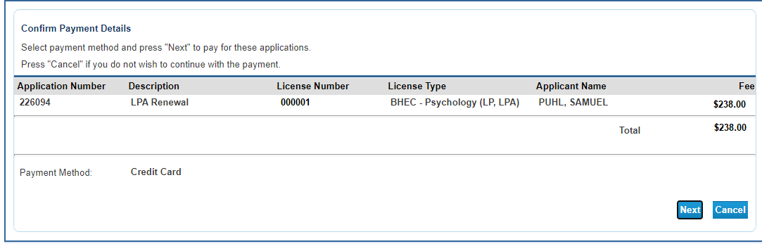

You will be redirected to the payment processor. Enter your customer information in the required fields then click “Next”.
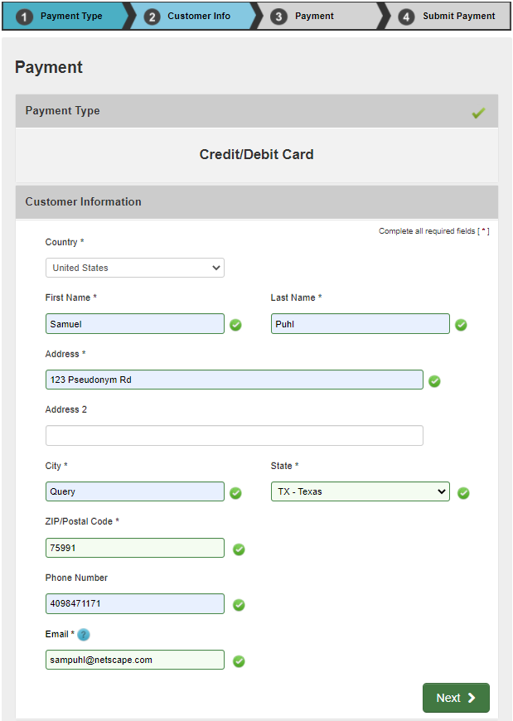

Enter your credit card information and click “Next”.

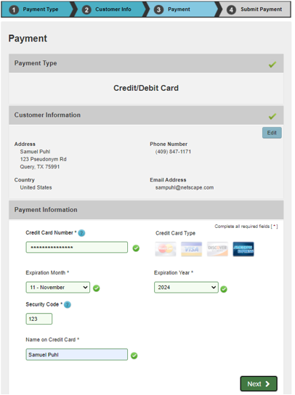

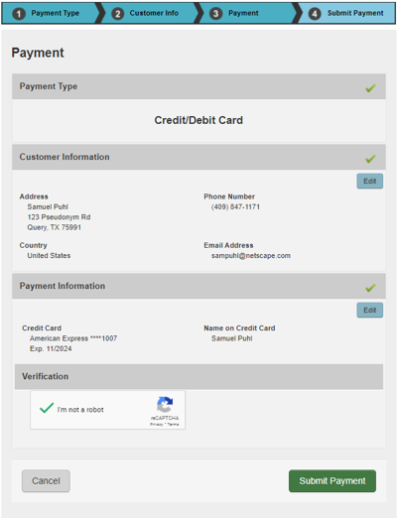

After your payment is processed you will be redirected to the payment success page. This will give you the opportunity to view/save a summary of your transaction.

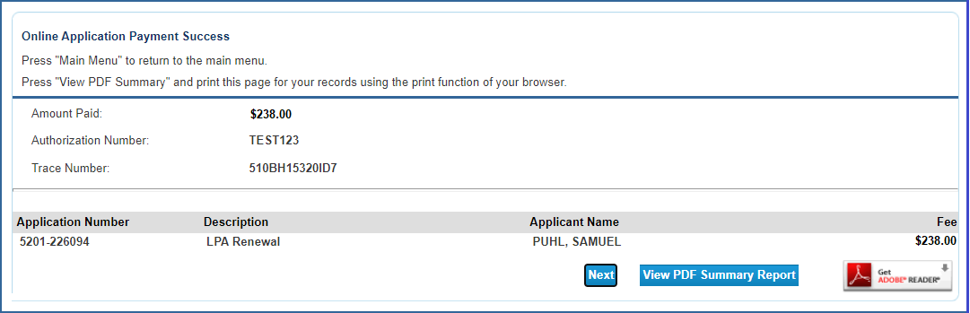

You will also receive two emails confirming your online payment. One will be from the online licensing system and the other will be from the payment processor. Please save these emails for your records.

This completes the online portion of the renewal. Your license should be updated within three business days of the transaction in most cases. If you are under CE audit or have outstanding fingerprints, the process may take longer.

