How to Reinstate Your BHEC License Online

Before you initiate the online application process, be sure you have the required supplemental documentation saved to your device. You will be prompted to upload this documentation toward the end of the process. The list of required documentation can be found

***IMPORTANT NOTE*** Online reinstatement is a two-part process.

Log into the Online Licensing System here: https://vo.licensing.hpc.texas.gov/datamart/login.do. If you do not yet have an online account, the instructions for creating one is the first option on this webpage.

From the “Quick Start Menu” you will see “Manage your license information”. Use the dropdown to select “Reinstatement Request (Online TRX)”. Then click “Select” to begin part one of online reinstatement.

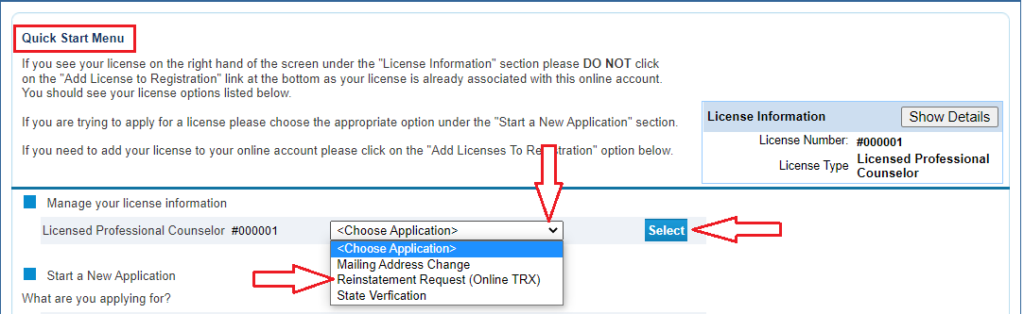

Read the Introduction information then click “Next”.

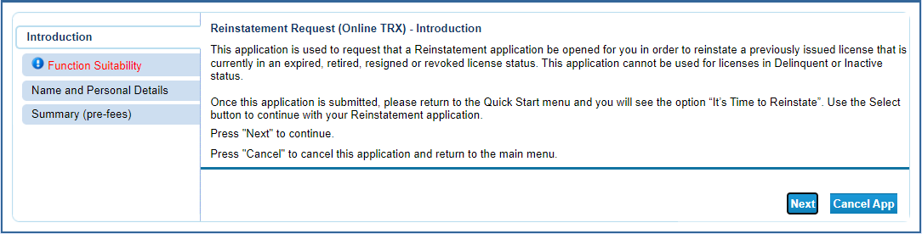

Answer the function questions then click “Next”. These answers help the system verify that you are using the correct online application.

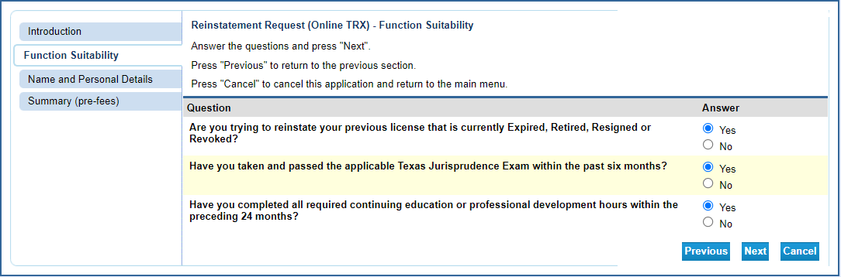

An answer that indicates a different application type will prompt an error message.

The Summary page allows you to review your entries and edit them if mistakes are found. Click on the “Edit” button in the section needing correction to update that information. Once the information is accurate, click “Submit”.

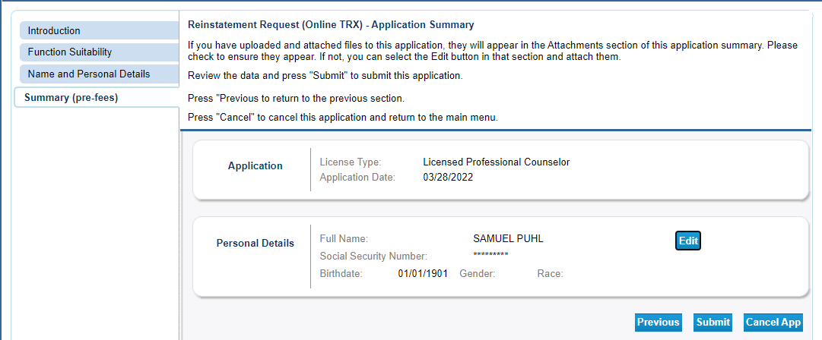

Answer the attestation question then click “Next”.

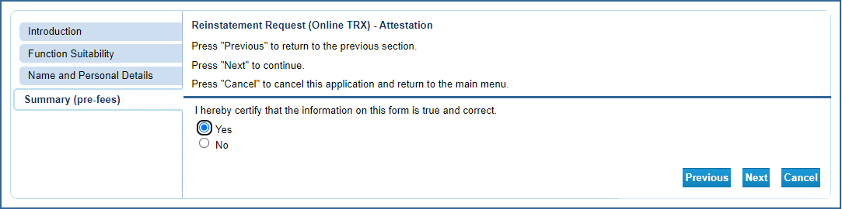

Click “Return” to go back to the main screen and begin the second phase of the reinstatement process.

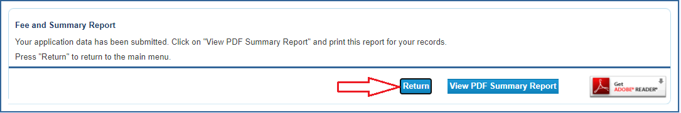

From the “Quick Start Menu” you will see “It is time to Reinstate”. Click “Select” to begin the online reinstatement.

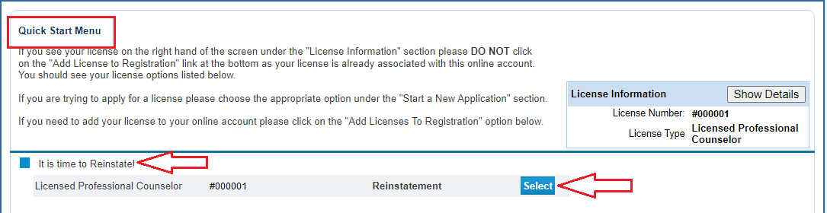

Read the introduction information then click “Next”.

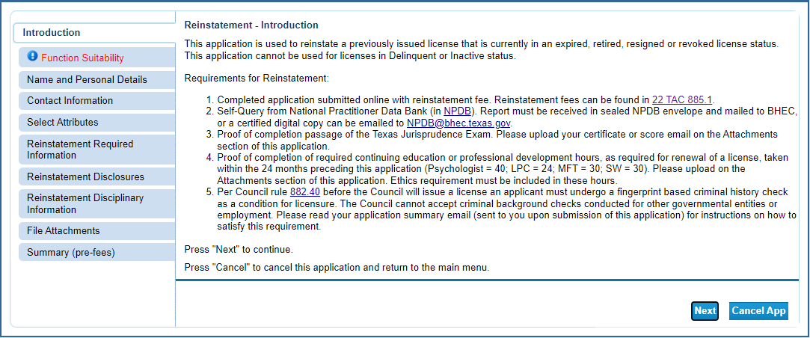

Answer the function questions then click “Next”. These answers help the system verify that you are using the correct online application.

An answer that indicates a different application type will prompt an error message.

Update your contact information and then click “Next”.

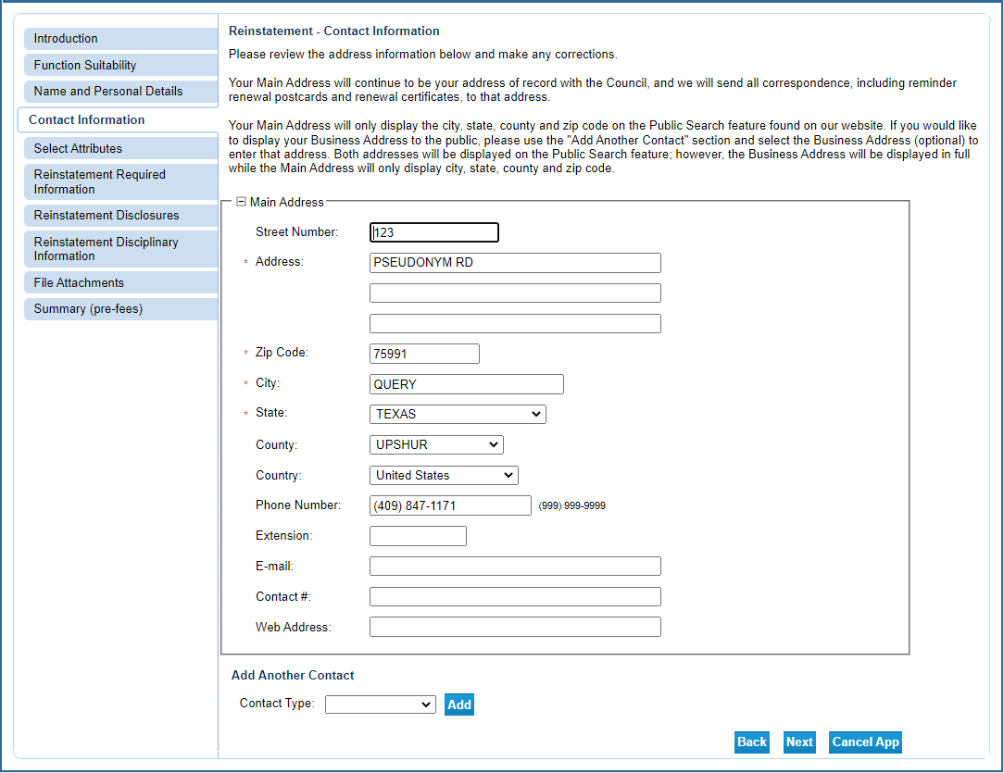

Select your military status (if any). This information will impact several aspects of the application process so be sure to answer correctly.

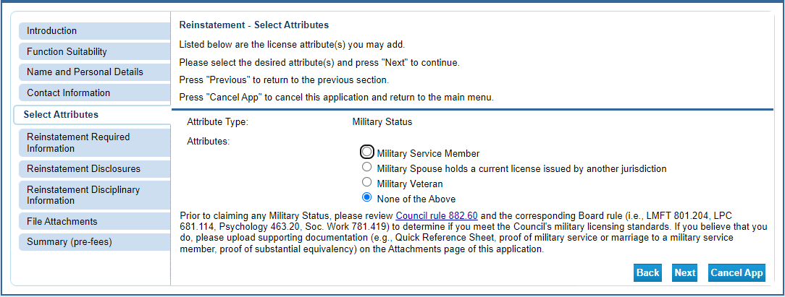

Answer the questions about reinstatement eligibility and continuing education then click “Next”.

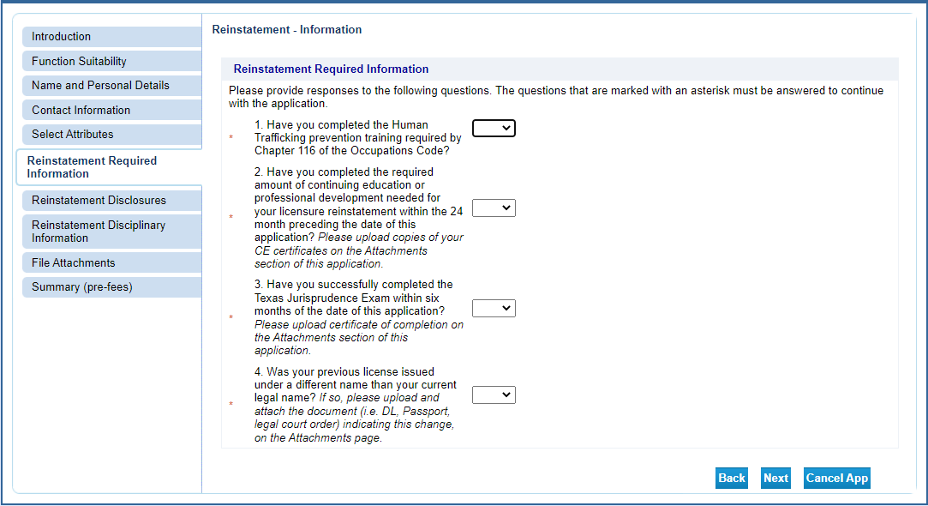

Answer the reinstatement disclosures then click “Next”.

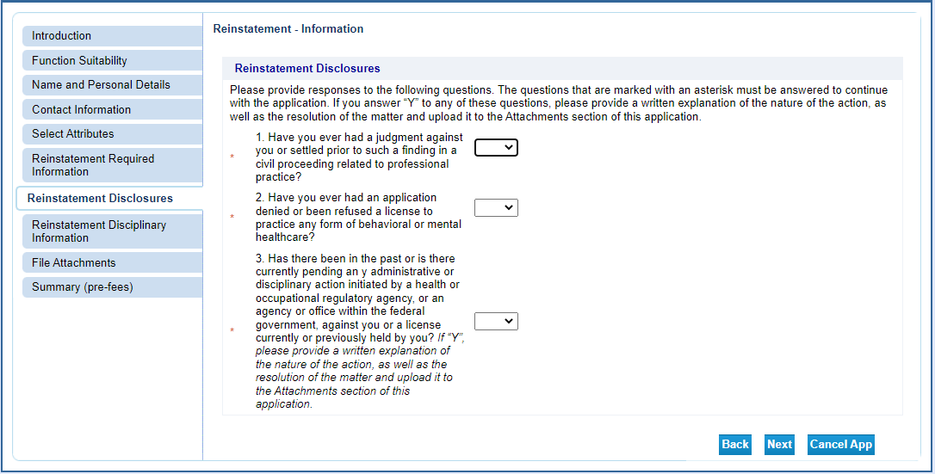

Answer the questions about previous disciplinary actions then click “Next”.

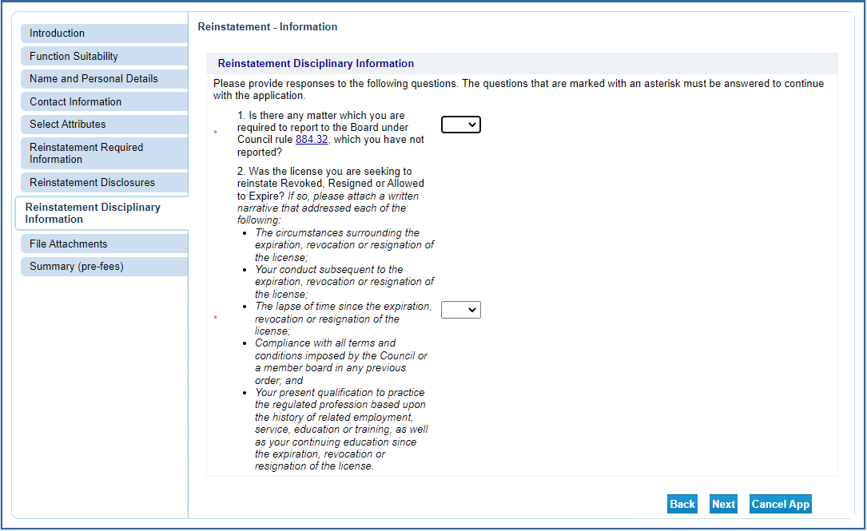

Attachments: This feature allows you to attach electronic files to your renewal that can be accessed by BHEC staff. There are several documents needed to

Click “Choose File” to open the selection window. Select the file you wish to upload and click “Open”. The file name will populate to the left of the Choose File button.
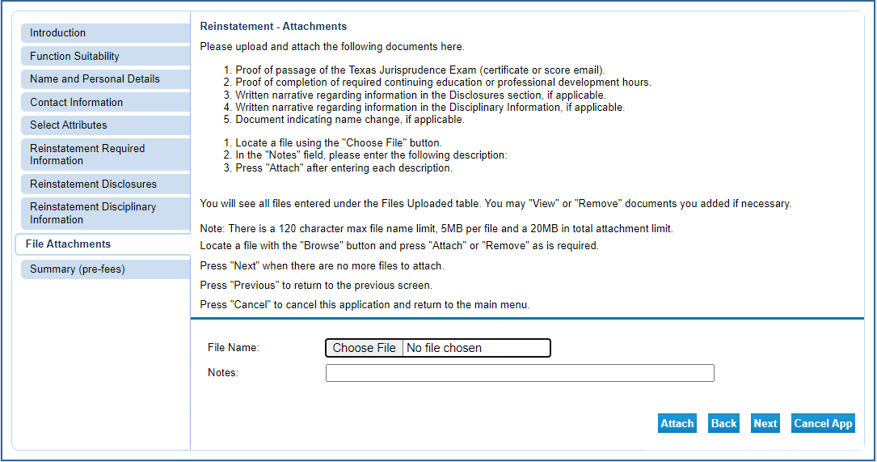

In the Notes section type in a brief description of the file then click “Attach”.

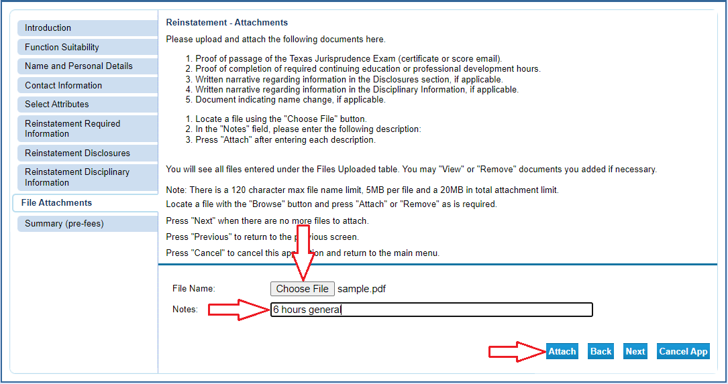

You will be able to attach multiple files in this manner. After each file is attached the screen will update and add that file to the list of attached files (Arrow 1). The total number of bytes is displayed (Arrow 2). The maximum number of bytes is 20 million (20MB). You can view each file (Arrow 3) and remove files (Arrow 4) during this process. Once you have added all the files click “Next”.

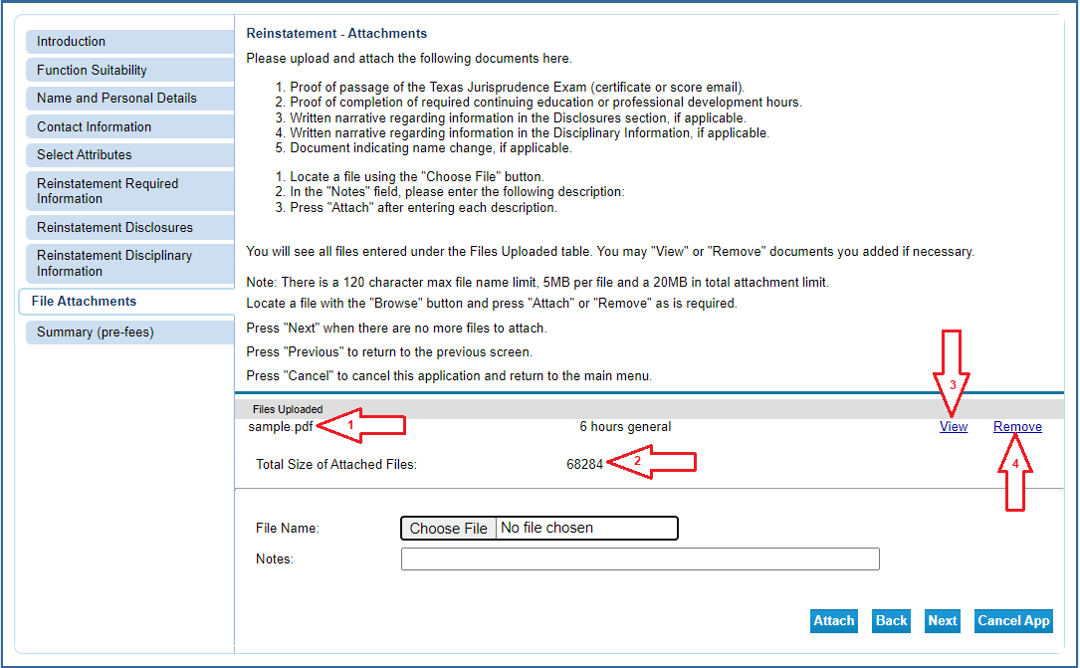
The Summary page allows you to review your entries and edit them if mistakes are found. Click on the “Edit” button in the section needing correction to update that information. Once the information is accurate, click “Submit”.

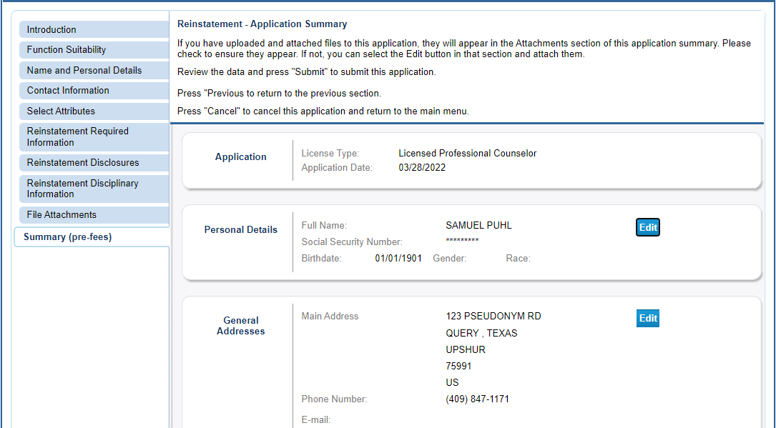

After clicking “Submit” you will be sent a confirmation email alerting you that your application data has been received. This email will include your application summary as an attachment.

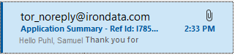

The Attestation requires you to affirm that the information provided is true and correct. Answer the attestation question and click “Next”.

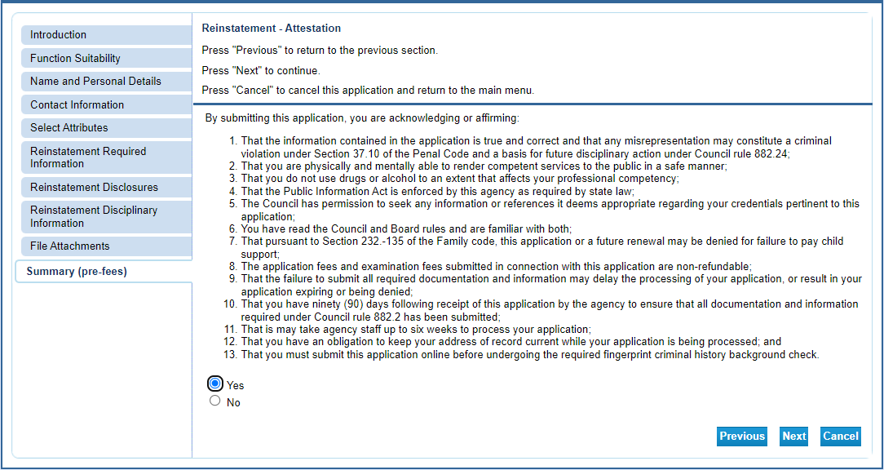

Click “Pay Now” to move to the online application payment screen.

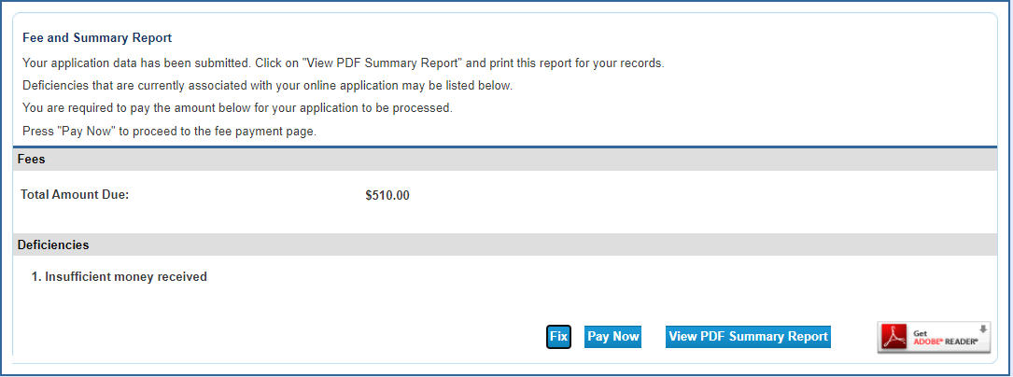

Click “Next” to move to the confirmation page.

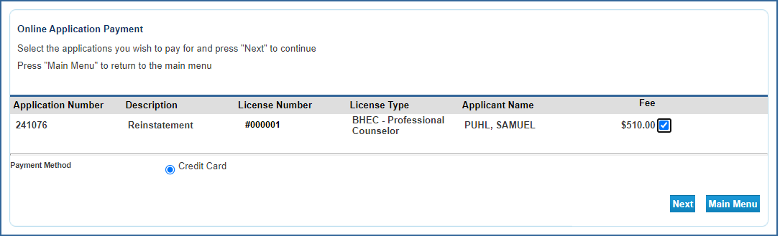

Click “Next” to move to the payment processor.

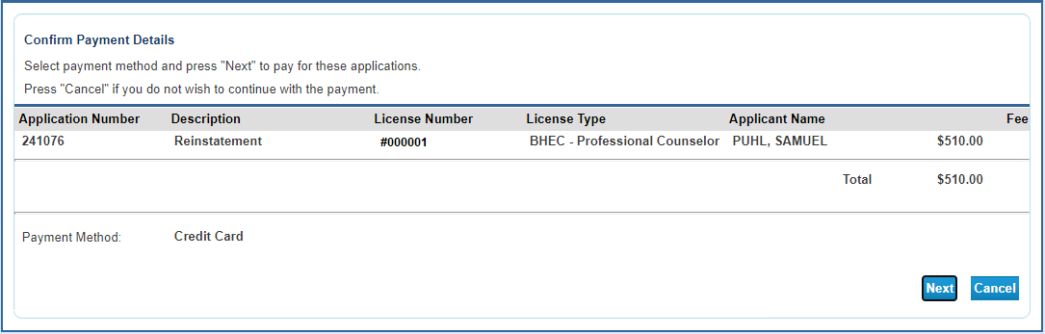

You will be redirected to the payment processor. Enter your customer information in the required fields then click “Next”.
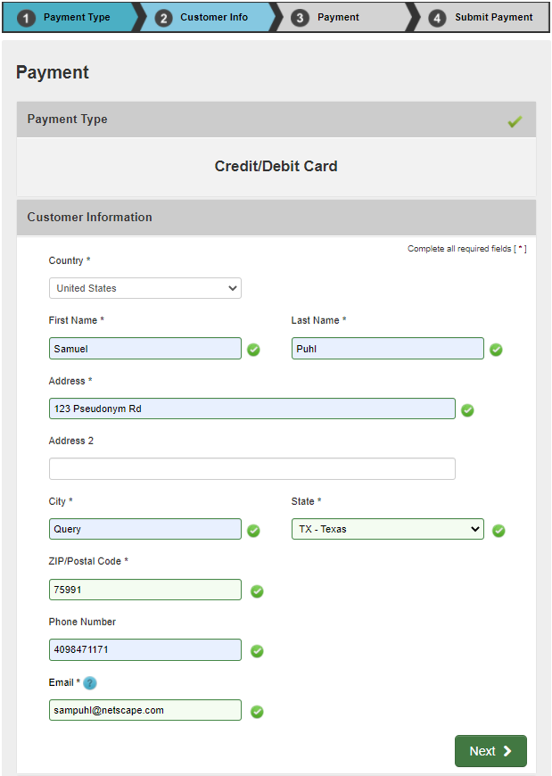

Enter your credit card information and click “Next”.

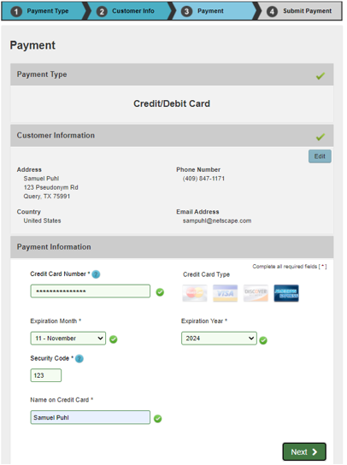

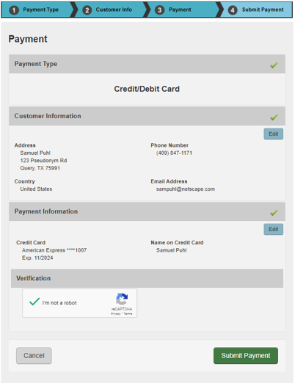

After your payment is processed you will be redirected to the payment success page. This will give you the opportunity to view/save a summary of your transaction.

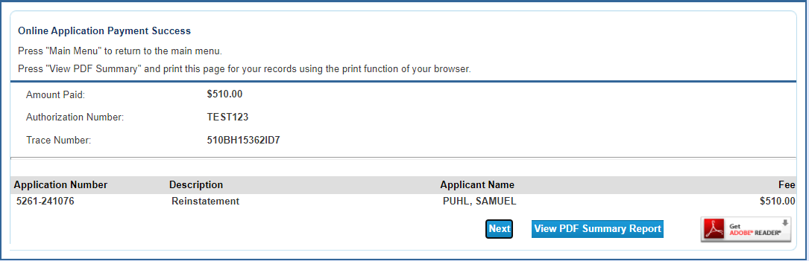

You will also receive two emails confirming your online payment. One will be from the online licensing system and the other will be from the payment processor. Please save these emails for your records.

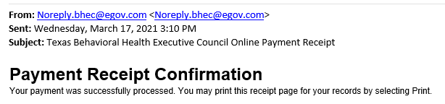

This completes the online portion of the reinstatement. Please allow 6 weeks to pass before contacting the agency for a status update.

