How to Request Your License be Moved to Retired Status

These instructions apply to LPC, MFT, and Social Worker license types.

***NOTE*** If your license is in “Delinquent” status you will have to complete the renewal process before you will be able to go into “Inactive” status.

Log into the Online Licensing System. If you do not yet have an online account, the instructions for creating one is the first option at the top of this page.

From the “Quick Start Menu” use the “Manage your license information” dropdown to choose “Request for Inactive Status” then click “Select”.

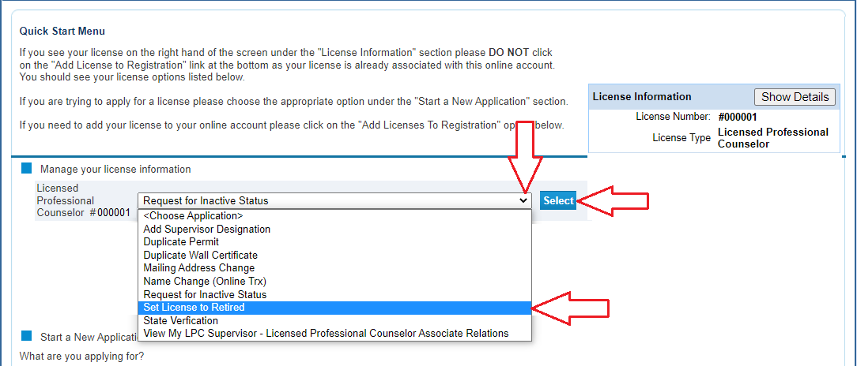

Read the Introduction information then click “Next”.

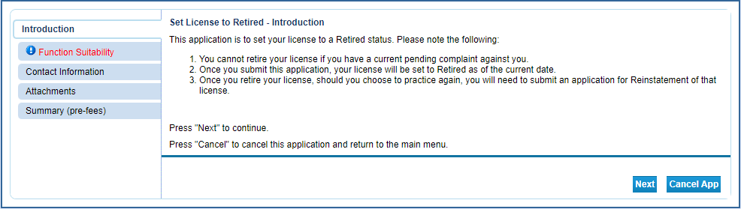

Answer the questions in the suitability section then click “Next”. These questions make sure you are accessing the correct function within the online system. If a question is answered in a fashion that indicates the incorrect function, you will receive an error message.
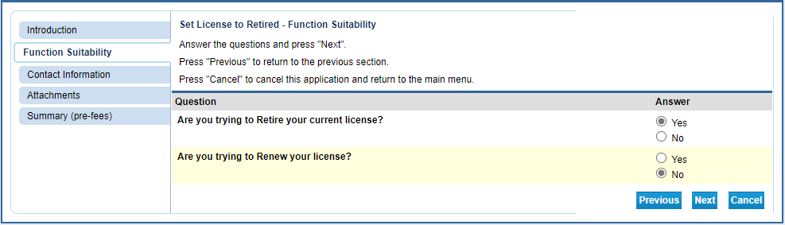

Review your contact information and make any corrections that are needed. Once complete, click “Next”.

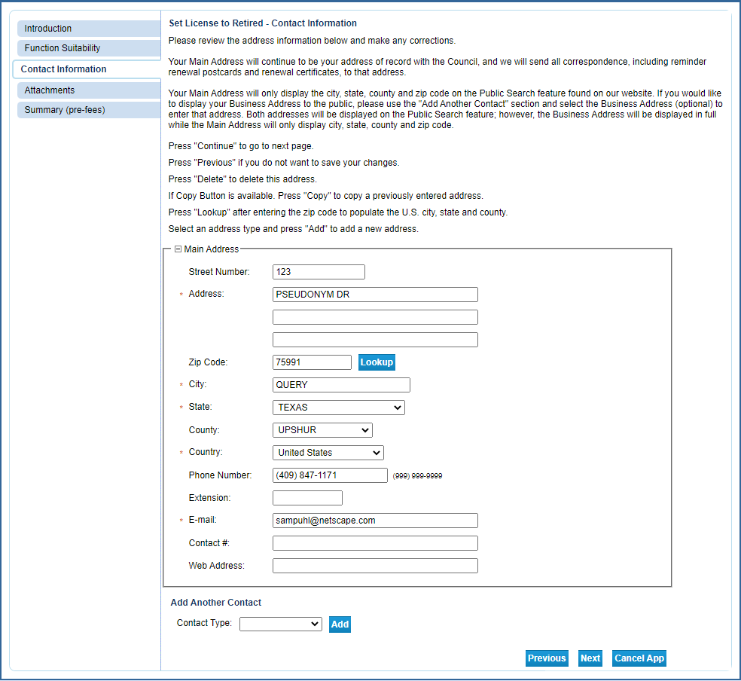

If there are any documents you wish to attach, do so here (not required). Click “Next” to advance.

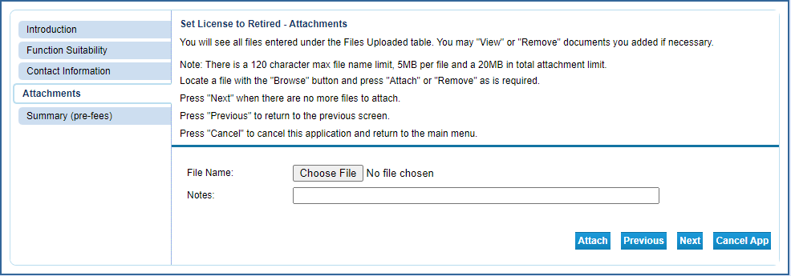

The Summary page allows you to review your entries and edit them if mistakes are found. Click on the “Edit” button in the section needing correction to update that information. Once the information is accurate, click “Submit”.

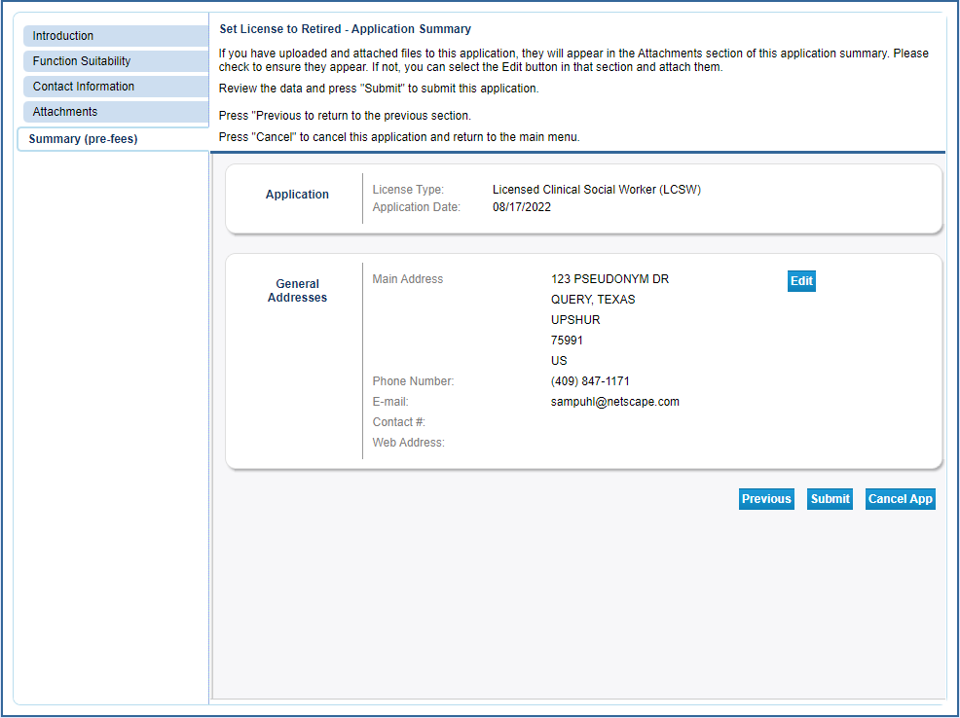

After clicking “Submit” you will be sent a confirmation email alerting you that your application data has been received. This email will include your application summary as an attachment.

The Attestation requires you to affirm that the information provided is true and correct. Answer the attestation question and click “Next”.

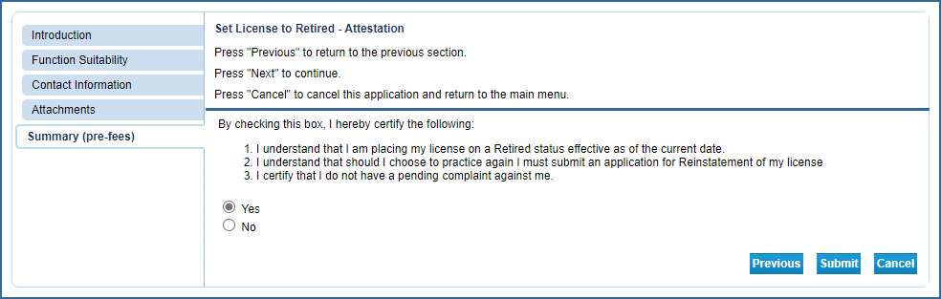

After clicking submit, you will be redirected to the summary page. This will give you the opportunity to view/save a summary of your transaction.

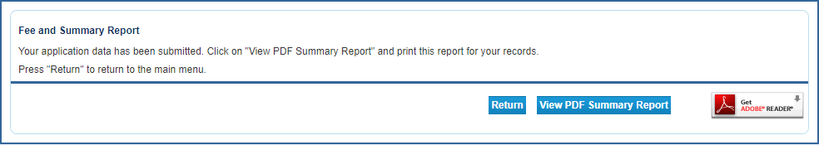

You will also receive an email confirming your request to retire the license. Please save these emails for your records.

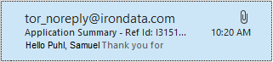

Your license will be retired effective the date you submitted the online request.

