How To Change Your Password

- Log into your online licensing system account. The online licensing system link is found here. If you do not yet have an account, you will need to create one. A guide on how to create a new account can be found at the top of this webpage.
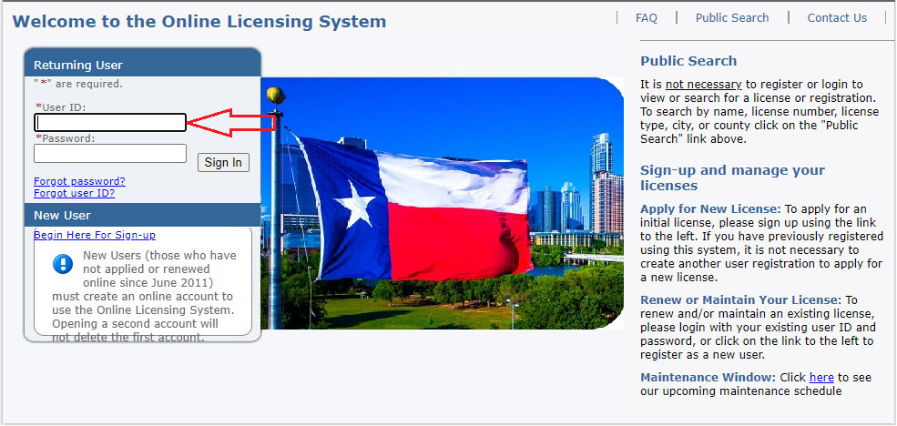

- Select “Update Profile” in the upper right hand portion of the page.
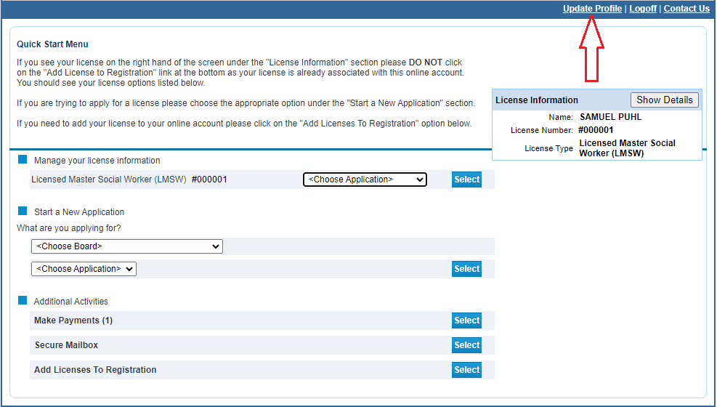

- Click the “Edit” button in the password row.

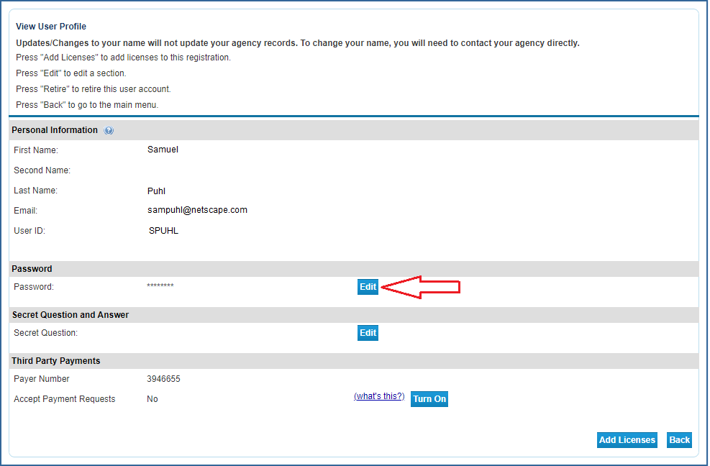

- Enter your current password followed by your new password then input the new password into the “Confirm Password” field to make sure there were no typos and click “Save”.

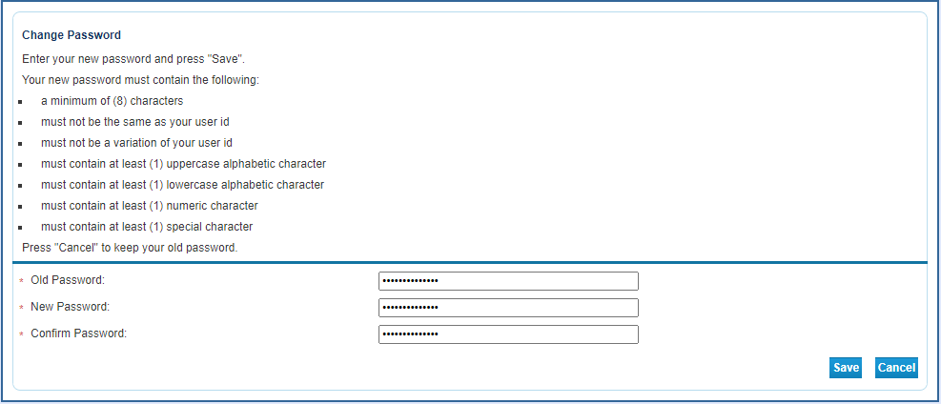

If the password cannot be accepted you will receive an error message listing the portion of the process that was triggered the error.

- Once accepted, you will be taken back to the View Profile screen and you will need to use the new password going forward.
