How To Apply To Add Doctorate Info To License

IMPORTANT: This feature is only available for holders of LPC, MFT, and Social Worker licenses. Additionally, only a doctoral degree that is acceptable for licensure grants eligibility in this process.

- Log into your online licensing system account. The online licensing system link is found here. If you do not yet have an account, you will need to create one. A guide on how to create a new account can be found at the top of this webpage.
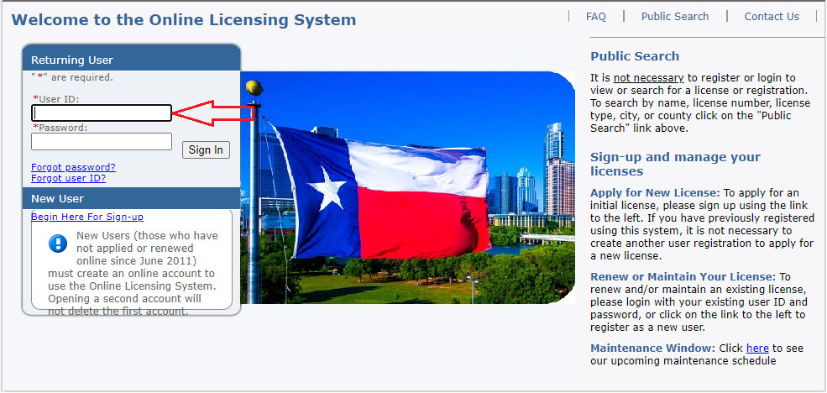

- Select “Texas Behavioral Health Executive Council” from the first drop-down then choose “Add Doctoral Degree” then click “Select”.
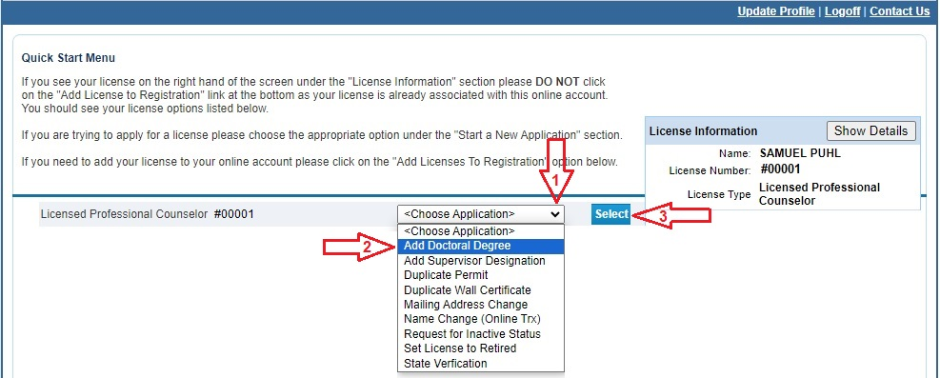

- Read the introduction and click “Next”.

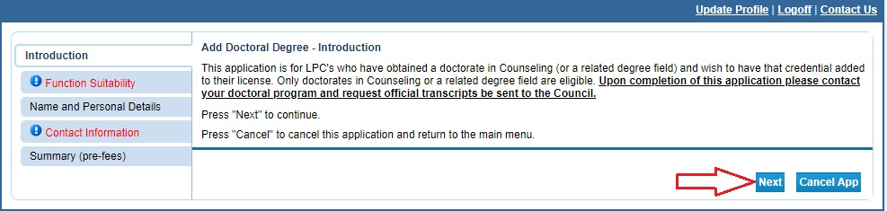

- Answer the function questions then click “Next”. These answers help the system verify that you are using the correct online application.

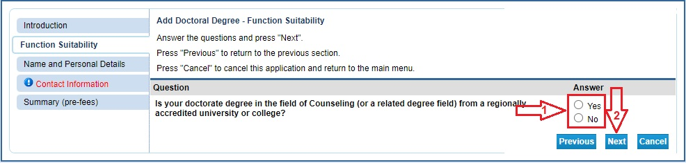

An answer that indicates a different application type will prompt an error message.

- Enter/Update your personal details then click “Next”.

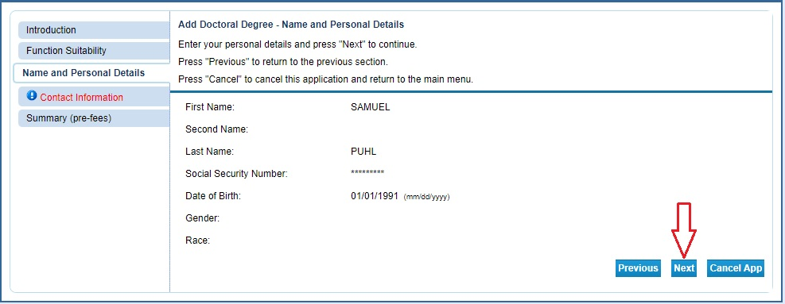

- Enter your contact information then click “Next”.
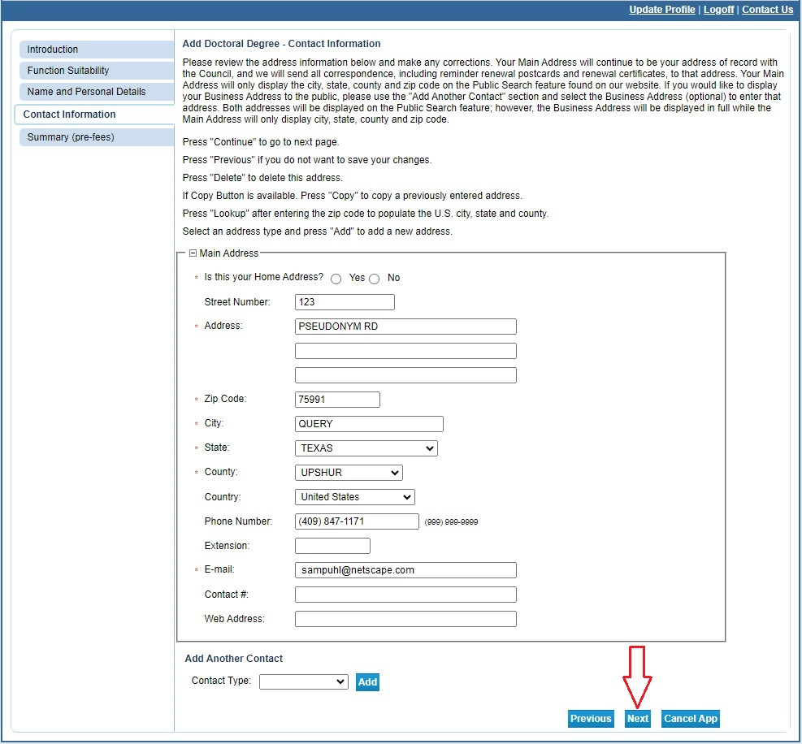

- Review your information and correct any errors. Once it is complete, click “Submit”. This will save the application and take you to the affirmation page.
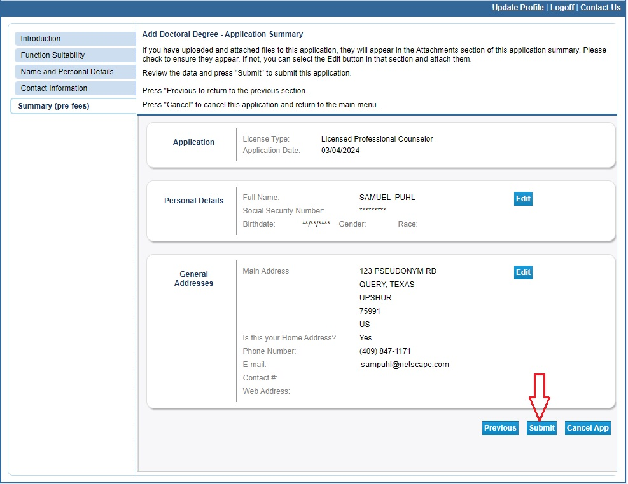

- Select “Yes” to agree to the affirmation and click “Submit”.
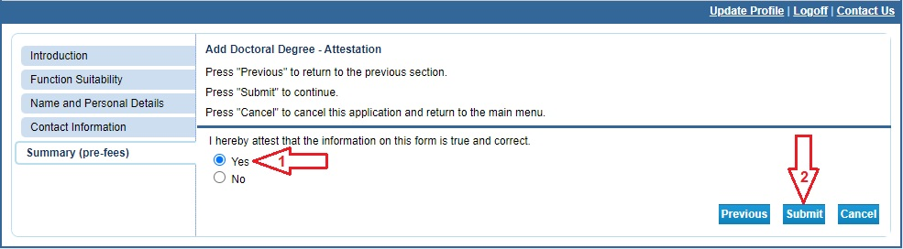

You will receive a confirmation email with a .pdf application summary attached.

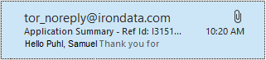

- Click on “Pay Now” to begin the payment process. If you fail to pay the fee the application will sit in limbo for 30 days and then be deleted.
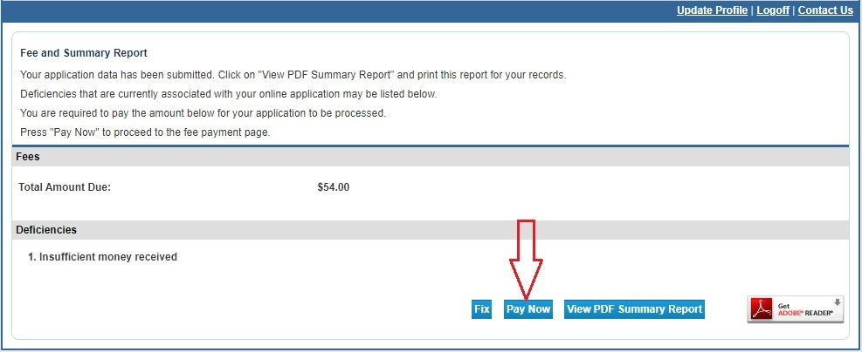

- Select the fee box then click “Next” to move to the confirmation page.
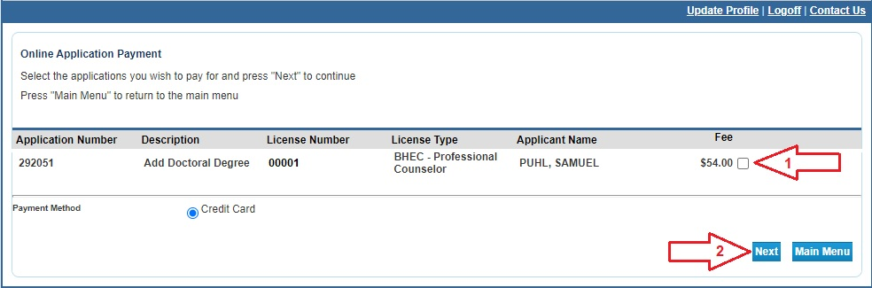

- Click “Next” to move to the payment processor.
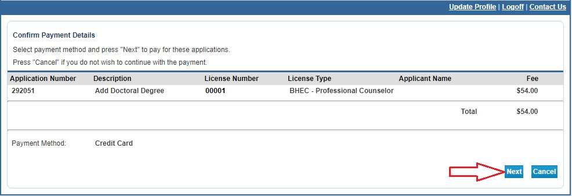

- You will be redirected to the payment processor. Enter your customer information in the required fields then click “Next”.
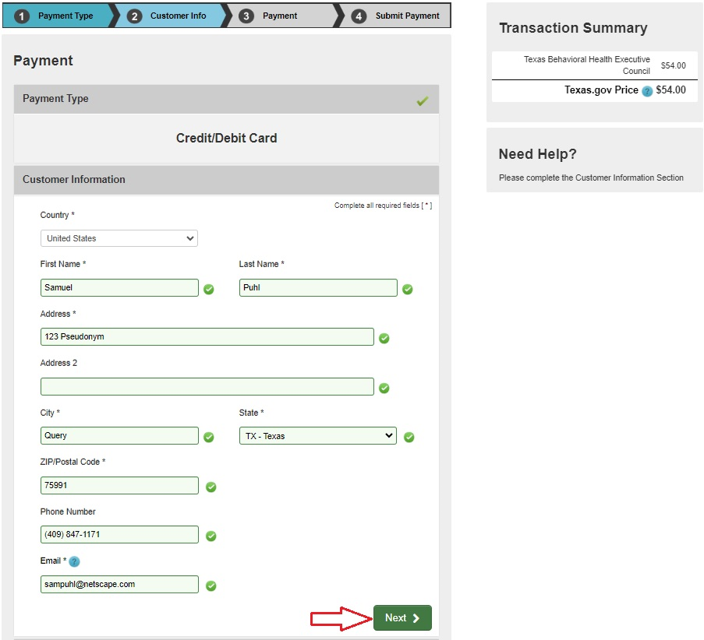

- Enter your credit card information and click “Next”.
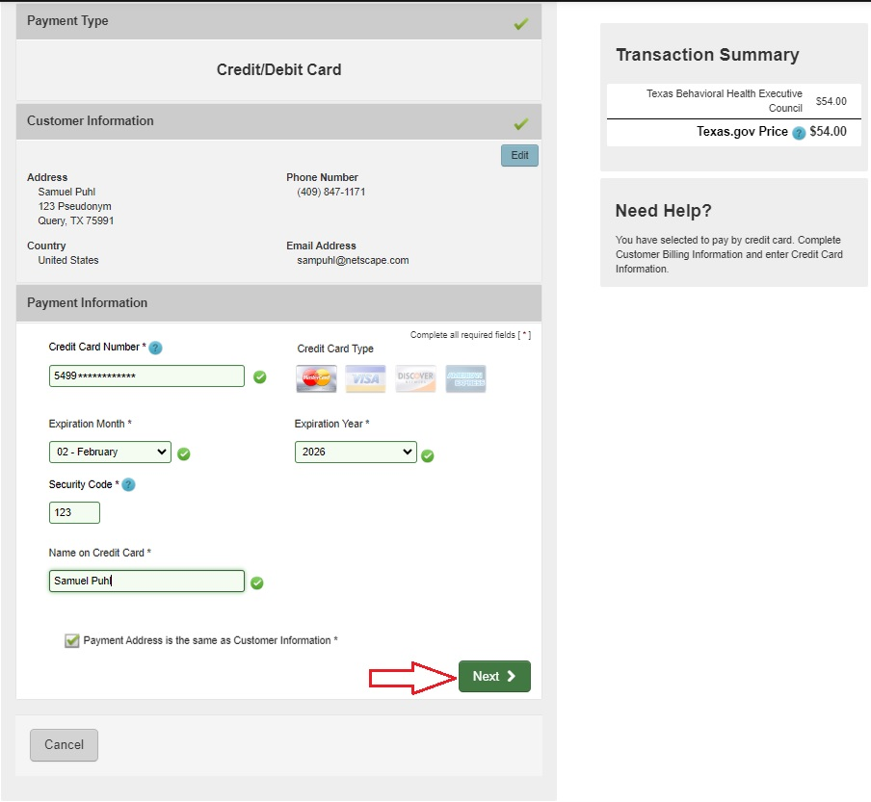

- Verify that you are not a robot, then click “Submit Payment”.
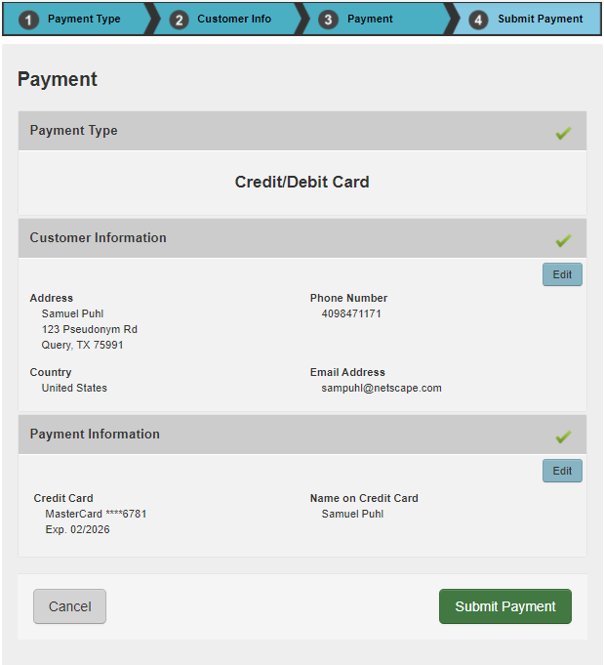

- After your payment is processed you will be redirected to the payment success page. This will give you the opportunity to view/save a summary of your transaction.
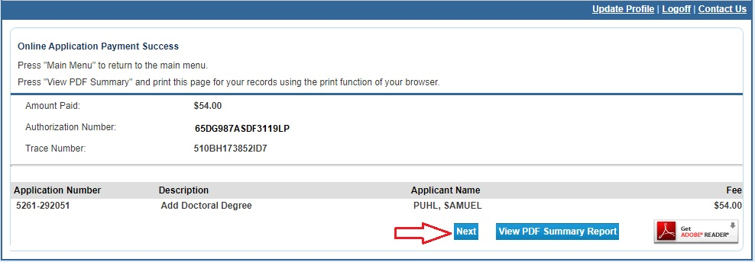

- You will also receive an email confirming your online payment. Please save the emails for your records.

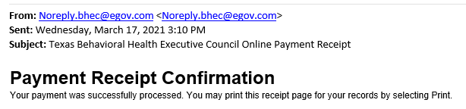

This completes the online portion of the application process. Your application will be reviewed by staff in the order it was received. Once reviewed, staff will either contact you to request missing documentation or, if everything in your application is complete and correct, send you the license. Due to heavy volume, please wait at least six weeks before contacting BHEC for a status update.

